Tribal ID Web Services Developers Guide

Environmental Protection Agency (EPA)

Delivery Order # GS00Q09BGD0022
Task Order # EP-G11H-00154
Project # TDD 10.09

Version 1.4

March 30, 2018

Table of Contents
List of Exhibits iv
Revision Log v
1 Introduction 1
1.1 Document Purpose 1
1.2 Project Overview 1
2 EPA Tribal Identification Web Services Overview 2
2.1 Access and Security 3
3 Data Publishing 4
3.1 GetTribe 4
3.1.1 Request 4
3.1.2 Response 5
3.2 GetTribes 5
3.2.1 Request 5
3.2.2 Response 7
4 Using the Tribal Web Service 8
4.1 Creating REST URLs 8
4.2 Example Tribal Web Service URLs 8
4.3 Example Usages 9
4.3.1 Search on a Tribe with Federal Recognition Status Change 9
4.3.2 Search on part of the Tribal Name on a Tribe with a Name Change 10
4.3.3 Search on Full Tribal Name on a Tribe with a Name Change 10
4.3.4 Search on State for a Tribe that Crosses State Borders 11
4.3.5 Search on BIA Codes 11
4.4 Business Rules 11
4.5 Use Cases 12
4.5.1 Use Case 1: Get Tribal Code(s) from Name 12
4.5.2 Use Case 2: Get Tribal Name(s) from BIA Tribal Code 13
4.5.3 Use Case 3: Get Tribal Name from Code when a Specific Date is Known 13
4.5.4 Use Case 4: Get EPA TII from Name 13
4.5.5 Use Case 5: Get EPA TII from Code 13
4.5.6 Use Case 6: Get EPA TII from Code when a Specific Date is Known 14
4.5.7 Use Case 7a: Get Tribal Name from EPA TII when a Specific Date is Known 14
4.5.8 Use Case 7b: Get Tribal Code from EPA TII when a Specific Date is Known 14
4.5.9 Use Case 8a: Get a Date Range for a given Tribal Name 14
4.5.10 Use Case 8b: Get a Date Range for a given Tribal Code 15
4.5.11 Use Case 8c: Get a Date Range for a given EPA TII 15
5 Future Services 16
6 Appendix A: Schema Information 17
7 Appendix B: Sample SOAP Requests and Responses 19

List of Exhibits
Exhibit 2-1 TRIBES Query Data Service Processing 3
Exhibit 3-1 GetTribe Query Parameters 5
Exhibit 3-2 GetTribes Query Parameters 6
Exhibit 4-1 URL Parameter Description 8
Exhibit 4-2 Example Tribal Web Service URLs 8
Exhibit 6-1 schema TRIBES_TRIBES_v1.0 (XML) 18
Exhibit 7-1 GetTribe Sample Request 19
Exhibit 7-2 GetTribe Sample Response 19
Exhibit 7-3 GetTribes Sample Request 21
Exhibit 7-4 GetTribes Sample Response 21

Revision Log
Date | Version No. | Description | Author | Reviewer | Review Date
8/27/12 | 0.01 | Initial Draft | G. Offutt | A. Ferner | 8/28/12
8/29/12 | 0.02 | Revised Per Details in EN Approval Package | J. Soosiah | A. Ferner | 8/29/12
8/31/12 | 0.03 | Comments Incorporated | G. Offutt | A. Ferner | 9/4/12
9/5/12 | 0.04 | Delivery of Draft TDD 10 09 Tribal ID User Guide | G. Offutt | A. Ferner | 9/5/12
9/14/12 | 0.04a | EPA comments on Draft TTD 10 09 Tribal ID User Guide | M. Pendleton |  | 9/14/12
11/15/12 | 1.0 | Delivery of final TDD 10 09 Tribal ID User Guide | G. Offutt | A. Ferner | 11/14/12
1/10/12 | 1.1 | Update to include security clarification | A. Ferner | N/A | N/A
12/23/14 | 1.2 | Updated TDD 10 09 Tribal ID User Guide | G.Woodring | K. Garrett | 12/22/14
09/18/15 | 1.3 | Added documentation and usage examples for TribalBandFilter parameter | J. Soosiah | G.Woodring | 9/21/15
3/30/18 | 1.4 | Updated language for tribes which cross state borders | J. Soosiah | T. Farewell | 3/30/18

Introduction

Document Purpose
This document serves as a guide for developers, both internal and external to Environmental Protection Agency (EPA), who wish to make use of EPA’s new Tribal ID web services. This guide outlines the data available through the web service and presents several use cases to assist developers in making the best use of the Tribal data.

Project Overview
EPA’s Tribal Identification data standard specifies the information (Tribal Names, Tribal Codes, and EPA Internal Identifiers) needed to constitute consistent and unambiguous identification of federally-recognized American Indian and Alaska Native Tribal entities. EPA's Tribal Identification data standard relies on authoritative Tribal Names and Tribal Codes that come from the U.S. Bureau of Indian Affairs (BIA), as well as EPA Internal Identifiers developed by the Agency. Implementing this data standard helps to ensure a means of uniquely identifying federally recognized Tribal entities across information systems so that Tribal identification information can be clearly exchanged. This service provides consuming systems with access to a centrally managed list of Tribal names, Tribal codes, and EPA Internal Identifiers, and supports implementation of EPA’s data standards.
In addition to providing the ability to access and consume a current list of political (non-geographic) Tribal entities, the services enable system list validation against standard names and codes, as well as provide Tribe names and codes for a specific time frame. Such services are needed because EPA’s Tribal ID data standard is based on the BIA official list of federally recognized Tribes, and that list changes over time as Tribes are added and/or removed, and names are changed. This version includes tribe names going back to 1979.

EPA Tribal Identification Web Services Overview
A web service is a method of communication between software applications using open protocols over the web. A common function of a web service is to query data from a centralized data source. Such query web services return data requests in XML format only; the queries do not display the data in a user interface. Data returned in a standardized XML format allows independent software applications to consume the same data in a consistent manner suited to their respective needs. All services offered by EPA Tribal Identification Web Services are query web services.
Web services generally run on either the Simple Object Access Protocol (SOAP) or Representational State Transfer (REST) protocol. The Tribal Identification Web Services support both SOAP and REST standards.
Use of a SOAP web service generally consists of XML message-passing between client and server. To invoke a typical web service with the SOAP protocol, the client sends an XML-formatted document that specifies the desired data service, authentication credentials, if needed, and service-specific parameters. The service receives this request and responds with the requested data in XML.
A REST web service can be called by entering the web service's URL into the browser. All service parameters can be set via URL parameters. The server interprets the data in the URL and responds with the requested data in XML.
The general flow of processing performed when issuing a request to a Tribal Identification Web Service is depicted in Exhibit 2-1 below.
Exhibit 2-1 TRIBES Query Data Service Processing
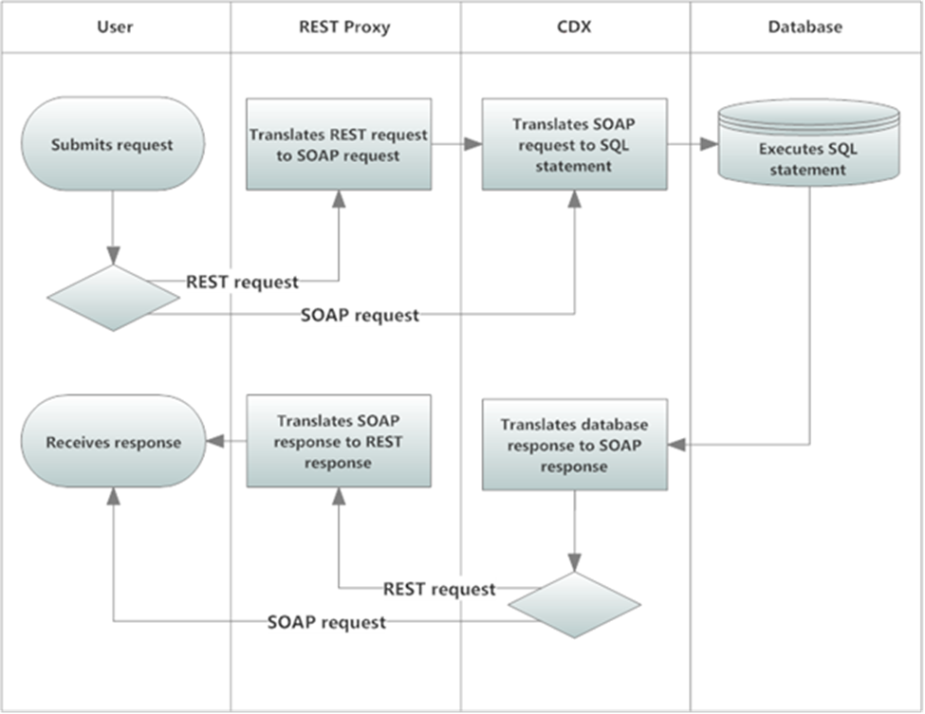

Access and Security
The REST services offered by EPA Tribal ID Web Services are publicly available through the CDX REST Proxy and do not require any additional security authorizations to access.
All requests to SOAP services must be accompanied by a valid Network Authentication and Authorization Services (NAAS) security token per the Exchange Network’s Node 2.0 specifications (http://www.exchangenetwork.net/node-2/). All partners must be authorized to NAAS and receive a valid security token before the TRIBES data services can be invoked by a SOAP request.
In order to acquire a valid security token the user must have the appropriate NAAS security policies in place and associated with EPA’s CDX node and EPA Tribal ID Web Services data flow. To obtain access, contact the CDX help desk for more information (http://www.epa.gov/cdx/contact.htm).

Data Publishing
EPA Tribal ID Web Services data flow offers two query data services. The service ‘GetTribe’ allows users to list detailed information, including historical data, on a particular Tribe based on Tribe identifier or name. The ‘GetTribes’ service allows users to search Tribes based on partial name, date, or regional information and shows only current data essential for identifying each Tribe. The sections below, along with Exhibit 3-1, provide a sample retrieval data publishing; the query is designed to be performed in the order listed.
Please note that the parameters rowId and maxRows are currently accepted only when using SOAP query data services. These parameters are expected to be operational in the future, at which time this documentation will be updated accordingly.

GetTribe
Description: This data service allows users to select Tribal entities (Tribes) or tribal component bands based on either the EPA Tribal internal identifier, the BIA Tribal code, or the full name of the Tribe. Historical information on the names and codes of the Tribe is included, as well as regional information and associations to other Tribes, such as Tribal band membership. Zero or more Tribes may be returned by this service, but in most cases a single Tribe will be returned. Multiple entities will only be returned in unusual cases, such as multiple Tribes sharing the same BIA Tribal code.
Type: Query
Data Service-level Business Rules: Not applicable
XML Header Usage: Not applicable

Request
Dataflow: TRIBES
Request: GetTribe
rowId: Any valid rowId value per the Node specification WSDL (e.g., -1, 0, or positive integer). For this query, each row represents one Tribe returned by the query (one instance of a Tribe XML tag and all of its child tags).
maxRows: Any valid maxRows value per the Node specification WSDL (e.g., -1, or positive integer). For this query, this is the maximum number of Tribes (rows) to be returned for this invocation of the query service.

Exhibit 3-1 GetTribe Query Parameters
Name | Data Type | Required | Max Length | Occurrences | Wildcard Behavior | Notes
EPATribalInternalID | String | No | N/A | 1 | None | EPA Tribal Internal Identifier of the Tribe.
BIATribalCode | String | No | N/A | 1 | None | The BIA Tribal Code of the Tribe.
Name | String | No | N/A | 1 | None | The full name of the Tribe. Case insensitive; no partial match.

Response
Response: See Exhibit 7-2 in Appendix B.
rowId: The integer representing the position of the first Tribe returned in the full result set of the query. For this query, each row represents one Tribe returned by the query.
RowCount: The integer representing the total number of Tribes returned for this query. This may not be all of the Tribes selected for this query based upon parameters passed to the query; the total number returned may be limited by the maxRows input parameter, or by the EPA Tribal ID Web Services application itself. Users can continue to issue the query, increasing the rowId input parameter each time to retrieve all entities selected by the query.
LastSet: Boolean indicating whether there are any more Tribes (rows) to return.

GetTribes
Description: This data service allows users to select Tribal entities (Tribes) or tribal component bands (not shown by default) based upon name, date, and regional information. Only current data essential to uniquely identify each Tribe is listed. Zero or more Tribes may be returned by this service. To include the tribal component bands see the TribalBandFilter parameter in section 3.1.2.1
Type: Query
Data Service-level Business Rules: Not applicable
XML Header Usage: Not applicable

Request
Dataflow: TRIBES
Request: GetTribes
rowId: Any valid rowId value per the Node specification WSDL (e.g., -1, 0, or positive integer). For this query, each row represents one Tribe returned by the query (one instance of a Tribe XML tag and all of its child tags).
maxRows: Any valid maxRows value per the Node specification WSDL (e.g., -1, or positive integer). For this query, this is the maximum number of Tribes (rows) to be returned for this invocation of the query service.
Exhibit 3-2 GetTribes Query Parameters
Name | Data Type | Required | Max Length | Occurrences | Wildcard Behavior | Notes
Date | String | No | N/A | 1 | None | If Specified, only Tribes federally recognized as of Date will be listed. Should not be specified if either StartDate or EndDate is specified.  Format: YYYY-MM-DD
StartDate | String | No | N/A | 1 | None | If specified, only Tribes federally recognized as of any time on or after StartDate will be listed.  Format: YYYY-MM-DD
EndDate | String | No | N/A | 1 | None | If specified, only Tribes federally recognized as of any time on or before EndDate will be listed.  Format: YYYY-MM-DD
Name | String | No | N/A | 1 | None, but partial matches are always included | If specified, only Tribes that have or have had names containing the term Name will be listed.  Case insensitive
Region | String | No | N/A | 1 | None, but partial matches are always included | If specified, only Tribes in the specified EPA Region will be listed.  Case insensitive
State | String | No | N/A | 1 | None, but partial matches are always included | If specified, only Tribes EPA has that are associated with the specified State will be listed.  Case insensitive
TribalBandFilter | String | No | N/A | 1 | None | Accepts one of three possible values:  • ExcludeTribalBands – List federally recognized tribes, excluding tribal bands.  • TribalBandsOnly – List tribal bands only.  • AllTribes – List all federally recognized tribes and component bands.  If the TribalBandFilter parameter is omitted, the behavior for ExcludeTribalBands is used by default.

Response
Response: See Exhibit 7-4 in Appendix B.
rowId: The integer representing the position of the first Tribe returned in the full result set of the query. See the Node 2.0 specification for more information. For this query, each row represents one Tribe returned by the query.
RowCount: The integer representing the total number of Tribes returned for this query. This may not be all of the Tribes selected for this query based upon parameters passed to the query; the total number returned may be limited by the maxRows input parameter, or by the TRIBES application itself. Users can continue to issue the query, increasing the rowId input parameter each time to retrieve all Tribes selected by the query. See the Node 2.0 specification for more information.
LastSet: Boolean indicating whether there are any more Tribes (rows) to return.

Using the Tribal Web Service

Creating REST URLs
EPA Tribal Identification's REST web services are exposed through EPA's CDX Exchange Network REST Proxy (ENRP). The URL template for EPA Tribal Identification REST services as generated by ENRP is as follows.

https://ends2.epa.gov/RestProxy/Query?Node=.NetNode2&Dataflow=TRIBES&Request={request}&Params={parameters}&rowId={rowId}&MaxRows={maxRows}

The URL parameters are detailed in Exhibit 4-1 below. One main point to remember when using this web service is that maxRows and rowId are parameters are only available when using the SOAP services and currently do not work within REST. The capitalization is also very important when using the parameters and must be copied identically from the way they appear in this document.
Exhibit 4-1 URL Parameter Description
URL Parameter | Description
request | The name of the service request (GetTribes_v1.0 or GetTribe_v1.0).
parameters | A list of all parameters for the Query service (described in 3.1.1 and 3.2.1) in the form of: param1|value1;param2|value2;...  where parameter name/value pairs are separated with a pipe (|) delimiter and parameters are separated with a semi-colon (;) delimiter. This parameter may be omitted if no Query service parameters need be supplied.

Example REST URLs are provided in section 4.2.

Example Tribal Web Service URLs
Below is a table of example URLs that would be used to call the REST service and the results returned by each.
Exhibit 4-2 Example Tribal Web Service URLs
URL | WS REST Web Service URL | Results
1 | https://ends2.epa.gov/RestProxy/Query?Node=.NetNode2&Dataflow=TRIBES&Request=GetTribes_v1.0 | List all currently recognized Tribes
2 | https://ends2.epa.gov/RestProxy/Query?Node=.NetNode2&Dataflow=TRIBES&Request=GetTribes_v1.0&Params=StartDate|2003-12-21 | List all Tribes which have been federally recognized at some point on or after 12-21-2003
3 | https://ends2.epa.gov/RestProxy/Query?Node=.NetNode2&Dataflow=TRIBES&Request=GetTribes_v1.0&Params=EndDate|2004-07-12 | List all Tribes which have been federally recognized at some point on or prior to 07-12-2004
4 | https://ends2.epa.gov/RestProxy/Query?Node=.NetNode2&Dataflow=TRIBES&Request=GetTribes_v1.0&Params=StartDate|2003-12-21;EndDate|2004-07-12 | List all Tribes which have been federally recognized at some point between 12-21-2003 and 07-12-2004
5 | https://ends2.epa.gov/RestProxy/Query?Node=.NetNode2&Dataflow=TRIBES&Request=GetTribes_v1.0&Params=Date|2006-03-15 | List all Tribes federally recognized as of 03-15-2006
6 | https://ends2.epa.gov/RestProxy/Query?Node=.NetNode2&Dataflow=TRIBES&Request=GetTribes_v1.0&Params=Name|cherokee | List all Tribes whose official name contains the term Cherokee
7 | https://ends2.epa.gov/RestProxy/Query?Node=.NetNode2&Dataflow=TRIBES&Request=GetTribes_v1.0&Params=Date|2006-03-15;Name|cherokee | List all Tribes federally recognized as of 03-15-2006, and whose official name contained the term Cherokee as of 03-15-2006
8 | https://ends2.epa.gov/RestProxy/Query?Node=.NetNode2&Dataflow=TRIBES&Request=GetTribes_v1.0&Params=State|OK | List all Tribes associated with the state of Oklahoma
9 | https://ends2.epa.gov/RestProxy/Query?Node=.NetNode2&Dataflow=TRIBES&Request=GetTribes_v1.0&Params=Region|9 | List all Tribes in EPA Region 9
10 | https://ends2.epa.gov/RestProxy/Query?Node=.NetNode2&Dataflow=TRIBES&Request=GetTribes_v1.0&Params=Date|2006-03-15;Region|9 | List all Tribes federally recognized as of 03-15-2006 in EPA Region 9
11 | https://ends2.epa.gov/RestProxy/Query?Node=.NetNode2&Dataflow=TRIBES&Request=GetTribe_v1.0&Params=BIATribalCode|440 | List the Tribe with BIA code 440
12 | https://ends2.epa.gov/RestProxy/Query?Node=.NetNode2&Dataflow=TRIBES&Request=GetTribe_v1.0&Params=Name|Menominee%20Indian%20Tribe%20of%20Wisconsin | List the Tribe with the official name Menominee Indian Tribe of Wisconsin
13 | https://ends2.epa.gov/RestProxy/Query?Node=.NetNode2&Dataflow=TRIBES&Request=GetTribe_v1.0&Params=EPATribalInternalID|100000298 | List the Tribe with EPA Tribal Internal Identifier 100000298
14 | https://ends2.epa.gov/RestProxy/Query?Node=.NetNode2&Dataflow=TRIBES&Request=GetTribes_v1.0&Params=TribalBandFilter|TribalBandsOnly | List all tribal component bands
15 | https://ends2.epa.gov/RestProxy/Query?Node=.NetNode2&Dataflow=TRIBES&Request=GetTribe_v1.0&Params=EPATribalInternalID|100000570 | List the tribal component band with EPA Tribal Internal Identifier 100000570

Example Usages
Provided below are example searches that will provide guidance on how to use the Tribal Web Service. These examples are of special cases that could potentially cause confusion when searching.

Please refer to Appendix B: Sample SOAP Requests and Responses for example SOAP XML responses.

Search on a Tribe with Federal Recognition Status Change
Scenario:
The "Delaware Tribe of Indians, Oklahoma" (code 816) was not listed by BIA on 2/16/1995, but they were listed as a recognized Tribe on 11/13/1996. They continued to be recognized on succeeding lists through 12/5/2003, then on 11/25/2005 they were removed from the list of recognized Tribes. They then stayed off the list until 2009, when they were re-recognized and included inon the list on 8/11/2009. Since that time they have remained on the list.

Results:
This case applies to the service GetTribes_v1.0 only (the other service doesn’t take dates). Example, using the Delaware Tribe of Indians, Oklahoma – if the date value specified is:
- 11/01/2004 – Then Delaware Tribe of Indians, Oklahoma will be included.
- 11/01/2007 – Then Delaware Tribe of Indians, Oklahoma will NOT be included.
- 11/01/2011 – Then Delaware Tribe of Indians, Oklahoma will be included.

Explanation/Rule:
If a date value is specified, then all Tribes that were recognized as of the specified date will be listed. If a date range is specified, then all Tribes that were recognized at any point within the date range will be listed.

Search on part of the Tribal Name on a Tribe with a Name Change
Scenario:
The Tribe "Pueblo of San Juan, New Mexico" (code 714) was changed to "Ohkay Owingeh, New Mexico" on 3/22/2007.

Results:
San Juan – currently known as Ohkay Owingeh, New Mexico will be listed with its most current name only.

Explanation/Rule:
The web service includes the ability to query for Tribes based on matching part or all of the Tribal name.

Partial name searching applies to the service GetTribes_v1.0 only. This service can be described as follows:
- When a partial name is specified, all Tribes that have (or have had) a name containing the search term will be listed.
- The response format of GetTribes_v1.0 is a list of rows, where each row refers to exactly one Tribe, and each row contains the minimum essential data to identify the Tribe. This includes EPA Tribal Internal ID, current name, BIA code, and so on. Regional information and past names are omitted.

Search on Full Tribal Name on a Tribe with a Name Change
Scenario:
The Tribe previously listed as "Cuyapaipe Community of Diegueno Mission Indians of the Cuyapaipe Reservation, California" (code 573) was changed to "Ewiiaapaayp Band of Kumeyaay Indians, California" and has continued with that name since that change.

Result:
Calling GetTribe_v1.0 with full name “Ewiiaapaayp Band of Kumeyaay Indians, California” will bring up all available data on that Tribe, and calling the same service with full name “Cuyapaipe Community of Diegueno Mission Indians of the Cuyapaipe Reservation, California” will give an identical result.

Explanation/Rule:
For the service GetTribe_v1.0, if a full name is provided, then all Tribes that have or have had the specified name will be listed in detail.

Search on State for a Tribe that Crosses State Borders
Scenario:
The Tribe Fort Mojave Indian Reservation covers territories in California, Nevada, and Arizona.

Result:
Performing a search on this Tribe using any of the possible query parameters, the service will list California, Nevada, and Arizona as this Tribe’s State Association.

Explanation/Rule:
For Tribes that cross state borders, the service returns all states that the Tribe covers geographically.

Search on BIA Codes
Scenario:
The Tribe Shinnecock Indian Nation has a BIA Code of TBD.

Result:
Performing a search on this Tribe using any of the possible query parameters, the service will list its BIA code as TBD.

Explanation/Rule:
Current values for the BIA Code field are numerical codes, TBD, or blank.Searchingfor a tribe with a TBD code will return many results.

Business Rules
The following business rules and clarifications apply to the Tribal data contained in EPA Tribal ID Web Services:
- For Tribes which cross state borders, the EPA Business State Association will list all states the Tribe covers geographically.
- Date parameters are defined as follows:
- Date – Only returns Tribes federally recognized as of Date. This parameter should not be used if either StartDate or EndDate is specified. Format: YYYY-MM-DD
- StartDate – Only returns Tribes federally recognized as of any time on or after StartDate. Format: YYYY-MM-DD
- EndDate – Only returns Tribes federally recognized as of any time on or before EndDate. Format: YYYY-MM-DD
- The Year 1000 is the substitute for any unknown Tribe start dates.
- If no parameter values are entered, the web service will return a list of all currently recognized Tribes.
- rowId represents the row number with which you would like the search results to begin. The default value is zero, which will return the very first matching result.
- maxRows represents the maximum number of rows to be returned from the search.

Use Cases
EPA Tribal ID Web Services data flow offers two query data services. The service GetTribe allows users to list detailed information, including historical data, on a particular Tribe based on Tribe identifier or name. The GetTribes service allows users to search Tribes based on partial name, date, or regional information, and shows only current data essential for identifying each Tribe.
Each of the use cases below are provided to assist the user of this Web Service with some of the most common searches. Provided are the REST URL that would be utilized, along with the expected inputs and outputs.

Use Case 1: Get Tribal Code(s) from Name
URL # 6: https://ends2.epa.gov/RestProxy/Query?Node=.NetNode2&Dataflow=TRIBES&Request=GetTribes_v1.0&Params=Name|cherokee

Input: Whole or part of a Tribal Name into GetTribes (not case sensitive)

Output: User receives a list of Tribal Names that includes the string of the name entered above.

URL # 12: https://ends2.epa.gov/RestProxy/Query?Node=.NetNode2&Dataflow=TRIBES&Request=GetTribe_v1.0&Params=Name|Menominee%20Indian%20Tribe%20of%20Wisconsin

Input: Whole Tribal Name into Get Tribe (not case sensitive)

Output: User receives historical data, which includes the Tribal Code, on the Tribe entered above.

Use Case 2: Get Tribal Name(s) from BIA Tribal Code
URL # 11: https://ends2.epa.gov/RestProxy/Query?Node=.NetNode2&Dataflow=TRIBES&Request=GetTribe_v1.0&Params=BIATribalCode|440

Input: BIA Tribal Code

Output: User receives the information of the Tribe associated with the entered BIA code.

Use Case 3: Get Tribal Name from Code when a Specific Date is Known
URL # 11: https://ends2.epa.gov/RestProxy/Query?Node=.NetNode2&Dataflow=TRIBES&Request=GetTribe_v1.0&Params=BIATribalCode|440

Input: BIA Tribal Code

Output: User receives the information of the Tribe associated with the Entered BIA code. The user can then use the provided data to decide which Tribal Name to choose based on the known date.

Use Case 4: Get EPA TII from Name
URL # 6: https://ends2.epa.gov/RestProxy/Query?Node=.NetNode2&Dataflow=TRIBES&Request=GetTribes_v1.0&Params=Name|cherokee

Input: Whole or part of a Tribal Name into GetTribes(not case sensitive)

Output: User receives a list of Tribal Names that includes the string of the name entered above. The user then decides which EPA Tribal Internal Identifier (TII) to choose based on the Tribal Name for which they are looking.

URL # 12: https://ends2.epa.gov/RestProxy/Query?Node=.NetNode2&Dataflow=TRIBES&Request=GetTribe_v1.0&Params=Name|Menominee%20Indian%20Tribe%20of%20Wisconsin

Input: Whole Tribal Name into GetTribe (not case sensitive)

Output: User receives historical data, which includes the EPA TII, on the Tribe entered above.

Use Case 5: Get EPA TII from Code
URL # 11: https://ends2.epa.gov/RestProxy/Query?Node=.NetNode2&Dataflow=TRIBES&Request=GetTribe_v1.0&Params=BIATribalCode|440

Input: BIA Tribal Code

Output: User receives the information of the Tribe associated with the entered BIA code.

Use Case 6: Get EPA TII from Code when a Specific Date is Known
URL # 13: https://ends2.epa.gov/RestProxy/Query?Node=.NetNode2&Dataflow=TRIBES&Request=GetTribe_v1.0&Params=EPATribalInternalID|100000298

Input: EPA Tribal Internal Identifier

Output: User receives the information of the Tribe associated with the entered BIA code. The user can then use the provided information to decide which EPA TII to choose based on the known date.

Use Case 7a: Get Tribal Name from EPA TII when a Specific Date is Known
URL # 13:
https://ends2.epa.gov/RestProxy/Query?Node=.NetNode2&Dataflow=TRIBES&Request=GetTribe_v1.0&Params=EPATribalInternalID|100000298

Input: EPA Tribal Internal Identifier

Output: User receives the information of the Tribe associated with the entered EPA TII. The user can then use the provided information to decide which Tribal Name to choose based on the known date.

Use Case 7b: Get Tribal Code from EPA TII when a Specific Date is Known
URL # 13: https://ends2.epa.gov/RestProxy/Query?Node=.NetNode2&Dataflow=TRIBES&Request=GetTribe_v1.0&Params=EPATribalInternalID|100000298

Input: EPA Tribal Internal Identifier

Output: User receives the information of the Tribe associated with the entered EPA TII. The user can then use the provided information to decide which Tribal Code to choose based on the known date.

Use Case 8a: Get a Date Range for a given Tribal Name
URL # 6: https://ends2.epa.gov/RestProxy/Query?Node=.NetNode2&Dataflow=TRIBES&Request=GetTribes_v1.0&Params=Name|cherokee

Input: Whole or part of a Tribal Name from GetTribes (not case sensitive)

Output: User receives a list of Tribal Names that includes the string of the name entered above.

URL # 12: https://ends2.epa.gov/RestProxy/Query?Node=.NetNode2&Dataflow=TRIBES&Request=GetTribe_v1.0&Params=Name|Menominee%20Indian%20Tribe%20of%20Wisconsin

Input: Whole Tribal Name from GetTribe (not case sensitive)

Output: User receives historical data, which includes the dates of the Tribe Name(s), on the Tribe entered above.

Use Case 8b: Get a Date Range for a given Tribal Code
URL # 11 https://ends2.epa.gov/RestProxy/Query?Node=.NetNode2&Dataflow=TRIBES&Request=GetTribe_v1.0&Params=BIATribalCode|440

Input: BIA Tribal Code

Output: User receives the information of the Tribe associated with the entered BIA code.

Use Case 8c: Get a Date Range for a given EPA TII
URL # 13: https://ends2.epa.gov/RestProxy/Query?Node=.NetNode2&Dataflow=TRIBES&Request=GetTribe_v1.0&Params=EPATribalInternalID|100000298

Input: EPA Tribal Internal Identifier

Output: User receives the information of the Tribe associated with the entered EPA TII.

Future Services
EPA is planning to provide a Tribal ID registry service, available through the current EPA System of Registries public access page. This registry service will consist of an interface that allows interested users to search the database of EPA Tribal ID data standards. Separate user documentation will be provided when this registry site becomes available.
Once the new services are cataloged by ENDS, users will also be able to access them using the Exchange Network Browser, the Exchange Network Service Center, or the REST Builder.

Appendix A: Schema Information
The following diagram depicts a high-level view of the TRIBES schema. A single Tribal entity is represented by the Tribe tag.

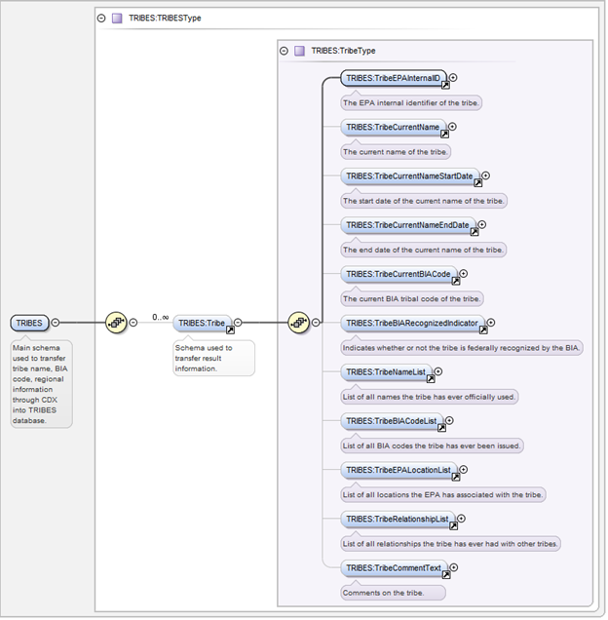

Exhibit 6-1 schema TRIBES_TRIBES_v1.0 (XML)
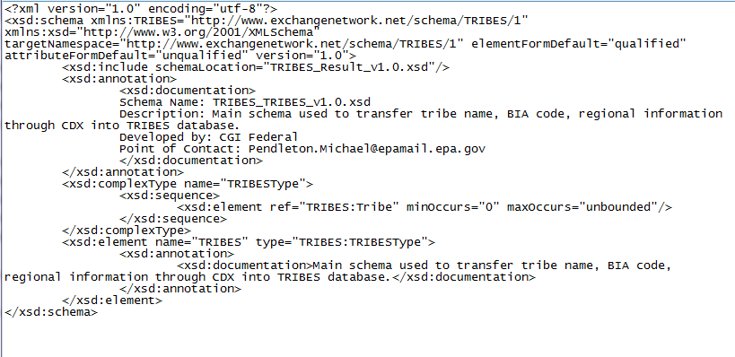

Appendix B: Sample SOAP Requests and Responses
Exhibit 7-1 GetTribe Sample Request

<soap:Envelope xmlns:soap="http://www.w3.org/2003/05/soap-envelope" xmlns:ns="http://www.exchangenetwork.net/schema/node/2">
<soap:Header/>
<soap:Body>
<ns:Query>
<ns:securityToken>
<!-- securityToken removed from example request -->
</ns:securityToken>
<ns:dataflow>TRIBES</ns:dataflow>
<ns:request>GetTribe_v1.0</ns:request>
<ns:parameters parameterName="EPATribalInternalID">100000032</ns:parameters>
</ns:Query>
</soap:Body>
</soap:Envelope>

Exhibit 7-2 GetTribe Sample Response
<?xml version="1.0"?>
<QueryResponse xmlns="http://www.exchangenetwork.net/schema/node/2" xmlns:i="http://www.w3.org/2001/XMLSchema-instance">
<LastSet>false</LastSet>
<Results>
<TRIBES xmlns="http://www.exchangenetwork.net/schema/TRIBES/1" i:schemaLocation="http://www.exchangenetwork.net/schema/TRIBES/1 https://cdxnode2.epacdxnode.net/config/query/xsd/TRIBES/shared/index.xsd">
<Tribe>
<TribeEPAInternalID>100000032</TribeEPAInternalID>
<TribeCurrentName>Capitan Grande Band of Diegueno Mission Indians of California: (Barona Group of Capitan Grande Band of Mission Indians of the Barona Reservation, California; Viejas (Baron Long) Group of Capitan Grande Band of Mission Indians of the Viejas Reservation, California)</TribeCurrentName>
<TribeCurrentNameStartDate>2012-08-10</TribeCurrentNameStartDate>
<TribeCurrentNameEndDate i:nil="true"/>
<TribeCurrentBIACode>571</TribeCurrentBIACode>
<TribeBIARecognizedIndicator>1</TribeBIARecognizedIndicator>
<TribeNameList>
<TribeNameDetails>
<TribeName>Capitan Grande Band of Diegueno Mission Indians of California: (Barona Group of Capitan Grande Band of Mission Indians of the Barona Reservation, California; Viejas (Baron Long) Group of Capitan Grande Band of Mission Indians of the Viejas Reservation, California)</TribeName>
<TribeNameStartDate>2012-08-10</TribeNameStartDate>
<TribeNameEndDate i:nil="true"/>
<TribeNameCommentText i:nil="true"/>
</TribeNameDetails>
<TribeNameDetails>
<TribeName>Capitan Grande Band of Diegueno Mission Indians of California: Barona Group of Capitan Grande Band of Mission Indians of the Barona Reservation, California; Viejas (Baron Long) Group of Capitan Grande Band of Mission Indians of the Viejas Reservation, California</TribeName>
<TribeNameStartDate>2010-10-01</TribeNameStartDate>
<TribeNameEndDate>2012-08-10</TribeNameEndDate>
<TribeNameCommentText i:nil="true"/>
</TribeNameDetails>
<TribeNameDetails>
<TribeName>Capitan Grande Band of Diegueno Mission Indians of California: Barona Group of Capitan Grande Band of Mission Indians of the Barona Reservation, California Viejas (Baron Long) Group of Capitan Grande Band of Mission Indians of the Viejas Reservation, California</TribeName>
<TribeNameStartDate>1993-10-21</TribeNameStartDate>
<TribeNameEndDate>2010-10-01</TribeNameEndDate>
<TribeNameCommentText i:nil="true"/>
</TribeNameDetails>
<TribeNameDetails>
<TribeName>Capitan Grande Band of Diegueno Mission Indians of California: Barona Group of the Barona Reservation, California Viejas Group of the Viejas Reservation, California</TribeName>
<TribeNameStartDate>1988-12-29</TribeNameStartDate>
<TribeNameEndDate>1993-10-21</TribeNameEndDate>
<TribeNameCommentText i:nil="true"/>
</TribeNameDetails>
<TribeNameDetails>
<TribeName>Capitan Grande Band of Diegueno Mission Indians of California: Barona Group of Capitan Grande Band of Mission Indians of the Barona Reservation, California Viejas Group of Capitan Grande Band of Mission Indians of the Viejas Reservation, California</TribeName>
<TribeNameStartDate>1986-07-10</TribeNameStartDate>
<TribeNameEndDate>1988-12-29</TribeNameEndDate>
<TribeNameCommentText i:nil="true"/>
</TribeNameDetails>
<TribeNameDetails>
<TribeName>Capitan Grande Band of Diegueno Mission Indians of the Capitan Grande Reservation, California</TribeName>
<TribeNameStartDate>1982-11-24</TribeNameStartDate>
<TribeNameEndDate>1986-07-10</TribeNameEndDate>
<TribeNameCommentText i:nil="true"/>
</TribeNameDetails>
<TribeNameDetails>
<TribeName>Capitan Grande Band of Diegueno Mission Indians, Capitan Grande Reservation, California</TribeName>
<TribeNameStartDate>1000-01-01</TribeNameStartDate>
<TribeNameEndDate>1982-11-24</TribeNameEndDate>
<TribeNameCommentText i:nil="true"/>
</TribeNameDetails>
</TribeNameList>
<TribeBIACodeList>
<TribeBIACodeDetails>
<TribeBIACode>571</TribeBIACode>
<TribeBIACodeStartDate>1000-01-01</TribeBIACodeStartDate>
<TribeBIACodeEndDate i:nil="true"/>
<TribeBIACodeCommentText i:nil="true"/>
</TribeBIACodeDetails>
</TribeBIACodeList>
<TribeEPALocationList>
<TribeEPALocationDetails>
<TribeEPAStateCode>CA</TribeEPAStateCode>
<TribeEPAStateName>California</TribeEPAStateName>
<TribeEPARegionCode>9</TribeEPARegionCode>
<TribeEPARegionName>Region 9</TribeEPARegionName>
<TribeEPALocationStartDate>1000-01-01</TribeEPALocationStartDate>
<TribeEPALocationEndDate i:nil="true"/>
</TribeEPALocationDetails>
</TribeEPALocationList>
<TribeRelationshipList>
<TribeRelationshipDetails>
<TribeRelativeEPAInternalID>100000582</TribeRelativeEPAInternalID>
<TribeRelationshipTypeDetails>
<TribeRelationshipTypeCode>RELATED</TribeRelationshipTypeCode>
<TribeRelationshipTypeName>Related</TribeRelationshipTypeName>
<TribeRelationshipTypeDescriptionText>Related Tribal Entities</TribeRelationshipTypeDescriptionText>
</TribeRelationshipTypeDetails>
<TribeRelationshipStartDate>1000-01-01</TribeRelationshipStartDate>
<TribeRelationshipEndDate i:nil="true"/>
</TribeRelationshipDetails>
<TribeRelationshipDetails>
<TribeRelativeEPAInternalID>100000581</TribeRelativeEPAInternalID>
<TribeRelationshipTypeDetails>
<TribeRelationshipTypeCode>RELATED</TribeRelationshipTypeCode>
<TribeRelationshipTypeName>Related</TribeRelationshipTypeName>
<TribeRelationshipTypeDescriptionText>Related Tribal Entities</TribeRelationshipTypeDescriptionText>
</TribeRelationshipTypeDetails>
<TribeRelationshipStartDate>1000-01-01</TribeRelationshipStartDate>
<TribeRelationshipEndDate i:nil="true"/>
</TribeRelationshipDetails>
</TribeRelationshipList>
<TribeCommentText i:nil="true"/>
</Tribe>
</TRIBES>
</Results>
<RowCount>14</RowCount>
<RowId>0</RowId>
</QueryResponse>

Exhibit 7-3 GetTribes Sample Request
<soap:Envelope xmlns:soap="http://www.w3.org/2003/05/soap-envelope" xmlns:ns="http://www.exchangenetwork.net/schema/node/2">
<soap:Header/>
<soap:Body>
<ns:Query>
<ns:securityToken>
<!-- securityToken removed from example request -->
</ns:securityToken>
<ns:dataflow>TRIBES</ns:dataflow>
<ns:request>GetTribes_v1.0</ns:request>
<ns:parameters parameterName="Region">4</ns:parameters>
</ns:Query>
</soap:Body>
</soap:Envelope>

Exhibit 7-4 GetTribes Sample Response
<?xml version="1.0"?>
<QueryResponse xmlns="http://www.exchangenetwork.net/schema/node/2" xmlns:i="http://www.w3.org/2001/XMLSchema-instance">
<LastSet>false</LastSet>
<Results>
<TRIBES xmlns="http://www.exchangenetwork.net/schema/TRIBES/1" i:schemaLocation="http://www.exchangenetwork.net/schema/TRIBES/1 https://cdxnode2.epacdxnode.net/config/query/xsd/TRIBES/shared/index.xsd">
<Tribe>
<TribeEPAInternalID>100000033</TribeEPAInternalID>
<TribeCurrentName>Catawba Indian Nation (aka Catawba Tribe of South Carolina)</TribeCurrentName>
<TribeCurrentNameStartDate>1997-10-23</TribeCurrentNameStartDate>
<TribeCurrentNameEndDate i:nil="true"/>
<TribeCurrentBIACode>032</TribeCurrentBIACode>
<TribeBIARecognizedIndicator>1</TribeBIARecognizedIndicator>
</Tribe>
<Tribe>
<TribeEPAInternalID>100000076</TribeEPAInternalID>
<TribeCurrentName>Eastern Band of Cherokee Indians</TribeCurrentName>
<TribeCurrentNameStartDate>2012-08-10</TribeCurrentNameStartDate>
<TribeCurrentNameEndDate i:nil="true"/>
<TribeCurrentBIACode>001</TribeCurrentBIACode>
<TribeBIARecognizedIndicator>1</TribeBIARecognizedIndicator>
</Tribe>
<Tribe>
<TribeEPAInternalID>100000159</TribeEPAInternalID>
<TribeCurrentName>Miccosukee Tribe of Indians</TribeCurrentName>
<TribeCurrentNameStartDate>2012-08-10</TribeCurrentNameStartDate>
<TribeCurrentNameEndDate i:nil="true"/>
<TribeCurrentBIACode>026</TribeCurrentBIACode>
<TribeBIARecognizedIndicator>1</TribeBIARecognizedIndicator>
</Tribe>
<Tribe>
<TribeEPAInternalID>100000162</TribeEPAInternalID>
<TribeCurrentName>Mississippi Band of Choctaw Indians</TribeCurrentName>
<TribeCurrentNameStartDate>2012-08-10</TribeCurrentNameStartDate>
<TribeCurrentNameEndDate i:nil="true"/>
<TribeCurrentBIACode>980</TribeCurrentBIACode>
<TribeBIARecognizedIndicator>1</TribeBIARecognizedIndicator>
</Tribe>
<Tribe>
<TribeEPAInternalID>100000204</TribeEPAInternalID>
<TribeCurrentName>Poarch Band of Creeks</TribeCurrentName>
<TribeCurrentNameStartDate>2012-08-10</TribeCurrentNameStartDate>
<TribeCurrentNameEndDate i:nil="true"/>
<TribeCurrentBIACode>028</TribeCurrentBIACode>
<TribeBIARecognizedIndicator>1</TribeBIARecognizedIndicator>
</Tribe>
<Tribe>
<TribeEPAInternalID>100000266</TribeEPAInternalID>
<TribeCurrentName>Seminole Tribe of Florida</TribeCurrentName>
<TribeCurrentNameStartDate>2012-08-10</TribeCurrentNameStartDate>
<TribeCurrentNameEndDate i:nil="true"/>
<TribeCurrentBIACode>021</TribeCurrentBIACode>
<TribeBIARecognizedIndicator>1</TribeBIARecognizedIndicator>
</Tribe>
</TRIBES>
</Results>
<RowCount>7</RowCount>
<RowId>0</RowId>
</QueryResponse>

