U.S. Environmental Protection Agency
Central Data Exchange
Region 4 Data Integration Project Demonstrating Distributed Queries on the Network, FY06

Subtask Area Plan 1106
CAFO Flow Configuration Document

October 24, 2006
Prepared for
U.S. Environmental Protection Agency
Contract Number: GS00T99ALD0203
Task Order Number: T038

Revision History
Change Record
Version Number | Description of Change | Change  Effective Date | Change  Entered By
1.0 | Initial submission | October 24, 2006 | T. Willard

Acknowledgements
This document was prepared with input and support from the following individuals:
State of Mississippi - Department of Environmental Quality | Melanie Morris, Chris Staten, Harry Boswell, Brian Shows
State of North Carolina - Department of Environment And Natural Resources | Randy Moody, Walt Scheper, Richard Marshall
State of South Carolina - Department of Health & Environmental Control | Stephen Robinson, Marvin Murray
US EPA - Region 4 | Hector Buitrago
US EPA – Office of Environmental Information | Cory Wagner, Chris Clark

Table of Contents
Section 1. Flow Summary Information 1-1
1.1 Flow Identification 1-1
Section 2. Detailed Data Service Information 2-1
2.1 CAFO.GetCafoDataByFacility_v1.0 2-1
2.2 CAFO.GetCafoDataByStateFacilityIdentifier_v1.0 2-1
2.3 CAFO.GetCafoDataByLocation_v1.0 2-2
Section 3. Query Processing 3-1
3.1 Query Process 3-1
3.2 Query 3-2
3.3 Query Process Sequence of Steps 3-2
Abbreviations and Acronyms AB-1

Flow Summary Information

Flow Identification
Flow Name: Confined Animal Feeding Operation (CAFO)
Flow Description: Version 1.0 of the CAFO flow makes state environmental data associated with CAFOs available on the Exchange Network.
Flow Background: Under the Southeast CAFO Environmental Information Exchange pilot project, the U.S. Environmental Protection Agency (EPA) committed to develop an initial CAFO schema, and a node client (Node Client 20006) that allows users to query multiple state nodes at once returning an aggregated result set. The states of Mississippi, North Carolina, and South Carolina committed to mapping the CAFO schema to their databases that house CAFO information and developing Web services that EPA Region 4 and partner states will be able to access via the EPA-developed client tool. For further detail, please see
http://www.epa .gov /OEI/proceedings/pdfs/nawyn.pdf.
Since the first version of the CAFO flow was primarily a pilot to demonstrate the ability of the Exchange Network to implement distributed queries, the complexity of the flow has been intentionally limited – with a small number of data services, no linkages with EPA transactional systems. This minimizes the resources required on the part of partner states to stand up the CAFO services, and leaves the door open for future enhancements to the flow.
Currently the flow defines only three Data Services – all Query requests. In the future flow partners may consider supporting a Solicit version of these requests, or other services.
Flow Owners
Cory Wagner, EPA Office of Environmental Information (OEI)
wagner.cory@epa.gov
202.566.1555

Hector Buitrago, EPA Region 4
buitrago.hector@epa.gov
404.562.8030
Data Services
Service Name | Service Type
CAFO.GetCafoDataByFacility_v1.0 | Query
CAFO.GetCafoDataByStateFacilityIdentifier_v1.0 | Query
CAFO.GetCafoDataByLocation_v1.0 | Query

Business Rules
- Each node implementing the flow may have a different maximum number of records that it chooses to return in response to a Query. If a request does exceed the maximum size allowed, the node will return an error with the following message, “Query result exceeds the maximum size supported by the node”.
Fault Follow-up Actions
- If the maximum result size has been exceeded, the user may issue a new Query with more constraints in order to reduce the result size and retrieve data from the node.

Detailed Data Service Information

CAFO.GetCafoDataByFacility_v1.0
Data Service Type: Query
Parameters
Position | Name | Data Type | Required? | Notes or Example Values
1 | FacilitySiteName | String | No | e.g., Tysons (partial entry supported)
2 | StateUSPSCode | String | No | e.g., NC
3 | AnimalTypeCode | String | No | e.g., CAT, CHI, CHL, DUC, HRS, MDC, OTH, SHP, SWO, SWU, TRK, VEC
Data Service-level Business Rules
- An empty string must be passed for any parameter for which a value is not provided.
- If no parameter values are passed in the query, the node will attempt to return all records. (Similarly, if no animal type code is entered, the node will return all animal types for a given facility name and State pair.)
- Parameters are linked logically by the “And” operator.
Return Payload Format: CAFO_CAFO_v1.0.xsd
XML Header Usage: The XML Header is not used in responses to this Query.

CAFO.GetCafoDataByStateFacilityIdentifier_v1.0
Data Service Type: Query
Parameters
Position | Name | Data Type | Required? | Notes or Example Values
1 | StateFacilityIdentifier | String | Yes | e.g., 2225
2 | StateUSPSCode | String | Yes | e.g., NC
Data Service-level Business Rules
- Parameters are linked logically by the “And” operator.
Return Payload Format: CAFO_CAFO_v1.0.xsd
XML Header Usage: The XML Header is not used in responses to this Query.

CAFO.GetCafoDataByLocation_v1.0
Data Service Type: Query
Parameters
Position | Name | Data Type | Required? | Notes or Example Values
1 | North Latitude | String | No | e.g., +35.000000
2 | East Longitude | String | No | e.g., -080.000000
3 | South Latitude | String | No | e.g., +30.000000
4 | West Longitude | String | No | e.g., -090.000000
5 | AnimalTypeCode | String | No | e.g., CAT, CHI, CHL, DUC, HRS, MDC, OTH, SHP, SWO, SWU, TRK, VEC
Data Service-level Business Rules
- An empty string must be passed for any parameter for which a value is not provided.
- Any number (from 0 to 4) of the spatial parameters may be entered. If only one of the Latitude parameters or one of the Longitude parameters is entered, the other boundary will be assumed to the Equator or the Prime Meridian, respectively. For example:
- Entering "+35.000000" for North Latitude and an empty string for South Latitude will return all records between 35ºN and the Equator.
- Entering "-090.000000" for East Longitude and an empty string for West Longitude will return all records to the west of 90ºW up to the Prime Meridian.
- If no animal type code is entered (in which case an empty string must be passed for this parameter), the node will return all animal types for a given bounding box.
- Parameters are linked logically by the “And” operator.
Return Payload Format: CAFO_CAFO_v1.0.xsd
XML Header Usage: The XML Header is not used in responses to this Query.

Query Processing
Query provides the mechanism for Exchange Network Partners to request data from the state nodes participating in the CAFO data flow. Exchange Network Partners can either use CAFO Windsor Node Client to request and view CAFO data or they can use the Java Node Client or standard DNC to perform this data exchange.

Query Process
The query process is displayed in Figure 3-1.
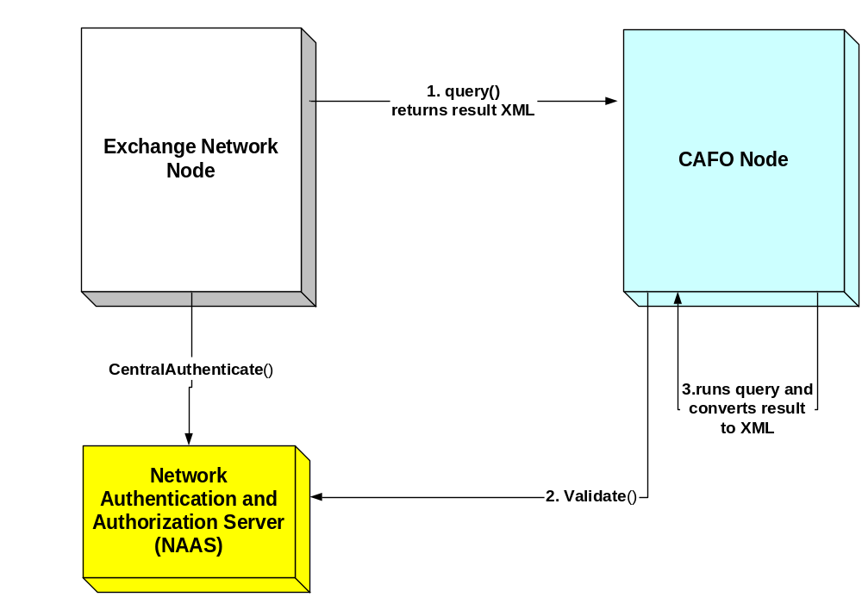 Figure 3-1. Authenticate
The authenticate method is used to obtain a security token from the Network Authentication and Authorization Server (NAAS) that will be passed in the subsequent methods in the exchange between the WQX Back-end Node and the Central Data Exchange (CDX) Node. Note that SecurityTokens will expire 10 minutes after the token is issued.
Parameters | userid  credential  authenticationMethod – "password"
Return on Success | security token
Return on Fail | SOAP Fault

Query
Query method is called to obtain data from CAFO Nodes. The returned XML encoded data will contain a CAFO data formatted according to the CAFO XML schema
Parameters | security token - Obtained from authenticate  request - The name of the service request. See the list of supported services in Detailed Data Service Information  rowed – integer of 0  maxRows – integer of 0  service parameters. See the list of supported parameters in  Detailed Data Service Information
Return on success | XML encoded data in CAFO XML output format CAFO_CAFO_v1.0.xsd
Return on fail | SOAP Fault

Query Process Sequence of Steps
- The Exchange Network Node queries CAFO Node (CAFO participating node) for CAFO data
- The Exchange Network Node authenticate against NAAS or CAFO Node
- Following end point URL will be used for NAAS
- Test NAAS: https://naas.epacdxnode.net (for Test and Dev)
- Production NAAS: https://cdxnodenaas.epa.gov
- Check the end point URL of CAFO participating states (NC, MS)
- Exchange Network Node performs Query request. Check the end point URL of CAFO participating states (NC, MS)
- Following parameters will be passed:
- SecurityToken (received from NAAS via Authentication Web service)
- Service Name (see the list of supported services in Detailed Data Service Information)
- rowed – integer of 0
- maxRows – integer of 0
- Array of service parameters (see the list of parameters in Detailed Data Service Information)
- CAFO Node receives the Query request
- CAFO Node performs security token validation
- CAFO Node calls query stored procedure (SQL or Java API) to perform query
- CAFO Node converts query result in XML format and returns result to Exchange Network Node
- If error occurs, CAFO Node returns Fault. Here is the list of possible errors:
  - “Database is down”
  - “Query result is too large.”
  - “System Error”
  - Exchange Network Node receives the query Result.

Abbreviations and Acronyms
Acronym/Term | Definition
CAFO | Confined Animal Feeding Operation
CDX | Central Data Exchange
EPA | Environmental Protection Agency
NAAS | Network Authentication and Authorization Server
OEI | Office of Environmental Information

