
Substance Registry System Redesign Flow Configuration Document

Version 2.0

Revision Date: December 19, 2006

Prepared for:
United States Environmental Protection Agency
Office of Environmental Information
1200 Pennsylvania Avenue, NW
Washington, DC 20460

Prepared by: 
National Environmental Information
Systems Engineering Center (NEISEC)
1010 N. Glebe Road
Arlington, VA 22201

Table of Contents
1. Introduction 3
2. Node Web Methods 3
3. SRS-Web Service Implemented Web Methods 3
3.1 NodePing Web Method 4
3.2 Authenticate Web Method 4
3.3 Query Web Method 4
3.4 Solicit Web Method 7
3.5 Submit Web Method 9
4. SRS-WS Data Flow Configuration 10

Appendix A – Chemical Identification and Biological Taxonomy Data Standard to SRS-WS XML Tag Cross Reference 13

Appendix B – Name Type Value Codes 18

Appendix C – Source Acronyms 19

Introduction
The Substance Registry System (SRS – www.epa.gov/srs ) is the Environmental Protection Agency's (EPA) central system for information about regulated and monitored substances. The system provides a common basis for identification of chemicals, biological organisms and other substances listed in EPA regulations and data systems, as well as substances of interest from other sources, such as publications. The SRS supports and conforms to EPA's Chemical Identification Data Standard and the EPA's Biological Identification Data Standard. The SRS is a part of the centralized Systems of Registries (SoR – www.epa.gov/sor ), which provides access to the Agency's core registry systems. SRS data is accessible, at the request of state clients, using custom web services technology. SRS web services (SRS-WS) are provided through a Central Data Exchange/Demonstrated Node Configuration (CDX/DNC) Network Node which exposes an interface to these services by the use of web methods.

Node Web Methods
The Network Node Functional Specification V2.0 describes the behavior and interfaces of the service provider component. The Network Node Functional Specification V2.0 is available on the Exchange Network (www.exchangenetwork.net ). A Node is a service provider. In the SRS exchange, web services will allow an exchange network partner to request SRS data from the SRS Node. The key interfaces that must be implemented in a Network Node include the following Web Methods:

- Authenticate
- Submit
- Query
- GetStatus
- Notify
- Solicit
- Download
- NodePing
- GetServices
- Execute (optional)

SRS-Web Service Implemented Web Methods
SRS-Web Service (SRS-WS) implements only the following request functionality from the above web methods:

- NodePing (to establish a line of communication between client and SRS-WS)
- Authenticate (to authenticate users of the system)
- Query (to query the SRS database)
- Solicit (Used to perform a requested operation in the background or offline. This method is designed for queries that take a long time to process)
- Submit – Used to send payload to a service provider
- Notify – Used to notify the requestor that a document, event, or status is available

NodePing Web Method
- Description:
NodePing is a utility method to determine whether a Node is accessible or not. A positive response (typically a string like “Ready”) from the Node indicates that it is listening for requests. A network error (no response) means that the service is not available at this time.
- Arguments:
NodePing method has one string argument that may contain arbitrary text (preferably a short word, like “hello”, or even an empty string).
- Return:
NodePing returns a positive response in the form of a human readable short text string (like “Ready”, “Busy”, or “Unavailable”). It may throw a fault message (an exception message) that the requester must catch and interpret its meaning.

Authenticate Web Method
- Description:
Authenticate method authenticates the credentials of a user. If the user successfully passes the authentication process, a security token (securityToken) string is returned. The securityToken must be used in all method invocations (except NodePing), as a proof of identity. The securityToken may be the result of some combination of user id, session id and a timestamp to provide a reference in relation to the life span of the user session. This authentication method relies on an EPA-hosted Network Authentication and Authorization Services (NAAS).
- Arguments:
User id: the user Id of a person or system.
Credentials: user credentials for accessing the services.
Authentication method: currently “password” is the only method supported by the Network Node functional specification V1.0. This parameter tells how to interpret the credentials passed in the second parameter.
- Return:
Upon successful authentication, SRS-WS returns a SOAP message with a securityToken. This is an encrypted string that becomes a security ticket for all subsequent service requests. SRS-WS throws a fault message (an exception message) in the following conditions:
  - The user record is unknown
  - The user credential is incorrect
  - An internal server fault (exception) occurred.

Query Web Method
- Description:
The Query method is a function in the database interface. This web method exposes a series of predefined information request functions that return response information in XML format (conforming to a predefined XML schema); in a synchronous RPC (Remote Procedure Call) style (the client waits for the results to be returned).

The SRS-WS Query Web Method allows the following requests to be made:
- getSubstanceByCAS
- getSubstanceByName
- getSubstanceByEPAID
- getSubstanceTSN
- getEPANameMatchByName
- getSubstanceByALTIDSource

A predefined XML schema shall be utilized in the XML response. The substance information details displayed in the XML is described in Table 3.3.1:

Web Method Return
The web method returns the results of a query in the form of an XML message string.

Table 3.3.1 – Substance Information Details
Substance Information | Submitter Information | Source Name Information
Substance Status  Internal Tracking Number  Category  Name  Systematic Name  Systematic Name Source  Category Classification  Definition  Characteristics  Comments  Analytical Method  Molecular Formula  Molecular Weight  Kingdom  ICTV  ITIS Taxonomic Serial Number  ITIS Taxonomic Serial Number Context Name  Default Name (either EPA Name or Systematic Name)  Current CAS  Former CAS Numbers (may have multiple values)  SMILES  INCHI  Create Date  Last Update Date | Name  Organization  Email  Phone  Note: There will be no more than one submitter for each substance. | Source  Program Name  Relationship Type  Name Type  Name Quality  Effective Date  End Date  Reason for Regulation  Sort Order  Comments  Alternate ID  Alternate ID Context  Creation Date  Last Update Date  Source Type

Table 3.3.2 – Web Method Input/Output Response Matrix
Web Method Name | Input Request | Output
getSubstanceByCAS | Chemical Abstracts Service (CAS) Registry Number (string format). This request can be called by passing arguments such as Current CAS numbers, Former CAS numbers, Invalid CAS numbers, Unknown CAS numbers, or Used Incorrectly CAS Numbers etc. | XML string containing the details for the associated substance. For contents of the substance information details, refer to Table 1.
getSubstanceByName | Name (string). This argument may be an EPA Name, Systematic Name or Related Term/Synonym name. | XML string containing the details for the associated Substances. For contents of the substance information details, refer to Table 1.
getEPANameMatchByName | Name (string). This argument may be an EPA Name, Systematic Name or Related Term/Synonym name. | XML string containing “Found” or “Not Found.”  “Found” is returned if the input name matches an existing SRS EPA name.  “Not Found” is returned if the input name does not match an existing SRS EPA name.
getSubstanceByEPAID | EPA Identifier (string) | XML string containing the details for the associated Substance. For contents of the substance information details, refer to Table 1.
getSubstanceByTSN | Taxonomic Serial Number (string) | XML string containing the details for the associated Substance. For contents of the substance information details, refer to Table 1.
getSubstanceByALTIDSource | Alternate Identifier and Source Acronym | XML string containing the details for the associated Substance. For contents of the substance information details, refer to Table 1.

3.4 Solicit Web Method
The Solicit Web Method shall be utilized to perform requested operations offline. This web method is designed for queries that may take an extended period of time to completely process. This web method exposes a series of predefined information request functions that return response information in XML format asynchronously (the client waits for a notification to retrieve results). All requests shall be processed on a daily basis at 8 PM EST. Requesters shall be notified when the results of the request have been generated.

The SRS-WS Solicit Web Method allows the following requests to be made:
- GetSubstanceListByCAS
- GetSubstanceListBySource
- GetSubstanceListByEPAIDs
- GetSubstanceListByNamesExact
- GetSubstanceListByCharacteristics
- GetSubstanceListByCategoryClassifcations
A predefined XML schema shall be utilized in the XML response. The substance information details displayed in the XML is described in Table 3.3.1.:

Table 3.4.1 – Web Method Input List/Output Response Matrix
Web Method Name | Input List Request | Output
getSubstanceListByCAS | Chemical Abstracts Service (CAS) Registry Numbers (string format). This request can be called by passing arguments such as Current CAS numbers, Former CAS numbers, Invalid CAS numbers, Unknown CAS numbers, or Used Incorrectly CAS Numbers etc. | XML string containing the details for the associated substances. For contents of the substance information details, refer to Table 3.3.1
getSubstanceListBySource | Source acronym (string)  A single source acronym may be provided. | XML string containing the details for the associated Substances. For contents of the substance information details, refer to Table 3.3.1
getSubstanceListByEPAIDs | EPA Identifiers (string) | XML string containing the details for the associated Substances. For contents of the substance information details, refer to Table 3.3.1
getSubstanceListByNamesExact | Name (string). This argument may be an EPA Names, Systematic Names or Related Term/Synonym names. | XML file containing the details for the associated Substances. For contents of the substance information details, refer to Table 3.3.1
getSubstanceListByCharacteristics | Substance characteristics such as allergen, food, etc. | XML string containing the details for the associated Substances. For contents of the substance information details, refer to Table 3.3.1
getSubstanceListByCategoryClassifcations | Substance category classifications (string) such Family, Genus, Group, Kingdom, and Order. | XML string containing the details for the associated Substances. For contents of the substance information details, refer to Table 3.3.1

3.5 Submit Web Method
The Submit Web Method shall be utilized to receive payloads for the submission of new program related terms and synonyms. This web method will be available in early 2007. Network Node Partners will be provided with an XML schema. The Network Node Partner shall populate the XML schema with data they wish to submit to SRS.

All XML documents received from Node Partners must conform to the predefined XML schema. Prior to updating SRS with new records, the system shall validate the following:

- XML schema conformance
- Business rules conformance (refer to Table 3.5.1)

The XML documents submitted through the SRS-WS must conform to all schema and business rule validations. If an error is detected, the system shall send the Node Partner a failure notification. If no errors are detected, the system shall send the Node Partner a successful update notification.

The XML schema shall include the following submission data:

Table 3.5.1 – Submission Parameters
Input | Input Description/Business Rules
Source Acronym | Mandatory  Source acronym must already exist in SRS. The submission will be rejected if the Source is not in SRS.  Note: CDX must pass as a parameter to SRS the Organization Name. This will verify the true identity of the organization.
EPA ID | Mandatory  Provide a value for only one ID. This ID must already exist in SRS.
Internal Sequence Number
CAS Number
Related Term/Synonym Name | Mandatory  Name cannot exceed 2000 characters.
Alternate ID | Optional
Alternate ID Context | Conditional mandatory if Alternate ID is provided.
Effective Date | Optional  YYYY/MM/DD
End Date | Optional  YYYY/MM/DD
Sort Order | Optional
Reason for Regulation | Conditional mandatory if a regulation source acronym is provided.
Name Type | Value code. Please see Appendix B for the list of valid codes. The submission will be rejected if Name Type is submitted with an invalid value code.
Comments | Characters cannot exceed 2000 characters.

SRS-WS Data Flow Configuration

The data flow description depicts how client requests are executed, what system components are involved in the processing of the requests, and how results are returned to the client caller as responses. The following diagram attempts to describe this data flow.

The following diagrams provide a visual description of the Query, Solicit and Submit web methods.

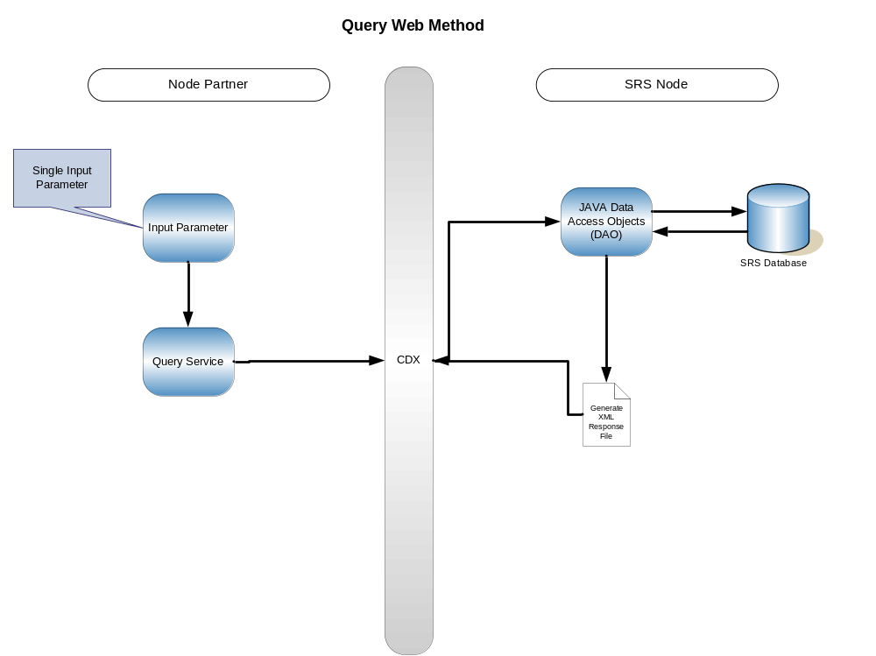 Figure 4.0 – Query Web Method - The input parameters are passed to the SRS Node from CDX invoking the Query service. The Java Data Access Objects (DAO) retrieves the requested data from the SRS Database. If the data exists and has been successfully retrieved from the database, an XML Response containing the requested data is generated and passed to CDX. If the data does not exist, the same XML Response is returned indicating “Query not found”.

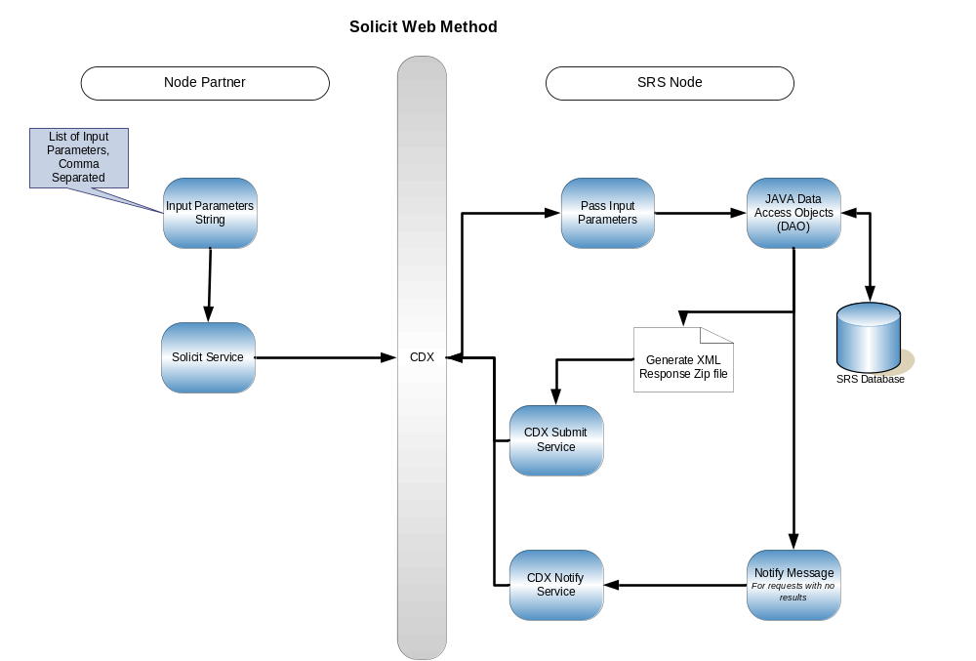Figure 4.1 – Solicit Web Method - The input parameters are passed to the SRS Node from CDX invoking the Solicit service. The parameters are then passed to the Java DAO where it retrieves the data from the SRS Database. An XML response file which contains the data is generated and passed back to CDX by invoking CDX’s Submit Service. At the same time, a notification message which contains notification of successes, failures, transaction ID, etc. is generated and passed back to CDX by invoking CDX’s Notify Service. In this method, the response information is returned asynchronously so the client has to wait for the notification in order to retrieve results.

If the data is not found or does not exist in the SRS Database, this is considered a “Failed” process. An XML response file is still generated and returned to CDX invoking CDX’s Submit Service and it will have “Query not found” in the content. The notification message with a status of “Failed” is returned to CDX invoking CDX’s Notify Service.

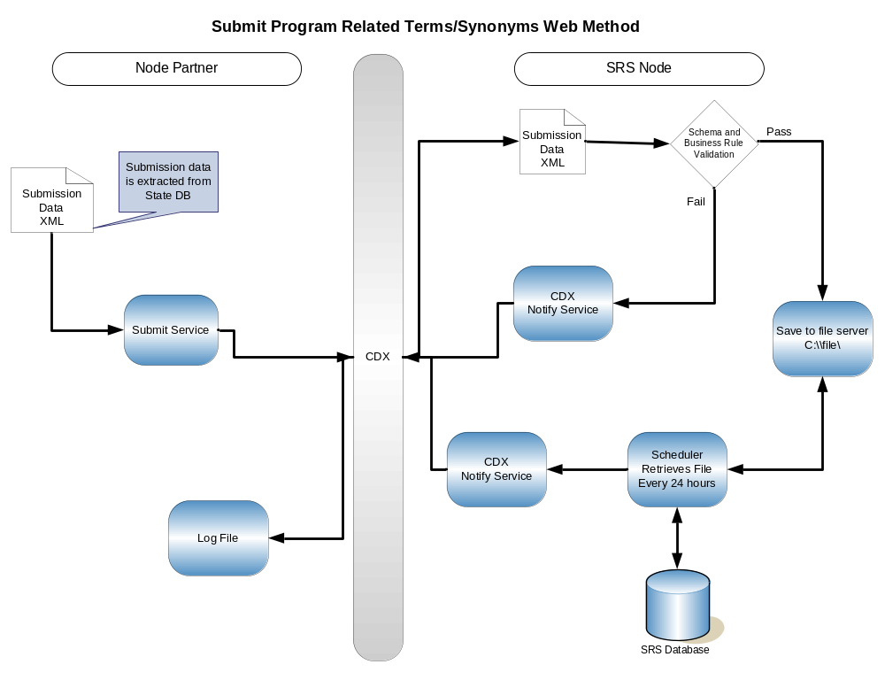Figure 4.2 – Submit Program Related Terms/Synonyms Web Method - The submission data in XML format is passed to the SRS Node from CDX invoking the SRS Node’s Submit service. The data passes through a schema and business rule validation process to check for any errors within the XML schema and that the data conforms to the appropriate business rules. If the data fails the validation process, CDX’s notification service is invoked with a status of “Failed”. If the data passes validation, it is then saved to a file server. A scheduler will retrieve files from this server every twenty four hours and update the SRS Database with the data. CDX’s notify service is then invoked passing a “Successful” status.

Appendix A – Chemical Identification and Biological Taxonomy Data Standard to SRS-WS XML Tag Cross Reference
Sno | SRS-WS XML Tags | Corresponding XML Tag in Data Standard | Name of EDR Data Standard | EDR Data Element Identifier | Comments
1 | SubstanceContext | N/A | N/A | N/A
2 | SubstanceDefinitionText | ChemicalDefinitionText | Chemical Identification(Final) | 20055
3 | SubstanceSystematicName | ChemicalSystematicName | Chemical Identification(Final) | 5799
3 | SubstanceSystematicName | BiologicalSystematicName | Biological Taxonomy(Final) | 20729
3 | SubstanceSystematicName | BiologicalGroupName | Biological Taxonomy(Final) | 20897 | The SubstanceSystematicName is also the BiologicalGroupName where SubstanceType is Group.
3 | SubstanceSystematicName | BiologicalSpeciesName | Biological Taxonomy(Final) | 20741 | The SubstanceSystematicName is also the BiologicalSpeciesName where SubstanceType is Species.
3 | SubstanceSystematicName | BiologicalSubspeciesName | Biological Taxonomy(Final) | 20742 | The SubstanceSystematicName is also the BiologicalSubspeciesName where SubstanceType is Subspecies.
4 | SubstanceSystematicName ContextName | ChemicalNameContextName | Chemical Identification(Final) | 20042
4 | SubstanceSystematicName ContextName | BiologicalGroupContextName | Biological Taxonomy(Final) | 26065 | The two Biological Standard Tag names have been combined in the SRS.
4 | SubstanceSystematicName ContextName | BiologicalSystematicContextName | Biological Taxonomy(Final) | 20743
5 | SubstanceType | ChemicalTypeName | Chemical Identification(Final) | 5818
5 | SubstanceType | More than one corresponding XML Tags. EDR Data Element Identifiers are provided. | Biological Taxonomy(Final) | 20730 to 20740
6 | SubstanceCommentText | ChemicalCommentText | Chemical Identification(Final) | 20056
7 | EPASubstanceIdentifier | EPAChemicalIdentifier | Chemical Identification(Final) | 19994
7 | EPASubstanceIdentifier | EPABiologicalIdentifier | Biological Taxonomy(Final) | 20728
8 | EPASubstanceInternalNumber | EPAChemicalInternalTrackingNumber | Chemical Identification(Final) | 20040
9 | EPASubstanceRegistryName | EPAChemicalRegistryName | Chemical Identification(Final) | 5801 | Registry Names are applicable only to chemicals.
10 | EPARegistryNameContextName | EPAChemicalRegistryNameSourceText | Chemical Identification(Final) | 20048 | Registry Names are applicable only to chemicals.
11 | CASRegistryNumber | CASRegistryNumber | Chemical Identification(Final) | 6165
12 | ICTVdBTaxonNumber | ICTVdBTaxonIdentifier | Biological Taxonomy(Final) | 19986
13 | ITISTaxonomicSerialNumber | ITISTaxonomicSerialNumber | Biological Taxonomy(Final) | 20727
14 | ITISTaxonomicSerialNumberContName | Not Available | Not Available | Not Available
1 | MolecularFormula | MolecularFormulaCode | Chemical Identification(Final) | 5812
16 | MolecularWeight | ChemicalFormulaWeightQuantity | Chemical Identification(Final) | 5814 | Formula weight is applicable only to chemicals.
17 | SubstanceSynonymName | ChemicalSynonymName | Chemical Identification(Final) | 5806
17 | SubstanceSynonymName | BiologicalSynonymousName | Biological Taxonomy(Final) | 20746
17 | SubstanceSynonymName | BiologicalVernacularName | Biological Taxonomy(Final) | 20744
17 | SubstanceSynonymName | ProgramSystemBiologicalName | Biological Taxonomy(Final) | 20748
17 | SubstanceSynonymName | BiologicalGroupName | Biological Taxonomy(Final) | 20897 | The SubstanceSynonymName is also the BiologicalGroupName where SubstanceType is Group.
18 | OtherNumbers | Not Available | Not Available | Not Available
19 | SubstanceAlternateAcronym | ChemicalSynonymSourceName | Chemical Identification(Final) | 26073
19 | SubstanceAlternateAcronym | BiologicalSynonymousNameContext | Biological Taxonomy(Final) | 20745
19 | SubstanceAlternateAcronym | InformationSystemAcronymName | Biological Taxonomy(Final) | 5712 | Note: The Data Standard name for this data element is Program System Abbreviated Name.
20 | SubstanceAlternateIdentifier | Not Available | Not Available | Not Available
21 | SubstanceAlternateIdContext | Not Available | Not Available | Not Available
22 | SubstanceAlternateIdTypeName | ChemicalSynonymName | Chemical Identification(Final) | 5806
22 | SubstanceAlternateIdTypeName | BiologicalSynonymousName | Biological Taxonomy(Final) | 20746
22 | SubstanceAlternateIdTypeName | BiologicalVernacularName | Biological Taxonomy(Final) | 20744
22 | SubstanceAlternateIdTypeName | ProgramSystemBiologicalName | Biological Taxonomy(Final) | 20748
22 | SubstanceAlternateIdTypeName | BiologicalGroupName | Biological Taxonomy(Final) | 20897 | The SubstanceSynonymName is also the BiologicalGroupName where SubstanceType is Group.
23 | AnalyticalMethod | Not Available | Not Available | Not Available
24 | CurrentCASRegistryNumber | CASRegistryNumber | Chemical Identification (Final) | 6165
25 | BiologicalKingdomName | BiologicalKingdomName | Biological Taxonomy(Final) | 20730
26 | Smiles | ChemicalSubstanceLinearStructureCode | Chemical Identification(Final) | 26069
27 | INCHI | Not Available | Not Available | Not Available
28 | CreateDate | Date | Representation of Date and Time | 5432
29 | LastUpdateDate | Date | Representation of Date and Time | 5432
30 | SubstanceStatus | Not Available | Not Available | Not Available
31 | Category | Not Available | Not Available | Not Available
32 | CategoryClassification | Not Available | Not Available | Not Available
33 | CharacteristicsName | Not Available | Not Available | Not Available
34 | CharacteristicsTypeOf | Not Available | Not Available | Not Available
35 | ProgramName | Not Available | Not Available | Not Available
36 | EffectiveDate | Date | Representation of Date and Time | 5432
37 | EndDate | Date | Representation of Date and Time | 5432
38 | ReasonForRegulation | Not Available | Not Available | Not Available
39 | SortOrder | Not Available | Not Available | Not Available
40 | SubstanceCommentText | Not Available | Not Available | Not Available
41 | CreationDate | Date | Representation of Date and Time | 5432
42 | LastUpdateDate | Date | Representation of Date and Time | 5432
43 | SubstanceRelationshipTypeOf | Not Available | Not Available | Not Available
44 | SubstanceTypeOf | Not Available | Not Available | Not Available
45 | SubstanceQuality | Not Available | Not Available | Not Available
46 | Source | Not Available | Not Available | Not Available
47 | SourceTypeOf | Not Available | Not Available | Not Available
48 | Name | IndividualFullName | Contact Information (Final) | 32400
49 | Organization | OrganizationFormalName | Contact Information (Final) | 32397
50 | Email | ElectronicAddressText | Contact Information (Final) | 88451
51 | Phone | TelephoneNumberText | Contact Information (Final) | 5706

Appendix B – Name Type Value Codes
The following is a list of valid Name Type Value Codes for submission. These value codes should be used to populate the XML schema for submission data to the SRS.

- ANSI  - BAN  - BSI  - CAS-6CI  - CAS-7CI  - CAS-8CI  - CSA  - Common  - EPA Acronym  - EPA Registry  - ESA  - FCH  - Former  - Generic  - ICPC  - INN  - ISO  - IUPAC  - Impurity  - Inert | - JAN  - JMAFF  - Null  - Product  - Related  - Systematic  - USAN  - WSSA

Appendix C – Source Acronyms
The following is a list of valid Source Acronyms for submission. These Source Acronyms should be used to populate the XML schema for submission data to the SRS.
Source Acronym | Source Acronym Description
AFS | Air Facility System
AQS | Air Quality System
ATSDR | Agency for Toxic Substances and Disease Registry
CA Index | Chemical Abstracts Index Name
CAA 109 | National Ambient Air Quality Standards
CAA 111 | Standards of Performance for New Stationary Sources of Air Pollutants - Equipment Leaks Chemical List
CAA 112B | Hazardous Air Pollutants
CAA 112R | Regulated Toxic, Explosive, or Flammable Substances
CAA 202A | Motor Vehicle Emission and Fuel Standards
CAA 602 | Protection of Stratospheric Ozone
CAA112(b) HON | Organic Hazardous Air Pollutants National Emission Standards
CAMEO | Computer Aided Management of Emergency Operations
CAS Registry | Chemical Abstracts Service Registry
CAS-8CI | Chemical Abstracts Service, 8th Collective Index Nomenclature
CAS-9CI | Chemical Abstracts Service, 9th Collective Index Nomenclature
CERCLA | Comprehensive Environmental Response, Compensation, And Liability Act Hazardous Substances
CERCLIS3 | Comprehensive Environmental Response, Compensation and Liability Information System - 3
ChemIDplus | ChemIDplus, Specialized Information Services
ChemIDStd | Chemical Identification
CHIPS | Chemical Hazard Information Profiles
CORR | Chemicals On Reporting Rules
CUS02 | Chemical Update System (CUS) 2002
CUS86 | Chemical Update System (CUS) 1986
CUS90 | Chemical Update System (CUS) 1990
CUS94 | Chemical Update System (CUS) 1994
CUS98 | Chemical Update System (CUS) 1998
CWA 304B | Effluent Limitation Guidelines
CWA 307A | Toxic Pollutants
CWA 311 | Clean Water Act List of Hazardous Substances
CWA Priority | 126 Priority Pollutants
DCNS | Dictionary of Chemical Names and Synonyms
ECOTOX | Ecotoxicology Database
EIMS | Environmental Information Management System
EPA | Environmental Protection Agency Data Systems
ERAMS | Environmental Radiation Ambient Monitoring System
ERNS | Emergency Response Notification System
FIFRA-Inerts | Inert Ingredients in Pesticide Products
GCES | Green Chemistry Expert System
GLENDA | Great Lakes Environmental Database
GLFMP | Great Lakes Fish Monitoring Program
GRTS | Section 319 Grants Reporting and Tracking System
HDDs/HDFs | Dibenzo-para-dioxins/dibenzofurans
HPVC List | United States High Production Volume Challenge Program List
HPVIS | High Production Volume Challenge Program / Voluntary Childrens Chemical Evaluation Program Information System
HSDB | Hazardous Substance Data Bank, 1998
IADN | Integrated Atmospheric Deposition Network
IARC | International Agency for Research on Cancer
ICIS | Integrated Compliance Information System
ICTVdB | International Committee on Taxonomy of Viruses Database
IRIS | Integrated Risk Information System
ITIS | Integrated Taxonomy Information System
Merck(11) | Merck Index, 11th Edition, 1989
Merck(12) | Merck Index, 12th Edition, 1996
MTL | Master Testing List
MTL96 | Master Testing List (MTL) 1996
NEI | National Emissions Inventory
NJ-RTK-HS | New Jersey Right to Know Hazardous Substances Fact Sheets
NTP Chemical Repository | National Toxicology Program Chemical Health and Safety Data
NTP Studies | National Toxicology Program Study Abstracts
OP PR 0899 | EPA Acts to Reduce Children's Exposures to Two Older, Widely Used Pesticides, August 2, 1999.
OP RPT 0798 | Hazard Assessment of the Organophosphates, July 7, 1998.
OPPIN | Office of Pesticide Programs Information Network
PAI | Organic Pesticide Active Ingredients
PBT | Persistent Bioaccumulative Toxic Chemicals
PCB List | Polychlorinated Biphenyls (PCBs) Manufacturing, Processing, Distribution in Commerce, and Use Prohibitions
PCS | Permit Compliance System
PEPS | Production/Exposure Profiles
PIC-DGD | Prior Informed Consent-Decision Guidance Documents
POPs | Persistent Organic Pollutants
RCRA Appendix VII | Basis for Listing Hazardous Waste
RCRA Appendix VIII | Hazardous Constituents
RCRA F Waste | Hazardous Wastes From Non-Specific Sources
RCRA K Waste | Hazardous Wastes From Specific Sources
RCRA P Waste | Acutely Hazardous Discarded Commercial Chemical Products
RCRA T Char | Characteristics of Hazardous Waste: Toxicity Characteristic
RCRA U Waste | Hazardous Discarded Commercial Chemical Products
RISCS | Radiation Information System for Cleanup Sites
RMP*Info | Risk Management Plans Information
SARA 110 | Priority List of Hazardous Substances
SARA 302A | Extremely Hazardous Substance List
SDWA NPDWR | National Primary Drinking Water Regulations
SDWA NSDWR | National Secondary Drinking Water Regulations
SDWIS-Enviro | Safe Drinking Water Information System in Envirofacts
SIDS | Screening Information Data Set-High Production Volume Chemicals
SPECIATE | SPECIATE
STN | Scientific and Technology Network
STORET | Storage and Retrieval for Water Quality Data
Sub Haz Prof | Substitute Hazard Profiles
TRI | Toxic Chemical Release Inventory
TRIS | Toxics Release Inventory System
TSCA 12(b) Export | Notices of Export
TSCA 4 TERM | TSCA 4 - Termination of Testing
TSCA 4 Tests | Testing of Existing Chemicals
TSCA 4(a) Test Rules | Procedures Governing Testing Consent Agreements and Test Rules
TSCA 5(e) Consent Orders | Testing Consent Order Chemicals
TSCA 5(f) Specific Labeling | Immediately Effective Rules
TSCA 5A SNUR | Significant New Use Rules
TSCA 6 Unreasonable Risk | Hazardous Chemicals Control Rules
TSCA 6A CCCR | Commercial Chemical Control Rules
TSCA 8A CAIR | Comprehensive Assessment Information Rules
TSCA 8A INFO | Toxic Substances Subject to Information Rules on Production Quantities, Uses, Exposures, and Adverse Effects
TSCA 8A PAIR | Preliminary Assessment Information Rules
TSCA 8C SARS | Allegations of Significant Adverse Reactions
TSCA 8D HSDR (a) | Health and Safety Data Reporting -- Specific Chemicals
TSCA 8D HSDR (c) | Health and Safety Data Reporting - By Category
TSCA 8D HSDR (d) | Health and Safety Data Reporting -- Listed Members of Categories
TSCA 8D TERM | Health and Safety Data Reporting Rule Terminations
TSCA Inv | TSCA Inventory
TSCA Inv Syns | Synonyms Provided by Submitters to the TSCA Inventory
TSCATS | Toxic Substances Control Act Test Submissions
TTO | Toxic Organics
UCMR 1999 | Unregulated Contaminant Monitoring Regulation for Public Water Systems
WQX | Water Quality Exchange

