
RCS

Flow Configuration Document

Version: v1.1
Revision Date: 08/12/2015

Prepared for: EPA
Prepared by: CGI Federal

THIS PAGE INTENTIONALLY LEFT BLANK

Table of Contents

Table of Contents 3
1 Component Alignment 4
1.1 Flow Component Versions Currently Supported 4
2 Introduction 5
2.1 Flow Identification 5
2.2 Background 5
2.3 Data Flow Overview 5
2.4 Flow Access and Security 6
2.5 Flow-level Business Rules 6
3 Data Publishing 7
3.1 Sample Retrieval Data Publishing (Query) 7
3.1.1 GetRCSResourcesByType_v1.0 7
3.1.2 GetRCSResourceByIdentifier_v1.0 8
4 Schema Information 9
4.1 Schema Structure 9

Component Alignment
The major and minor version number of the FCD should be identical to the major and minor version number of the current schema supported by this exchange. If the FCD is changed without changes to the schema, then a revision number should be used on the FCD’s version number.

Flow Component Versions Currently Supported

Component | Version(s) Supported | Explanation
FCD | 1.0 | Captures the detailed data exchange processing rules governing the data exchange using narrative text, diagrams and examples.
Schema | 1.0 | Defines the form and structure of the RCS data being exchanged.
DET | 1.0 | Lists each data element in the RCS schema with definitions, validation rules, and example content.

Introduction

Flow Identification
Flow Name: EPA Reusable Components Services (RCS)
Flow Owner: EPA
Flow Owner Contact Information: Lico Galindo; galindo.lico@epa.gov; 202.566.1252

Background
The EPA Reusable Components Service data flow is a new web service that allows EPA and its partners to access catalogued reusable information resources. EPA intends this data flow to provide metadata and other information that will enable and promote reusability across the agency.

Data Flow Overview
EPA’s Reusable Components Service provides a central point of access to a broad range of IT resources, components, and services used in various EPA and partner systems. This data flow will provide access to this catalog of resources by allowing a user to input a resource type, and resources of that type with all associated metadata will be returned. It will be used in part to keep the EPA Shared Services Catalog up to date. In general, it will also enable the reuse of these resources, which helps reduce cost, quicken development, and produce higher quality systems and applications. By enabling and promoting reusability, this data flow will help users in the development of applications that meet standards, ensure quality, reduce cost, and minimize development time.

The RCS data services are provided through the Exchange Network (www.exchangenetwork.net) and are accessed through the EPA’s Central Data Exchange Node (the “CDX node”) using the Exchange Network’s node web service specifications.

The RCS dataflow offers only Query Data Publishing services. The data for the services is provided solely by the EPA; therefore, no Data Processing services are present. The Query Data Publishing services support both REST and SOAP requests. The general flow of processing performed when issuing a Query data service request is depicted in Figure 2.3.

The SOAP services are traditional Exchange Network services. However, the RCS dataflow is also configured on the CDX Rest Proxy. The CDX REST Proxy allows anonymous REST requests using the SOAP services on the backend.

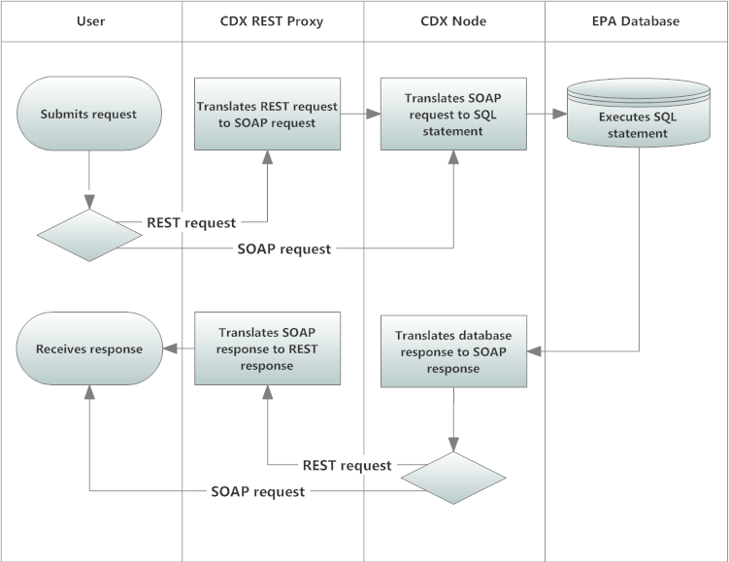

Flow Access and Security
The REST services offered by the RCS data flow are publicly available through the CDX REST Proxy. However, all requests to SOAP services must be accompanied by a valid NAAS security token per the Exchange Network’s Node 2.0 specifications. All partners must be authorized to NAAS and receive a valid security token before the RCS data services can be invoked by a SOAP request.

In order to acquire a valid security token (via the partner’s Node client technology using the Node specification’s authenticate operation), the user must have the appropriate NAAS security policies in place and associated with the EPA’s CDX node and the RCS data flow. To obtain access, contact the CDX help desk for more information (http://www.epa.gov/cdx/contact.htm).

Flow-level Business Rules
Current Business Rules: Not applicable. See the sections that follow for relevant descriptions of business rules associated with the RCS data services.

Fault Follow-up Actions: Error messages are returned when errors occur during the execution of query data services, such as those caused by malformed parameter input. The user must correct the error and resubmit the request.

Data Publishing
The RCS data flow offers two query data services at this time. The service GetRCSResourcesByType_v1.0 allows users to list all metadata about resources registered in RCS by a given resource type. The types of resources available in RCS include: APIs, web services, XML schemas, blocks of code, code libraries, data models, software tools, and more. The metadata includes basic information such as: resource ID, resource name, description, contact individuals and organizations. It also includes information or links to documentation about access to resources, examples, and instructions for use. The service GetRCSResourceById_v1.0 allows users to list all metadata about a single resource in RCS by a given resource identifier.

Sample Retrieval Data Publishing (Query)

GetRCSResourcesByType_v1.0
Type: Query

Data Service-level Business Rules: Not applicable.

XML Header Usage: Not applicable.

Request
Dataflow: RCS

Request: GetRCSResourcesByType_v1.0

RowId: Any valid rowID value per the Node specification WSDL (e.g., -1, 0, or positive integer). For this query, each row represents one resource returned by the query (one instance of a Resource XML tag and all of its child tags).

maxRows: Any valid maxRows value per the Node specification WSDL (e.g., -1, or positive integer). For this query, this is the maximum number of resources (rows) to be returned for this invocation of the query service.

Parameters:

Name | Data Type | Required | Max Length | Notes
ResourceTypeName | String | Yes | N/A | The name of the resource type.

Response
Response: See schema RCS_RCS_v1.0.xsd

RowID: The integer representing the position of the first resource returned in the full result set of the query. See the Node 2.0 specification for more information. For this query, each row represents one Resource returned by the query.

RowCount: The integer representing the total number of resources returned for this query. This may not be all of the resources selected for this query based upon parameters passed to the query; the total number returned may be limited by the maxRows input parameter, or by the RCS application itself. Users can continue to issue the query, increasing the rowID input parameter each time to retrieve all entities selected by the query. See the Node 2.0 specification for more information.

GetRCSResourceByIdentifier_v1.0
Type: Query

Data Service-level Business Rules: Not applicable.

XML Header Usage: Not applicable.

Request
Dataflow: RCS

Request: GetRCSResourceByIdentifier_v1.0

RowId: Any valid rowID value per the Node specification WSDL (e.g., -1, 0, or positive integer). For this query, each row represents one resource returned by the query (one instance of a Resource XML tag and all of its child tags).

maxRows: Any valid maxRows value per the Node specification WSDL (e.g., -1, or positive integer). For this query, this is the maximum number of resources (rows) to be returned for this invocation of the query service.

Parameters:

Name | Data Type | Required | Max Length | Notes
ResourceIdentifier | String | Yes | N/A | The resource identifier.

Response
Response: See schema RCS_RCS_v1.0.xsd

RowID: The integer representing the position of the first resource returned in the full result set of the query. See the Node 2.0 specification for more information. For this query, each row represents one Resource returned by the query.

RowCount: The integer representing the total number of resources returned for this query. This may not be all of the resources selected for this query based upon parameters passed to the query; the total number returned may be limited by the maxRows input parameter, or by the RCS application itself. Users can continue to issue the query, increasing the rowID input parameter each time to retrieve all entities selected by the query. See the Node 2.0 specification for more information.

Schema Information

Schema Structure
The following diagram depicts a high-level view of the RCS schema. A single resource entity is represented by the Resource element.



