

NHD Update

Flow Configuration Document

Version: 1.1

Revision Date: 8/20/2008

Prepared for: USEPA Office of Environmental Information

Prepared by:
Land Management Information Center, Office of Geographic and Demographic Analysis,
Minnesota Department of Administration
And
United States Geological Survey – NHD Team

Table of Contents

1. Acknowledgements 4
2 Introduction 5
2.1 Background 5
2.2 How to use this FCD 5
3 Component Alignment and Change History 8
3.1 Flow Component Version History 8
3.2 Flow Component Versions Currently Supported 8
3.3 Business Rule Change History 9
4 Flow Summary Information 10
4.1 Flow Identification 10
4.2 Data Flow Overview 10
4.3 Flow Access and Security 19
4.4 Flow-level Business Rules 19
4.4.1 General Business Rules Relating to Local Updating of the NHD 19
4.4.2 Business Rules for Submitting Local Updates to USGS via this Data Flow 20
4.4.3 Business Rules Relating to USGS Distribution of NHD Updates 21
4.5 Additional Flow Tools and Resources 21
5 Schema Information 23
5.1 Schema Structure 23
5.2 Schema Components 23
6 Data Service Information 24
6.1 Data Services 24
6.2 SubmitNHDUpdate 25
6.3 GetStatusNHDUpdate 26
7 Exchange Network Header Information 27
7.1 Header Elements, Description and Examples 27
8 Supplemental Information 30
8.1 Processing Overview 30
8.1.1 Local to USGS Data Flow (To_USGS): 30
8.1.2 USGS to Local Data Flow (From_USGS): 31
8.2 Operational Data Store Interface - USGS 31
8.3 Submission Processing and Feedback 32
8.3.1 Local to USGS (To_USGS): 32
8.3.2 USGS to Local (From_USGS): 33
Attachment A – NHDUpdate Submit Data Service Payload Information 35
Information Carried by the Data Flow 35
Data Flow Payloads 37
Attachment B – About the Minnesota Stewardship Pilot Project 39
Attachment C – Using Windsor Solutions’ NodeClientLite 41

1. Acknowledgements

This Flow Configuration Document was produced by the Land Management Information Center (LMIC) for the Environmental Protection Agency’s Office of Environmental Information under and Exchange Network FY 05 Challenge Grant - Assistance ID # OS-83260201. This document was prepared in cooperation with: United States Geological Survey (USGS) – NHD Team; EPA Office of Water, Wetlands, Oceans, and Watersheds (EPA-OWOW); Minnesota Pollution Control Agency (MPCA); and the Exchange Network CDX Team.

This document was prepared with input and support from the following individuals:

Susanne Maeder | LMIC
Jerry Ornelas | USGS
Colleen Keeling | USGS
Jessica Janssen | USGS
Paul Kimsey | USGS
Steve Andrews | Indus Corp.
Scott Kocher | Indus Corp.
Mark Olsen | MPCA
Tommy Dewald | EPA - OWOW
Cindy McKay | Horizon Systems

2 Introduction

2.1 Background

The purpose of this project is to develop a data flow to transmit geospatial information updates to the National Hydrography Dataset (NHD). The National Hydrography Dataset (NHD) is a nationwide framework GIS database supporting surface water hydrologic applications. The data flow is designated as ‘NHDUpdate’ – or the ‘NHD Update Flow’. The NHD Update Flow enables the transmittal of updates to the National Hydrography Dataset created by local updaters or state data stewards of the NHD to the Master NHD data repository administered by the United States Geological Survey (USGS). The NHD Update Flow also enables the transmittal of updates from the master NHD database at USGS to satellite NHD databases administered by other agencies, including state stewards of the NHD.

This data flow is being developed by the United States Geological Survey – NHD Team and the Land Management Information Center, Office of Geographic and Demographic Analysis, Minnesota Department of Administration. Supporting agencies include the Minnesota Pollution Control Agency and the Environmental Protection Agency – Office of Water.

This project will develop the procedures necessary to support the transmittal of NHD update data. USGS NHD update procedures and tools are already designed to create a standardized XML as the update medium. As such, table definition structures have already been defined, if not described in the standard schema format required to support a data flow. This project will complete the process and develop the documentation and tools necessary to formally transmit this data set as an Exchange Network Data Flow. At the state level the data will be transmitted through Minnesota’s state node maintained by the Minnesota Pollution Control Agency. To accommodate this project the USGS is constructing its own node to distribute and accept the NHD Update Flow.

Note that this data flow defines only updates passed between NHD data stewards and updaters and the USGS NHD Database. Users of NHD data who are not updaters of the data are able to use the data directly via an online internet map service, or download NHD data for an area of interest in multiple formats through an already established web-based data distribution mechanism (See http://nhd.usgs.gov/data.html). This data flow will not be used to support routine data distribution to NHD users.

2.2 How to use this FCD

The purpose of this FCD is to describe the operation of the NHD Update Flow using XML-based data submissions through Node-to-Node or Client-to-Node transfers. The focus of the document is the spatial data flow of NHD updates between the state, local, and tribal agencies and USGS that meet the NHD requirements.

This Flow Configuration Document (FCD) is intended to define the supported data services, the approaches and processes that are used to exchange information over the Exchange Network via Web services technology. In addition, the FCD serves as a guide for trading partners to the details and challenges associated with a specific flow.

The scope of this FCD has been limited to the following primary functions:

- Submission of the data; and
- Reporting of the submission status.
This document does not include any query or data retrieval services. The data is to be submitted from local NHD updaters through state nodes to a node at the USGS, from which the data can be incorporated into the master NHD data repository using standard update processes already defined by the USGS. Updates from USGS back to the stewards can be transmitted in reverse using the same services.

This document includes the following five main sections and three attachments:

Flow Summary Information (Section 4)

This section describes the process of submitting NHD update data from the submitter environment via the USGS node, through the loading of the data into the NHD data repository at USGS. It also describes the reverse process by which USGS can send updates to satellite NHD databases hosted by states, tribes, or other federal entities.

Schema Information (Section 5)

This section provides basic overview information about the schema and references to the full schema.

Data Service Information (Section 6)

This section describes the ‘Submit’ and ‘GetStatus’ data services used to transact the NHD Update Flow.

Exchange Network Header Information (Section 7)

This section describes the Exchange Network Header information used in the NHD Update Flow. This submission structure will be used for both Node-to-Node and Client-to-Node submissions.

Supplemental Information (Section 8)

This section includes additional information considered to be useful to the understanding of the data flow.

Attachments

Attachment A describes in more detail the payloads carried by the NHD Update Data Flow.

Attachment B describes the Minnesota Stewardship Pilot Project.

Attachment C describes data submission using Windsor Solutions’ NodeClientLite software.

3 Component Alignment and Change History

Note: The major and minor version number of the FCD should be identical to the major and minor version number of the current schema supported by this exchange. If the FCD is changed without changes to the schema, then a revision number should be used on the FCD’s version number.

3.1 Flow Component Version History

Component | Version | Date | Changed By | Description of Change
FCD | 0.3 | 2/20/2008 | S. Maeder | Internal Project Distribution draft; also submitted to NRB for pre-review, informational purposes.
FCD | 1.0 | 6/27/2008 | S. Maeder | Submission Draft Version 1.0
Schema | 1.0 | 6/27/2008 | J. Ornelas/ C. Keeling | Submission Schema Version 1.0
DET | 1.0 | 6/27/2008 | J. Ornelas/ C. Keeling | Submission DET Version 1.0
FCD | 1.1 | 8/20/2008 | S. Maeder | Revision in response to NTG Review
Schema | 1.1 | 8/20/2008 | J. Ornelas/ C. Keeling | Revision in response to NTG Review
DET | 1.1 | 8/20/2008 | J. Ornelas/ C. Keeling | Revision in response to NTG Review

3.2 Flow Component Versions Currently Supported

Component | Version(s) Supported | Explanation (optional)
FCD | 1.1
Schema | 1.1
DET | 1.1
Submit | 1.1
GetStatus | 1.1

3.3 Business Rule Change History
Current business rules are listed in Section 4.4.

Business Rule Change | Date of Change | Explanation (optional)

4 Flow Summary Information

4.1 Flow Identification

Flow Name: NHDUpdate

Flow Description:

This data flow is being created to support the transmission of updates to the National Hydrography Dataset. The data flow supports updates submitted to the United States Geological Survey master NHD data repository from local updaters and data stewards. The flow also supports updates extracted from the master NHD data repository by USGS and distributed to state stewardship databases and other satellite databases of the NHD.

Flow Steward:

This data flow is being developed by the United States Geological Survey – NHD Team and the Land Management Information Center, Office of Geographic and Demographic Analysis, Minnesota Department of Administration. Supporting agencies include the Minnesota Pollution Control Agency and the U. S. Environmental Protection Agency – Office of Water.

Flow Steward Contact Information:

Questions about this data flow can be directed to Jerry Ornelas, USGS-NHD Team (303-202-4143, jxornelas@usgs.gov) or Susanne Maeder, Land Management Information Center, Mn Dept. of Administration (651-201-2488, susanne.maeder@state.mn.us).

4.2 Data Flow Overview

Background

The National Hydrography Dataset (NHD) is a nationwide framework GIS database supporting surface water hydrologic applications. NHD is the national geospatial framework theme for hydrography. The United States Geological Survey serves as the theme lead for the National Hydrography Dataset. Additional support at the federal level comes from the U.S. Environmental Protection Agency Office of Water and the United States Forest Service. For more information on the content, theory, schemas, and activities supporting the NHD see http://nhd.usgs.gov.

NHD data nationwide is available at two scales: medium-resolution (1:100,000 scale) and high-resolution (1:24,000 scale). Users in some parts of the U.S. have created ‘local resolution’ data (e.g. 1:4800), which will be incorporated into the high-resolution database. The United States Geological Survey (USGS) and the United States Environmental Protection Agency (EPA) created the medium-resolution data by combining key elements of their native hydrography data sets. Creation of the high-resolution NHD was a cooperative effort which involved the USGS and other federal agencies, as well as many state, local, and tribal governments. High-resolution NHD was completed nationwide in August, 2007.

USGS maintains the national NHD database in a dual storage framework:
- A Production database houses the main database and is used to process updates provided by USGS and contributors. This is the ‘Master’ NHD database for the entire U.S. This database is versioned and processes updates reported as XML documents defined in a USGS native schema and format - Feature Communication Protocol (FCP).
- A Distribution database is a mirror image of the most current version of the database that can be accessed by users as a map service or through a data extraction process. Users can choose to extract the data in several formats.

As creating the NHD was a cooperative effort, updating and maintaining the NHD is also intended to be an effort involving many partners. The NHD was designed with the intention that the data can and will be updated and that all updates must be carefully tracked, coordinated, and validated. USGS is currently performing prescribed maintenance data steps (designated as ‘maintenance lite’) against the entire database. USGS is also working with numerous partners under ‘stewardship’ arrangements. Through the stewardship process USGS recognizes that local units of government are more familiar with their own hydrography, and supplies tools, training, and support to partners who wish to function as technical or administrative stewards. USGS tools implemented at both ends of the process assure that updates follow specified rules and are submitted in a specified format. (USGS stewardship information can be found at http://webhosts.cr.usgs.gov/steward/).

The NHDUpdate data flow does not pass through the Central Data Exchange, but is transmitted directly between the United States Geological Survey node and state nodes.

Many organizations (state, tribal, county, regional, local) may perform updates to the NHD and submit them to USGS: the entire stewardship environment was designed by the USGS to accommodate updaters from many types of jurisdictions. Entities exchanging updates with USGS through the NHD Update Data Flow will work through an established Exchange Network node to do so. Although this document generally describes the non-USGS node as a ‘state node’, it is possible that the Exchange Network node used by updaters could be a tribal or other node.

The USGS – NHD update process already operates in a controlled environment. Since the NHD Update programs already write out XML according to the NHDUpdate_v1.0 schema, there is no reason for an additional validation of the XML during the data flow transmission. Further validation at both ends of the process checks the update for validity within the logic of the NHD database.

The update processes described in this document are based upon current USGS practice for the NHD. This practice was developed using ArcGIS 9.1 capabilities and tools. There is the potential that update tools will be enhanced or changed in the future with newer database replication tools. At that point this document may have to be modified.

NHD Stewardship Roles and Responsibilities

The NHD Stewardship overview defined by the USGS is as follows:
- The community of users becomes the stewards of the data.
- The USGS facilitates the stewardship process.
- The users evolve the data to best meet their needs.
- The USGS guides the evolution for national continuity.

For the NHD Updating process, USGS defines three layers of roles:

- NHD National Steward (USGS): provide for continuity of the NHD; provide tools, training, quality control, database definition, ‘master’ NHD national database; (U=USGS)
- NHD State Steward (Administrative): provide area coordination; possibly also provide updating and local quality control; (S=State Steward)
- NHD technical stewards (local updaters/maintainers): provide enhancements to the data using the NHD tools, submitting updates either to the NHD State Steward or directly to the USGS. (L=Local Updater)

Data Transmittal Pathways:

USGS to local users: From its Distribution database, USGS gives all users access to the data through a data extract process; users can choose their area of interest and download data in a variety of formats (personal geodatabase, shapefile, or file geodatabase). Users may also use the data directly via the USGS published map services. This distribution and use of the data are not changed by the NHD Update Data Flow process.

USGS to state stewards: USGS also can provide state stewards - or another federal agency – with extracts of NHD for their full area of interest (e.g., all hydrologic subbasins that fall completely or partially within the state). The initial database distribution is generally done with a database export, and is not part of the NHD Update data flow process. Once states have established their own copy of the NHD, USGS has developed a system of providing updates to the state on a periodic basis. This update involves tracking the versioning of the database; each update includes only changes to any feature since the last update submitted to the state. All of these changes are written out to an XML file using the USGS NHDUpdate_v1.0 schema, based on the USGS Feature Communication Protocol. This update has been provided manually in the past but can now be distributed through the NHD Update Data Flow.

Local Updaters or State Stewards to USGS (general process): All local edits to the NHD are done offline. USGS-provided tools for local updaters include an ‘NHDGeoEdit’ tool – which is a controlled environment for creating updates to a subbasin of the NHD. The NHDGeoEdit tool tracks the changes made to the NHD during an edit session. An ‘XMLExtract’ tool is provided for extracting the changes from the NHDGeoEdit session geodatabase and converting those changes into an XML format that the national NHD database can read, validate, and apply. The schema behind the ‘XMLExtract’ routine is the NHDUpdate_v1.0.xsd. Updates to the NHD must be provided to the USGS in this format. Using the NHDGeoEdit and associated tools assures that updates to the USGS are provided to the USGS in the required format. USGS defines a quality assurance process that updaters should use before submitting the data to the USGS. Currently, local updaters then submit their updates, as a zip file, to the USGS by placing the zip file in a ‘blind drop’ folder at USGS, and notify their USGS Technical contact of its availability. USGS then tracks the new submission and places the data in a ‘Load/Validate’ Queue, and, if successfully validated, into a ‘Reconcile/Post’ Queue. This update can now be submitted through the NHD Update Data Flow.

Roles of State Administrative Stewards:

Relationships vary between state stewards, local updaters and USGS. In some cases (such as in the Minnesota implementation) the state administrative steward plans to take a more active role, providing a first-level quality control of NHD data updates before those updates are passed along to the USGS for final quality control and integration into the national database. In this environment, the state steward runs the standard USGS quality control checks on the updated data (Loads, Validates, and Reconciles) - comparing the updates to its own copy of the NHD; if the data passes these checks then the data sets are submitted to USGS for final processing. Having the intermediate level of QC at the state level should make the updates cleaner by the time they get to the USGS, and eliminate some validation and reconciliation failures at the national level. These steward roles are identified as ‘S’ in the data flow process steps tables and diagrams.

Process Steps Tables:

These tables describe the process steps for updating the National Hydrography Dataset that are outlined in the Flow Diagrams on pages 17 and 18. These include USGS business process steps and describe tools USGS has created to support the updates. Only the boxes highlighted actually become part of the data flow.

Process Steps – Table 1: Local Updater to Steward or USGS

# | Task | Description
L1 | Obtain NHD Data from USGS Distribution Database or State Stewardship Distribution Database | Updaters must first extract a new copy of the NHD for the area they wish to update.  - If they will deliver their NHD updates directly to the USGS for QC (U1), then they will extract the data from the USGS Distribution Database, or download pre-staged updates from the USGS ftp site. (XU3)  - If they will deliver their NHD updates to a state steward for QC (S1), then they will extract the data from the State Stewardship Distribution Database. (S0)
L2 | Create Updates to NHD | Update process (usually by subregion or subbasin) uses NHDGeoEdit tool (USGS) on a personal geodatabase. This tool is used in conjunction with ESRI ArcMap software. The NHDGeoEdit Tool tracks all changes to a status table. ‘XMLExtract’ tool is used to extract the changes from the status table and convert them into an XML file and an RCL file.
L3 | Updater checks updates | Updater applies updates (XML, RCL) against the original geodatabase they started from to ensure that all updates that they thought they had made had been written to the status table (and captured by the XML); more QC is applied.  - If all updates have been captured go to L4  - If some updates are missing or errors occur go back to L2 and continue editing.
L4 | Updater submits updates | When local updater is confident that all updates have been captured correctly and XML, RCL files are correct, user submits updates – either directly to USGS (U1) or to the state steward (S1). For purposes of understanding the data flow, you can go directly to U1.  - Email or ftp to state steward (S1) – or –  - Submit the update to the USGS via the NHD Update Data Flow – or –  - Ftp ‘blind drop’ the update files to USGS Update site (U1) and notify USGS Technical Point of Contact (POC).  The zip file package that is submitted includes the XML file, RCL file, and the original and edited geodatabases. The zipfile submitted via the NHD Update Data Flow also contains the XML Header Document.

Process Steps – Table 2: Quality Control (QC) Process (USGS or State Steward)

This step is not involved in the data flow. It is described here for completeness.
The steps labeled ‘U’ must be done. The steps labeled ‘S’ will only be done if the state has chosen to take on an intermediate level of QC processing before the updates are submitted to USGS.

# | Task | Description
U1 | USGS QC | USGS POC notifies QC staff; Update (zip file – subbasin or subregion) is logged in a tracking spreadsheet.
U2 | USGS Load/Validate | XML and RCL tables are placed in the USGS Load Queue; Update is processed through the Load/Validate Process.  - If update passes validate, load update to post queue (U3)  - If update fails validate:  - USGS may fix (if it is simple) and return to Load Queue. This is where having the geodatabases submitted with the XML helps identify the problems that made the validate fail  - USGS may send back to submitter for correcting (Probably via an email to the submitter, with the log and debug files attached.)
U3 | USGS Reconcile/Post Queue | Update (XML and RCL) tables are loaded to the Post queue. This process reconciles these updates with other updates that have been made since the update version was extracted.  - If the update reconciles successfully go to U4  - If the update fails to reconcile:  - USGS may fix (if it is simple) and return to Post Queue.  - USGS may send back to submitter for correcting (Probably via an email to the submitter, with the log and debug files attached.)
U4 | USGS Posts Data | If reconcile is successful the update data is ‘Posted’ – i.e., updated version becomes the ‘default’ version of the database.
S1 | State Steward QC | Updater notifies State QC staff. Update is logged in a tracking spreadsheet.
S2 | State Steward Load/Validate | XML and RCL tables are placed in the State Load Queue; Update is processed through the Load/Validate Process.  - If update passes validate, load update to state reconcile queue (S3)  - If update fails validate:  - State steward may fix (if it is simple) and return to Load Queue. This is where having the geodatabases submitted with the XML helps identify the problems that made the validate fail  - State steward may send back to submitter for correcting (Probably via an email to the submitter, with the log and debug files attached.)
S3 | State Steward Reconcile Queue | Update (XML and RCL) tables are loaded to the State Reconcile queue. This process reconciles these updates with other updates that have been made since the update version was extracted.  - If the update reconciles successfully go to S4 (Submit updates to USGS)  - If the update fails to reconcile:  - State steward may fix (if it is simple) and return to Reconcile Queue.  - State steward may send back to submitter for correcting (Probably via an email to the submitter, with the log and debug files attached.)  Note: the state steward never actually ‘Posts’ the update to its own production database; once the data been sent to the USGS and has gone through the USGS reconcile process, the update is posted (U4) and is returned to the state through data update process (XU2).
S4 | State Steward Submit Updates | State steward delivers update to USGS via the NHD Update Data Flow – or –  State steward delivers update to USGS through an ftp ‘blind drop’ to USGS Update site (U1) and notifies USGS Technical Point of Contact (POC) of the update.

Process Steps – Table 3: USGS to Steward

# | Task | Description
XU1 | Original Delivery of Full Database to state (or other federal) partner | USGS can provide an SDE or Oracle database export of the full database over the area of interest to interested parties. An interested party might be a state partner who is planning to take an active stewardship role, or another federal agency. This step to establish the baseline dataset would NOT be done as part of the data flow.
XU2 | Delivery of NHD Updates to state (or other federal) partner | USGS has developed a system to provide updates to the state on a periodic basis. This update involves tracking the versioning of the database; each update includes only changes to any feature since the last update submitted to the state. These changes are written out to an XML file using the USGS NHDUpdate schema. There are now two data delivery options:  - USGS submits to state steward using NHD Update Data Flow – or -  - USGS posts updates to the USGS ftp site and notifies the user by email that the update is available.  Updates are sent by USGS to state partners according to an agreed-upon schedule.

Process Steps – Table 4: NHD Data Extract (USGS to Local or State to Local)

# | Task | Description
XU3 | USGS NHD Data Extract Process | USGS Distribution Database provides a map-based data extraction interface where local updaters can specify an area of interest and format of interest and extract the NHD data for the area they want to update (L1).The most common unit of data extractions for updates is the subbasin. USGS also has pre-staged subregion updates available at their ftp sites. Local updates that plan to submit their updates directly to USGS should download the data from the USGS database. (XU3)
XS1 | State Stewardship NHD Data Extract Process | State Stewardship site uses map-based data extraction interface developed by USGS to let local updaters download the NHD from the state site. The state site in Minnesota mimics the USGS site, except that the state does not offer the pre-staged ftp downloads. Local updaters who plan to submit their updates to the state stewardship site should download the data from the state stewardship database (S0).

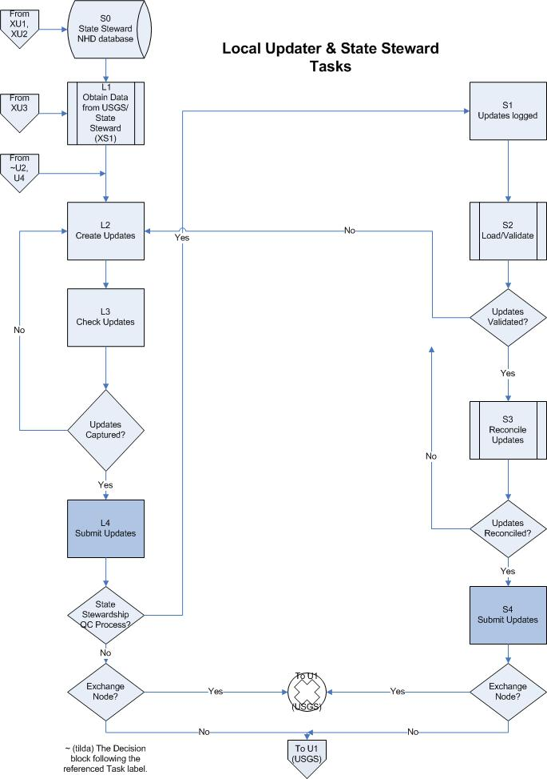
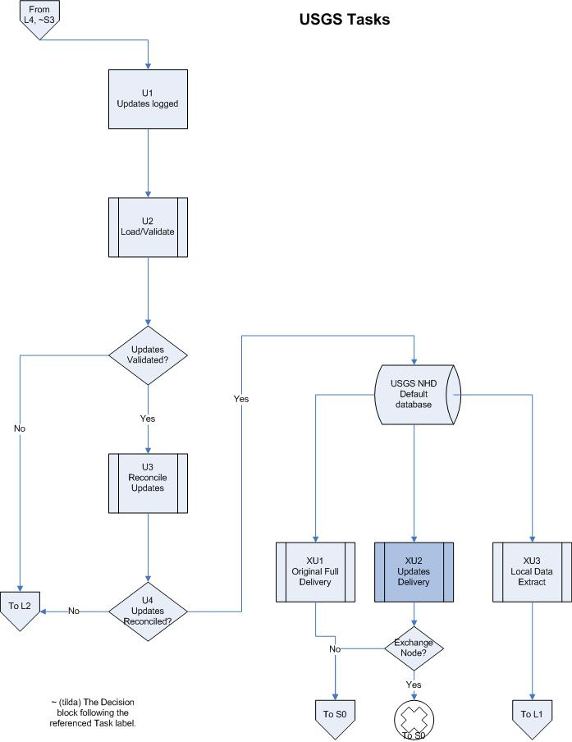

Expected Size and frequency of update submittals:

USGS to State Steward Data Update

Updates distributed from the USGS back to the state stewards contain only changes to the database since the last update distribution. USGS and state stewards agree upon a workable update schedule. Updates from the USGS back to the Minnesota database are expected to occur at the most monthly. Experience with monthly updates to Minnesota’s database to date suggests file sizes in the 2 MB – 25 MB range. A maximum update file size would probably be 50 MB.

This file size range would not apply for very large states, multi-state areas (such as the Pacific Northwest Hydrography Framework) or nation-wide updates applied to a database (for example, USGS providing updates to a U.S. Forest Service national database.)

Local or State Steward to USGS Data Update

State or local updates to USGS will probably be produced and submitted as subbasin updates. These will tend to be larger than the ‘USGS to state steward’ updates because the zip files include the pre-editing and post-editing versions of the geodatabase in addition to the update files themselves. Based on Minnesota’s experience, subbasin-based updates are expected to be in the range of 15 MB to 25 MB in size. These size estimates will probably not apply for some update activities – such as the stream densification update activities being carried out by the Pacific Northwest Hydrography Framework participants.

4.3 Flow Access and Security
Authorization of all participants in the data flow will be via the NAAS authentication process. The standard NAAS authentication processes should be sufficient to secure the NHD Update Flow.

4.4 Flow-level Business Rules

4.4.1 General Business Rules Relating to Local Updating of the NHD

The United States Geological Survey NHD Team has established procedures for local updaters of NHD to interact with the USGS Database:

- Data updaters must use the USGS-provided NHD tools for creating updates and providing quality control of the updates before submission to USGS. These tools are described in section 4.5
- Data updaters must be trained in the use of the NHD tools. Training is provided by USGS – NHD Team staff.
- Data updaters must obtain a ‘Processing Organization’ (ProcOrg) code from USGS. This code is associated with all updates provided by that organization.
- Data updaters must obtain a username and password in order to be able to download NHD Update processing tools from the USGS NHD Stewardship web site.
- As of June, 2008, data updaters must access the Maintenance/Revision Status page on the NHD Stewardship web site to officially ‘check’ out a subbasin, to register the fact that they are planning to update a subbasin. In the future, local updates will not be accepted back into the NHD update processing queue unless they have been officially checked out.
- All data submitted to the USGS as potential updates to the NHD need to be submitted in the format required by USGS. The current process requires that the production tools and QC tools and processes developed by the USGS and distributed via their NHD Stewardship website be used to create and verify the update before it is submitted to the USGS. At the USGS level (and stewardship QC level) the updates must be loaded through USGS-provided Load/Validate and Reconcile/Post tools that assure that the updates are formatted correctly and are logically consistent. Use of the USGS NHD Tools for creation of NHD data updates assures that the data updates submitted to USGS are in the correct NHD format.
- The business rules for capturing NHD data updates do not have to be explicitly described in this Flow Configuration Document since those rules are enforced by the tools which NHD updaters are required to use. For descriptions of the tools see:
http://webhosts.cr.usgs.gov/steward/scripts/st2_software.pl .
- Local updaters NOT submitting updates using the NHD Update Exchange Network Data Flow would copy the update to a ‘blind drop’ folder at the USGS and notify their Technical Point of Contact via email that an update has been submitted.

Additional rules and changes to rules for updating the NHD are published by USGS at http://webhosts.cr.usgs.gov/steward/index.html.

4.4.2 Business Rules for Submitting Local Updates to USGS via this Data Flow

Local updaters submitting NHD updates to the USGS using the NHD Exchange Network Data Flow must still follow all of the business rules listed in section 4.4.1 except for the last bullet. To use the NHD Exchange Network Data Flow, updaters must submit the data flow through their state CDX node or a client CDX node using the NHDUpdate Data Flow configuration. The XML Header Document value for the Property <FlowDir> must be ‘To_USGS’.

4.4.3 Business Rules Relating to USGS Distribution of NHD Updates

Data submitted by the USGS back to users as updates to their database are extracted by USGS from the USGS NHD database and formatted correctly to be applied as updates locally – again using a program written by USGS. Use of the program assures that the updates are in the correct format.

Data Distribution - Flow Process: To use the NHD Exchange Network Data Flow, USGS submits the data flow through its own Exchange Network node to a state CDX node or client CDX node in that state, using the NHDUpdate Data Flow configuration. The XML Header Document value for the Property <FlowDir> must be ‘From_USGS’.

Data Distribution - Non-Flow process: USGS places the zipfile containing the update on the USGS ftp site. USGS then notifies the local user that the download is available. For correct application, the update XML file contains information on the NHD version that it represents.

4.5 Additional Flow Tools and Resources

4.5.1 Tools for local updaters of the NHD:

The primary tools used for creating updates to the NHD on a user desktop include the following:

- NHDGeoEdit - Tool for performing edits on a particular NHD sub-area.
- XMLExtract – Tools for extracting information about updates from the editing sessions performed using the NHDGeoEdit tool and creating an update file in the correct XML format based on the FCP Schema. The XMLExtract tool also creates the .RCL table (a text file) required to process the update.
- Task_Assistant – required for installation of NHDGeoEdit
- Various maintenance utilities and tool scripts

These tools are designed to be used with ArcGIS geospatial software (versions 9.1 or 9.2) on the user desktop. Documentation for these tools is incorporated into the NHDGeoEdit tool download zipfile.

Tools to be used by local NHD updater organizations (L4 or S4) are available from the NHD Stewardship website at http://webhosts.cr.usgs.gov/steward/scripts/st2_software.pl . Users desiring access to these tools should contact their USGS NHD Technical Point of Contact (POC) for permission to access this password-protected download. Technical POCs for each state can be identified from the website: http://webhosts.cr.usgs.gov/steward/index.html.

    - Tools for QC (to be used for quality control by USGS or by a state steward performing QC reviews for the NHD)

The tools for the database-level quality control of NHD updates are provided by the USGS to potential data reviewers on a request basis. The tools include:

- Load/Validate and Reconcile/Post (USGS Level only)
- Load/Validate and Reconcile (Steward Reviewer)

These tools are designed to be used against an ESRI spatial geodatabase implemented in Oracle. Documentation for these processes is available from USGS.

    - Tools for applying Updates from the USGS NHD repository to satellite installations

The tools for applying updates from USGS to a satellite installation are provided by USGS and are available on a request basis. The tools include:

- LoadUSGSUpdates – program to apply updates from USGS back to the state satellite site – based on previous update dates in the file.
- NHDTrans – used if the satellite site has both a ‘Production’ and a ‘Distribution’ database – pushes updates from the Production to the Distribution Database.

These tools are designed to be used against an ESRI spatial geodatabase implemented in Oracle. Documentation for these processes is available from USGS.

5 Schema Information

5.1 Schema Structure

The schema used in this data flow is the Feature Communication Protocol (FCP) used by the USGS for updating the NHD.

The underlying NHD database is based on the NHD Model Version 1.06. A .pdf file describing the NHD Model Version 1.06 can be viewed at: http://nhd.usgs.gov/NHD_v1.06_June12_2007.pdf

5.2 Schema Components

The schema documents describing this data flow are delivered as a package in NHDUpdate_Schema_Package_v1.1.zip. This package, created by USGS-NHD Team staff, contains the following files:

NHDUpdate_Data_Exchange_Template_v1.1.xls
NHDUpdate_Schema_Conformance_Report_v1.1.doc

Index.xsd
NHDUpdate_v1.1.xsd
NHDUpdate_Transactions_v1.1.xsd
NHDUpdate_CMD_Feature_v1.1.xsd
NHDUpdate_CMD_Event_v1.1.xsd
NHDUpdate_CMD_Relationship_v1.1.xsd
NHDUpdate_Create_Metadata_v1.1.xsd
NHDUpdate_CM_VAA_v1.1.xsd
NHDUpdate_Shared_v1.1.xsd

6 Data Service Information

6.1 Data Services

The Submit service is used to submit updates from a local updater or state data steward to the USGS master NHD repository, or to transmit updates from the USGS NHD repository back to a satellite NHD site. A GetStatus service lets the submitter track the submission to successful completion.

Service Name or Description | Service Type
SubmitNHDUpdate | Submit
GetStatusNHDUpdate | GetStatus

Services for this data flow are detailed in the following configuration table.

FCD Specification Area | Value | Notes
Flow Name | NHDUpdate
Network Method/parameters | Submit  with the following parameters:  § securityToken: A security token issued by the service provider or a trusted service provider.  § transactionId: A unique transaction identifier generated by the Submit service  § dataflow: The name of target dataflow : “NHDUpdate”  § documents: An array of  nodeDocument. Each nodeDocument structure describes a single attachment or payload. NodeDocument object for this data flow is a zipfile.  GetStatus  with the following parameters:  § securityToken: A security token issued by the NAAS  § transactionId: A transaction ID obtained from the submission call.
Payload Schema | NHDUpdate_v1.1.xsd
Payload Operation |  | Not Used.
Payload Formatting/  Structure | Zipfile
GetStatus Responses | Received, Pending, Completed, or Failed
Timing | Timing of submissions will be based on agreements between USGS and partners.
NAAS Authorized  User Accounts | NAAS must have a policy to authorize Submit and GetStatus for the NHDUpdate exchanges.

6.2 SubmitNHDUpdate

Data Service Type: Submit

Returns: A transactionId that identifies the submission. This transactionId is used in the ‘GetStatus’ operation to track the progress of the submission.

Payload Format:

The payload attached to the Submit service is a zipfile which incorporates several files, including an XML Header Document. One of those files is an XML file which conforms to the payload schema NHDUpdate_v1.0.xsd. The exact file content in each zipfile is determined by the Property <FlowDir> in the XML Header Document. The Property <FlowDir> contains one of two values: ‘To_USGS’ or ‘From_USGS’. The value ‘To_USGS’ identifies the submission as an update from a local updater or state data steward to the national NHD data repository at the USGS. The value ‘From_USGS’ identifies the submission as an update from the USGS national NHD repository back to a local satellite NHD installation. The section below lists the files contained in the zipfile for each value of <FlowDir>. A complete description of zipfile components is provided in Attachment A.

For a data submission with <FlowDir>=’To_USGS’:

The zip file that currently carries an update from the national USGS database to a stewardship database contains the three mandatory and two optional files:
- The XML Header Document.
- An XML file containing actual NHD database updates.
- A text file with a suffix *.txt which lists all new or modified features in this update.
- NHDAllocatedReachcodes.dbf table and NHDAllocatedReachcodes.dbf.xml (metadata) table. (optional)

For a data transmission with <FlowDir>=’To_USGS’:

The zip file that currently carries an NHD update from a data steward to the national USGS database contains the following five files:
- The XML Header Document.
- An XML file all updates to the maintenance unit of the NHD. (normally a subbasin or subregion).
- A text file with the suffix *.RCL.
- Geodatabase (*.mdb) that reflects one subbasin at the version that was the basis for the editing.
- Geodatabase (*.mdb) that reflects the subbasin after the editing process was completed.

XML Header Usage: The submit data service contains an XML Header Document embedded in the zipfile.

6.3 GetStatusNHDUpdate

Data Service Type: GetStatus

Returns: The status of the specified submission, identified by its transactionId: Received, Pending, Completed, or Failed.

Error Conditions and Fault Follow-up Actions: Submission Processing and Feedback is discussed in detail in Section 8.3 of this document. If the flow property <FlowDir> is “To_USGS”, then the follow-up actions are described in section 8.3.1. If the flow property <FlowDir> is “From_USGS”, then the follow-up actions are described in section 8.3.2.

7 Exchange Network Header Information

The Exchange Network Header provides additional information about the contents of a message payload. It was developed to further automate the data exchange process so that data can be more readily identified during transport and managed at its processing destination. The Header Document can describe what a data payload contains, who submitted it, and when it was submitted, as well as instructions on processing the payload contents, such as whether the contents are inserts and updates or deletions. The Header is independent of payload contents.

7.1 Header Elements, Description and Examples
The table below describes the Header elements used in the NHDUpdate data flow.

Header Element | Description | Example Value | Req’d | Notes
Author | First and Last Name of Individual generating the XML document | Joe Smith | Yes | Reference only
Organization | Name of company or environmental agency or individual generating the XML document | State X Department of Environmental Quality | Yes | Reference only
Title | Type of Submission | NHDUpdate | Yes | Reference to the flow.
CreationTime | Date/Time when the document was generated | 2003-01-01T12:12:12  (where date is a valid XML date format string) | Yes | Used to validate submission requirements.
Comment | Free text description of the message contents. |  | No | Reference
Data Service | Name of the backend application |  | No | Unused
ContactInfo | Name, mailing address, city, state, zip, telephone number, and email address of person who may be contacted with questions concerning the submission. | Joe Smith  123 Main St.  St. Paul, MN 55512  503 123 4567 Joe@deq.statex.gov | Yes | Reference
Notification | URL where return document is sent in instances of invoking solicit services. Multiple values allowed. | N/A | No | Unused
Sensitivity | Level of Document Sensitivity | N/A | No | Unused
Property | Name Value pairings used to describe specific properties of the document. | 1. <FlowDir> valid values=  To_USGS or From_USGS  2. <SourceProcOrg> valid values from USGS NHD table; required if <FlowDir>=’To_USGS’  3. <TargetOrg> USGS will create a list of valid organization codes; required if <FlowDir>is ‘From_USGS’  4. <NHDVersion> Internal version of the NHD update being submitted to a partner; required if <FlowDir> is ‘From_USGS’  5. <PreviousNHDVersion> Previous NHD version provided by USGS; optional field can be provided if <Flow_Dir> is ‘From_USGS’. | 1. Yes  2. Yes (cond.)  3. Yes  (cond.)  4. Yes (cond.)  5. Yes (cond.)  (op-tional) | 1. Used to indicate the direction of flow: ‘partner to USGS’ (To_USGS) or ‘USGS to partner’ (From_USGS)  2. Use is conditional; if data flow is from a local updater to USGS, then local updater must include the ‘Processing Organization’ code assigned to it by USGS. This identifies the submitter of the update.  3. Use is conditional; if data flow is from USGS to a local site, then USGS must include the ‘Target Organization’ code, from a list established by USGS. Examples: ‘MN’, ‘PA’  4. Use is conditional; if data flow is from USGS to a local site, then USGS must include the ‘NHDVersion’ represented by the update.  5. Use is conditional; if data flow is from USGS to a local site, then USGS must include the ‘PreviousNHDVersion represented by the update.’ This value indicates that loading the data will update the database from PreviousNHDVersion to the current version (NHDVersion);
Payload Operation Attribute | This is specified by payload and describes the operation to be performed on the payload. |  | No | This describes the disposition of the data on receipt by the backend databases.
Schema Reference | NHD approved schema for submission | NHDUpdate_v1.1.xsd | Yes

8 Supplemental Information

8.1 Processing Overview

This data flow is a two-way data flow:
- From a local updater or state steward to the USGS (<FlowDir> identified as a ‘To_USGS’ )
- From the USGS to a state steward or other satellite database (<FlowDir> identified as ‘From_USGS’)

8.1.1 Local to USGS Data Flow (To_USGS):

Text boxes L4 and S4 in section 4.2 of this document (Data Flow Overview) provide a general description of what the processes are and why they are done. A local updater or state steward submits an NHD update as a zipfile through its state node to the USGS node. From the USGS node the NHD Update submission is automatically copied to an internal location designated by USGS. Upon receipt at the USGS update location, two notifications are automatically sent:
- A notification to the sender of the update indicating the update data delivery has been completed. This is part of the normal Submit process. The sender can also execute a GetStatus service to find out the status of the transaction.
- A notification to the USGS Technical Point of Contact (POC) for the update, indicating that the update is available and needs to be moved into the normal USGS update processing queue. In order to notify the correct Technical Point of Contract within USGS, the process reads the <SourceProcOrg> value in the XML header file. A <ProcOrg> value within a USGS table lists the unique code assigned to each updater by USGS. This table also contains contact information for the Technical POC for each Processing Organization, and can use this to send an email notification to the USGS POC for the data submission.
Once the update zipfile has been copied to the correct location at USGS and the USGS Technical Point of Contact has been notified of the update, then the standard internal USGS Load/Validate/Reconcile/Post and Distribute for update processing are initiated.

Results of the full update processing at USGS continue to be reported using already-established procedures: through the processing logs which USGS makes visible to updaters at the stewardship website, through the Area of Interest emails from USGS to updaters, and through communication between USGS staff and data submitters. Update processing can be tracked at http://webhosts.cr.usgs.gov/steward/ (Option: Data Load and Post Status).

The USGS – NHD update process already operates in a controlled environment. Since the NHD Update programs already write out XML according to the NHDUpdate_v1.0 schema, there is no reason for an additional validation of the XML during the data flow transmission. Further validation at both ends of the process checks the update for validity within the logic of the NHD database.

8.1.2 USGS to Local Data Flow (From_USGS):

Text box XU2 in section 4.2 of this document (Data Flow Overview) provides a general description of what the processes are and why they are done. The USGS submits an NHD update as a zipfile through its own node to a state node for distribution to a state steward or other satellite database. Upon receipt the state node sends an email to the state (or other) NHD database administrator to let them know that a new transmission is available. The state node and receiving organization pre-determine the location that the submission is copied to. That location could be at the state node site, or at the receiving organization. The receiving organization picks up the zipfile and applies the XML update to their local database using a program provided by USGS.

The NHDUpdate data flow is being piloted between USGS and the state of Minnesota. USGS potentially will be implementing this flow with other states in the future.

The USGS – NHD update process already operates in a controlled environment. Since the NHD Update programs already write out XML according to the NHDUpdate.xsd schema, there is no reason for an additional validation of the XML during the data flow transmission. Standard submission status and reports (acknowledgement that the submission has been received) will be made available through the established data flow processes.

8.2 Operational Data Store Interface - USGS

The operational data store for this data flow is the NHD Database at USGS. There is one USGS web service that accepts all submissions for this data flow, and it both distributes the data submissions to the appropriate internal location for further processing and provides GetStatus information to the data submitter.

The NHD Database has processes to load and validate the submitted data against the current (default) version of the NHD Production Database, then post the updates to the Production database. Submitted data that fails to validate is either corrected by USGS or sent back to the submitter for correction. From the Production database, the updates are further transmitted to the NHD Distribution Database (using the process “NHDTrans”). From the Distribution database the data including all updates available to the user public. The processes for loading these data are detailed in the NHD internal database documentation. None of this processing is part of the data flow.

8.3 Submission Processing and Feedback

Before an NHD Update submission can be made, an updater must register with NAAS and obtain a User ID. Furthermore, a NAAS policy must be established that allows the account to invoke the Submit and GetStatus processes.

8.3.1 Local to USGS (To_USGS):

Submission of the NHD Update Exchange Network Documents to the USGS node will follow the following processing steps:

- State / local / tribal Node executes a Submit operation to USGS.
- All submission documents are archived at USGS.
- The Submission documents will be transferred to the appropriate location at USGS for further processing.
- A Transaction ID is issued to the Node submitter for the transmission.
- An email notification is sent to the sender that the submission was sent successfully and received at USGS.
- The submitter can also obtain the status of the transaction via the GetStatus method provided by the USGS Node web service. (Note: if the transaction worked correctly the GetStatus response will be “Completed”.)
- An email notification is sent to the USGS Technical Point of Contact for the local updater – based on information in the header – indicating that a local update has been received.
- If the GetStatus response is “Failed”, then the sender must contact USGS to resolve the problem.
Items 1-8 complete the To_USGS data flow. The remaining items describe the process used by USGS to review and load the data once it is received. . These items are NOT part of the data flow.
- The update is processed by USGS using its standard Load/Validate/Reconcile procedures.
  - If the update validates and reconciles correctly it is applied to the NHD Production database; then that update is transmitted to the distribution database. Data updaters can track the load/validation status of the update on the NHD Stewardship website. Data stewards are notified of the successful load of the data through to the NHD Distribution database by means of an ‘Area of Interest Notification Report’ automatically distributed by USGS.
  - If the update fails the ‘load, validate, or reconcile’ process at USGS, USGS will either identify and correct small errors internally, or return the data to the updater.
- The submitter can obtain the status of the Load/Validate/Reconcile/Post process for the data update at USGS (standard USGS processing for the data) through the NHD stewardship website. An ‘Area of Interest’ report is also generated by USGS and sent to local updaters when updates are processed through to the USGS NHD Distribution Database.

8.3.2 USGS to Local (From_USGS):

This ‘From_USGS’ submission description is based on the pilot data flow established between USGS and Minnesota. The flow established with other states may work slightly differently. Submission of the NHD Update Exchange Network Documents from the USGS node to a local site will follow the following processing steps:

- USGS executes a Submit operation to the state node.
- A Transaction ID is issued by USGS for the submission.
- Once received, the submission documents are archived at the state node.
- An email is sent to USGS from the state node indicating that the submission was received.
- An email is sent from the state node to the recipient that a data transmission has been received.
- The submission files are copied by the state receiving node to a location at the state node site, or forwarded by the node process to an agreed-upon location. (For instance, there may be a client node of the state node that can accept the file).
- The local contact obtains the NHDUpdate zipfile from agreed-upon location and copies it to a local site for further processing.
- USGS can obtain the status of the transaction via the GetStatus service provided by the state node. If the transaction worked correctly the GetStatus response will be “Completed”. If the GetStatus response is “Failed”, then USGS staff must contact the state node staff to resolve the problem.

Items 1-8 complete the From_USGS data flow. The remaining items describe the process used by a local updater load the data once it is received. These items are NOT part of the data flow.
- The local updater applies the XML updates to the local database using a program written by USGS (LoadUSGSUpdates). Information in the XML header file provided with the data flow identifies the NHDVersion that the update represents and the period covered by the update (PreviousNHDVersion, NHDVersion). This is important because updates that a local user receives form USGS must be applied in NHDVersion order. If there are multiple updates that have not yet been applied, the NHDVersion value in the XML header will indicate the order that the updates need to be applied in.
- If the local steward has a Production and a Distribution database, then the updates are pushed from the Production Database to the Distribution Database using the ‘NHDTrans’ program.
- If the local steward is doing local validation of local updates before they are submitted to USGS, then the stewardship database also needs a new copy of the ‘NHDAllocatedReachCodes’ table internal to the master NHD database. This is provided as a .dbf file and it used to replace what is currently in the local database.
- Local updater notifies USGS by email when the data update has been applied successfully.

Attachment A – NHDUpdate Submit Data Service Payload Information

This attachment describes in detail the contents of the payload zipfiles attached to the NHDUpdate Submit Data Services.

The content of the data flow depends upon the direction of the flow:
- USGS to a state steward or other satellite database (From_USGS)
- Local updater or state steward to USGS NHD repository (To_USGS)

The direction of the flow can be determined from the <FlowDir> property in the XML Header Document.

Information Carried by the Data Flow

Structure and Content of XML Files: The XML file that contains the main update information has the same structure for the loads in both directions and adheres to the NHDUpdate schema (NHDUpdate_v1.0.xsd). The XML Header Document also has the same structure for the loads in both directions; there is some difference in the Property tags that are filled in, based on the value of the Property, <FlowDir>.

Because these exchange files are created by a program which is designed to write out the XML in the correct predefined format, there is no need for further validation in the data flow process.

USGS to Steward data update (From_USGS): This is process XU2 in the process flow diagram

Note: The first distribution of a full NHD dataset to a stewardship or secondary distribution site will be a database export of the entire database over the steward’s area of interest. This database export is not part of the data flow. Updates to this initial installation will be implemented as follows:

The zip file that currently carries an update from the national USGS database to a stewardship database contains the following files:
- The XML Header Document.
- An XML file (e.g., 5761_NHD070605.xml) contains all updates to the database since the previous update, as identified by the version information on the database. If the version has changed, then all features which have a newer date are extracted and incorporated into the XML format. The version will also be tracked as a property in the XML header document, and is generally also carried in the name of the update file. The structure and tags for this XML file are based upon a native USGS update format – NHDUpdate_v1.0.xsd.
- A text file with a suffix *.txt (e.g., 5761_NHD070605_mvalues.txt), which lists all new or modified features in this update. (According to the USGS documentation, the ‘LoadUSGSUpdates’ program will calculate the MValues for Flowline features with reachcodes listed in the mvalues.txt file provided by the USGS.)
- NHDAllocatedReachcodes.dbf table and NHDAllocatedReachcodes.dbf.xml (metadata) table. This updated file of all Reach Codes that have been assigned by the national system is required by the state steward for QC checking. Note that these two files are optional: they are only needed if the state steward is performing a QC function on local updates for the USGS.

Local Updater or Steward to USGS data update (To_USGS): This is process L4 or S4 in the process flow diagram

Updates from a stewardship level are normally carried out on all or a portion of a hydrologic unit. Commonly this update would be done on the subbasin (8-digit hydrologic unit code) level. More general updates might be submitted at the subregion (4-digit Hydrologic Unit Code) level. The 8-digit number used as a prefix in the update files is a USGS subbasin code.

The zip file that currently carries an NHD update from a data steward to the national USGS database contains the following files:
- The XML Header Document.
- An XML file (e.g., 07100002_geo_load.xml) contains all updates to the maintenance unit (normally a subbasin or subregion). Updaters use the USGS NHDGeoEdit tool to make updates to the data. Updates are recorded to a status table. After making the updates and doing QC tests, the updater uses the ‘XMLExtract’ program to create the update file that is delivered to USGS. The structure and tags for this XML file are based upon a native USGS update format – NHDUpdate_v1.0.xsd.
- A text file with the suffix *.RCL. The .RCL table (e.g., 07100002_geo_load.rcl) - also created by the ‘XMLExtract’ program – is basically a ReachCrossReference table – describing changes to the reach code that occurred during the editing process. The Reach Code is a primary identifier of the system, and changes to this code must be tracked.
- Subbasin geodatabase that reflects one subbasin at the version that was the basis for the editing. (e.g., 07100002_gdb.mdb)
- Subbasin geodatabase that reflects the subbasin after the editing process was completed. (e.g., 07100002_geo_load.mdb)

Note that items 3 and 4 – the pre-edit and post-edit versions of the subbasin geodatabase are provided for quality control purposes. Only the XML and RCL tables are actually used by USGS to process the updates; the geodatabases are provided so that USGS can do additional quality control if needed, make sure that the newest version of the ‘XMLExtract’ tools are used to create the XML, and trouble-shoot the edit process if the updates fail the Load/Validate or Reconcile processes in the final update.

Data Flow Payloads

Process XU2: USGS to steward (From_USGS) update:

The data flow submission is a zipfile. The zipfile includes three mandatory files and possibly two additional optional files:
- The XML Header Document.
- The XML file representing NHD Updates (Schema NHDUpdate_v1.0.xsd)
- Xxx_mvalues.txt – List of
- NHD_Allocated_Reachcodes.dbf file (optional - required only if the local source is doing QC on local updates before submitting to USGS)
- NHD_Allocated_Reachcodes.dbf.xml (metadata) (optional required only if the local source is doing QC on local updates before submitting to USGS)

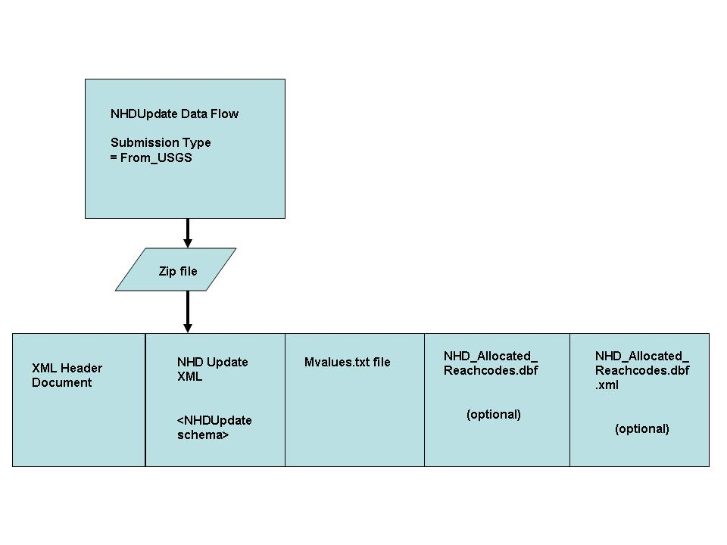

Process L4 or S4: Local updater or state steward to USGS (To_USGS) update:

The data flow submission is a zipfile. The zipfile includes five mandatory files:
- The XML Header Document.
- The XML file representing NHD Updates (Schema NHDUpdate_v1.0.xsd)
- RCL file associated with the NHD Update
- Original personal geodatabase
- Updated personal geodatabase

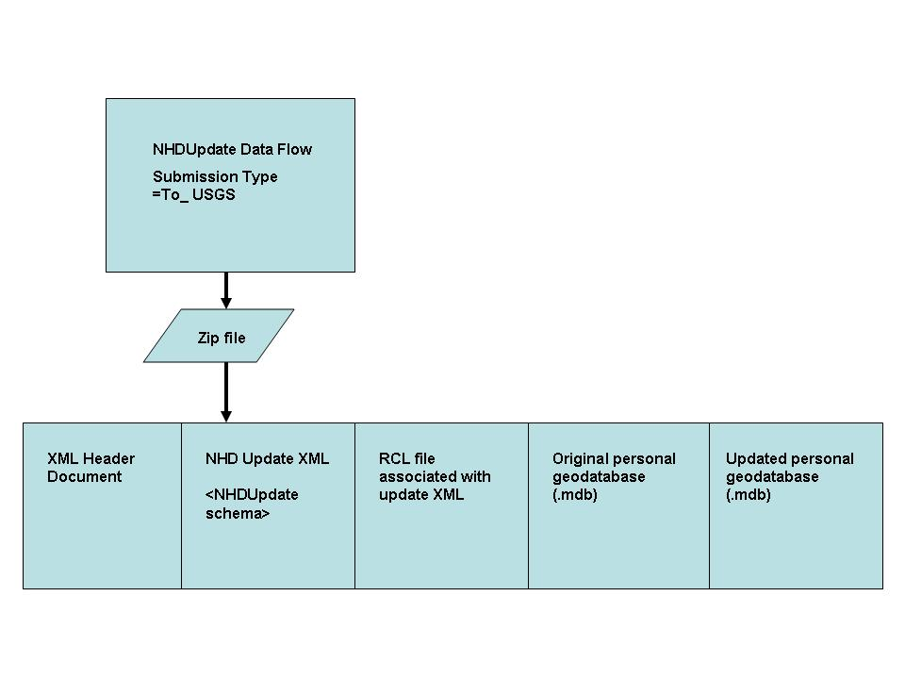

Attachment B – About the Minnesota Stewardship Pilot Project

This Data Exchange Pilot establishes the NHD Update data flow using as the test case the Minnesota NHD Stewardship environment and Minnesota’s working relationship with the USGS.

The Land Management Information Center (LMIC) of the Minnesota Department of Administration is serving as the NHD Administrative Steward for Minnesota.

Relationships can vary between state stewards, local updaters and USGS. A state Administrative Steward can just coordinate NHD update activities that occur at the local level, with local updaters submitting updates directly to USGS. (This is represented by tasks identified as ‘L’ in the Data Flow Overview tables and diagrams.)

In some cases (and in the Minnesota implementation) – the state administrative steward plans to take a more active role, providing a first-level quality control of all locally-produced NHD data updates. Once QC’d at the state level, updates are passed along to the USGS for final quality control and integration into the national database. This means that all updates to the NHD – not just those produced by LMIC - need to pass through the tracking and quality control process at LMIC before being passed on to the NHD National Database. LMIC will track and coordinate update activities occurring over the state’s area of interest to avoid data conflicts. LMIC also is serving as a primary updater of the data. Other local updaters are being trained to participate in this effort.

Minnesota’s role as a steward providing quality control activities is used to describe the Quality Control tasks identified as ‘S’ in the Data Flow Overview tables and diagrams.

Minnesota maintains a full copy of the NHD database over the state’s area of interest. Minnesota uses this to support its stewardship quality control process and to support additional local applications – including the need to store non-USGS events with the NHD. Therefore Minnesota receives updates from the national NHD database on a periodic basis.

To support this project, United States Geological Survey developed an Exchange Network node and the software (NHDUpdate plugin) to implement this data flow at USGS. On the state side, the Minnesota Pollution Control Agency administers Minnesota’s Exchange Network node. In order to complete the data flow through the state node, software (a state-level NHDUpdate plugin) needs to be developed. This Flow Configuration Document describes the full data flow as it will be processed through the state node. This is the expected eventual outcome of this project, resulting in optimal coordination and automation. Due to differences in the version of the node implemented at USGS and MPCA, the NHDUpdate plugin developed at USGS is not directly transferable to the state node. The MPCA expects to develop the software (a state-level NHDUpdate plugin) to handle this data flow as resources permit.

In the meantime, LMIC and USGS demonstrated the success of the data flow using the Windsor Solutions NodeClientLite software on the state side. LMIC installed NodeClientLite on a local desktop and was able to Submit NHD Update data to the USGS node and Solicit and Download USGS updates back, proving that the USGS node and tools worked. The NodeClientLite implementation will be used at the state end to exchange data until a working NHDUpdate plugin is developed at Minnesota’s node. This is considered an interim solution for Minnesota, but this software would be easy for other states’ updaters to use, without a big technology investment. Attachment C describes the process of using the NodeClientLite to exchange NHD data with USGS.

Attachment C – Using Windsor Solutions’ NodeClientLite
Interim Methods to Support the Data Flow

As an interim solution, until MPCA can complete an NHDUpdate data flow plugin for the state’s Exchange Network node, the NodeClientLite software developed by Windsor Solutions can be used locally to submit NHD update data zipfiles to the USGS node and to get NHD update data from the USGS.

As part of this project, USGS and LMIC successfully implemented the data flow using this software. The difference between using NodeClientLite and using a state node is that this software can ‘send’ but not ‘receive’. To actually receive data the transaction must be ‘node-to-node’ – and there are more firewall issues. In the ‘To_USGS’ direction the state was able to ‘Submit’ the zipfile according to the data flow rules. In the ‘From_USGS’ direction the state had to ‘Download’ the data after first using a ‘Solicit’, having been informed that the data was there. This pilot data flow was completed using the following steps at the state level:

Setup Steps
- Download the NodeClientLite software and install on a user desktop. Software is available from: http://www.windsorsolutions.biz/nodeclient.
- User must have a valid NAAS account for the Production Exchange.
- Menu options are displayed in the left-hand column:
  - Set preferences in My Preferences
  - Functions are listed under Things I can do
  - Tracking of past activities is covered under Things I have done

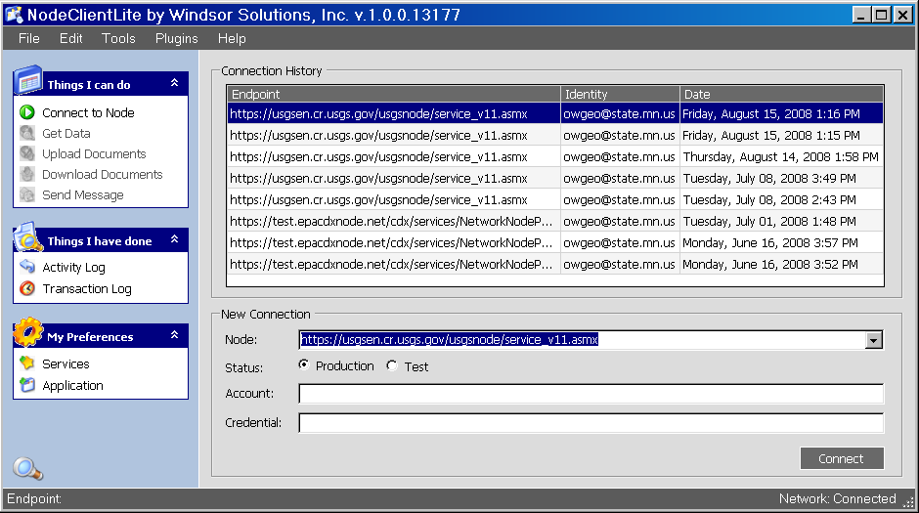

Connect to USGS Node

Under the Connect to Node option, connect to the USGS node https://usgsen.cr.usgs.gov/usgsnode/service_v11.asmx using the Production Exchange system and valid NAAS account user name and password.

Add Services

Under My Preferences: Services, add the following services:

1.
Data Flow: NHDUpdate
Name: GetNHDData
Description: Download NHD data from USGS
Service Parameters: USPS (required)

2.
Data Flow: NHDUpdate
Name: ProcessNHDDocument
Description: Upload NHD data to USGS

You can also set default download and upload directories on your desktop.

Submit data to USGS Node (To_USGS)

Once connected, select Upload Documents; specify the data flow (NHDUpdate). A Transaction ID is assigned. Add the zipfile that you want to send, then hit Submit. A successful submission results in a ‘Submission Results’ popup screen with a Transaction ID. The zipfile is sent and USGS staff is notified by email.

To check status, select Transaction Log: Type in the Transaction ID or put in the Data Flow name (NHDUpdate) and search. Transaction status (date, time, Type=Submit). If the transaction successfully transmitted data to USGS then the status is ‘Processed’.

Get data from USGS Node (From_USGS)

Once connected, select Get Data. In the Request window, enter:
Data Flow: NHDUpdate
Service: GetNHDData
Parameters: USPS: enter your state’s Postal Service code (e.g., ‘MN’ for Minnesota). This parameter aligns the user’s data requests with data distribution outboxes at USGS.
Use ‘download later’ option. Then hit Submit

A successful submission results in a ‘Data Request Results’ popup screen with a TransactionID.

To check status, select Transaction Log: Type in the Transaction ID or put in the Data Flow name (NHDUpdate) and search. Transaction status (date, time, Type=Solicit). If the transaction successfully transmitted data to USGS then the status is Processed.

Download the Data that has been requested from USGS

Highlight the record in the transaction log that represents your Get Data request. Right mouse click and hit Download Results.

    - OR –

Go to Things I can Do: Download Results in the left-hand toolbar. Specify Data Flow and Transaction Id and hit Submit.

A successful download results in a ‘Document Download Results’ popup scrren listing file name, TransactionID, and download location.

