System High-Level Design Document

Exchange Network AQS/MassAir Project
(AQS)

Air Monitoring Public Data Website

Massachusetts Department of Environmental Management

Version: 1.2

February 6, 2008

This Page Intentionally Left Blank

Revision History

Version | Date | Created By | Reviewed By
0.9 | 1/16/2008
Description: | Draft SYSTEM HIGH-LEVEL DESIGN DOCUMENT
1.0 | 1/22/2008 |  | MassDEP
Description: | The following updates/additions were made in this version of the document:  - Updated the Website Design Decision section to identify the decisions made (page 16)  - Updated the “Non-AQS Data” Content Management Design Section (page 22)  - Added Pending System Design Features (page 25)  - Updated Database Design Section to include more info on how data gets from EPICS to the Website (page 53)  - Updated Page-by-Page Layouts (page 40)  - Updated MassDEP Mock Screens (page 71)
1.1 | 1/25/2008 |  | MassDEP
Description: | The following updates/additions were made in this version of the document:  - Updated the Document Purpose section to indicate that the team has come to a consensus on each of the Pending Design Decisions (page 8)  - Updated the Data Population to the Website section to indicate that only data that would be submitted to the EPA via the AQS Schema will be populated to the Website via the AQS Schema. The other types of data will be fed directly from ePub Database stored procedures to the Air Monitoring Data Website (page 21)
1.2 | 2/6/2008 |  | MassDEP
Description: | The following updates/additions were made in this version of the document:  - Updated the Document Introduction to indicate that this document only covers the Air Monitoring Public Website (page 8)  - Updated the Document Overview Section (1.4) to include Appendices C and D (page 10)  - Updated the Full AQS Data Exchanged to EPICS Section (2.1.4) to indicate that the Full AQS Data will be maintained in EPICS, but will not be flowed to the EPA (page 14). Please see the QA Tools System Design Document for more information on this decision.

This Page Intentionally Left Blank
Table of Contents
1. Introduction 8
1.1 Purpose 8
1.2 Scope 8
1.3 Definitions, Acronyms, and Abbreviations 9
1.4 Document Overview 10
2. System High-Level Design Overview 12
2.1 System High-Level Design Goals, Scope, and Objectives 12
2.1.1  Data Polled and Maintained in E-DAS 13
2.1.2  Aggregate and Store Complete set of AQS Data in EPICS (ARA) 13
2.1.3  Capitalize on AirNOW FTP submission to Feed AQS Raw Data to EPICS 14
2.1.4  Full AQS Data Exchanged to EPICS 14
2.1.5  Parse Data to EPICS Oracle Database 15
2.1.6  QA Tools 15
2.1.7  Node Plug-in Submits AQS Data through MassDEP Network Node to EPA 16
2.1.8  Node Plug-in Submits Updated (QA) AQS Data to AirNOW (Optional) 16
2.1.9  Air Quality Data Reporting Public Website 16
2.1.10  Utilize Existing Exchange Network Technology to Support Public Data Download on the Air Monitoring Website 17
2.2 Pending Design Decisions 17
2.2.1 Using Web Services to feed the Air Monitoring Website 17
2.2.2 Data Source for Data Download Module 19
3. Detailed System Overview – Air Quality Data Monitoring Website 21
3.1 System Design Components 21
3.1.1 Integration with Mass.gov Website 21
3.1.2 Data Population to Website 22
3.1.3 “Non-AQS Data” Content Management 23
3.1.4 Maps 24
3.1.5 Section 508 Compliance 25
3.1.6 User Types and Security Roles 26
3.1.7 Pending System Design Features 26
3.2 User Interface 27
3.2.1 Two Level Navigation 27
3.2.2 Webpage “Sections” 29
3.2.3 Page by Page Layouts 41
3.3 EPICS AQS Database Expansion 53
3.3.1 Database Design Standards 53
3.3.2 Database Size Estimates 54
3.3.3 Getting Data from EPICS to the Air Monitoring Data Website 54
4. Deployment 56
4.1 Overview 56
4.2 Web Server Requirements 56
4.3 Database Server Requirements 57
4.4 Application Server (Optional) Requirements 57
5. Appendix A – Webpage Flow Diagrams 59
6. Appendix B – WebAIM Section 508 Compliance Checklist 63
7. Appendix C – EPICS Expansion Draft Entity Relationship Diagrams 71
8. Appendix D – Air Monitoring Data Website Mock-up Web Pages from MassDEP 72

Tables and Figures
Table 1: Definitions, Acronyms and Abbreviations 9
Table 2: Web Server Hardware Requirements 55
Table 3: Database Server Hardware Requirement 56
Table 4: Application Server (Optional) Hardware Requirements 57

Figure 1: Overview of the AQS System Components 13
Figure 2: Website Data Population 22
Figure 3: Google Maps Design 24
Figure 4: Example of Two Level Navigation from CNET 26
Figure 5: Representative Google Maps Screenshot 30
Figure 6: Representative Graph Screenshot (with existing Infragistics capabilities) 32
Figure 7: Representative Simple Link Screenshot 33
Figure 8: Representative Complex Link Screenshot 34
Figure 9: Representative Body Text Screenshot 35
Figure 10: Representative Alert Screenshot 36
Figure 11: Representative Webcam/Image Screenshot 37
Figure 12: Representative Table Data Screenshot 38
Figure 13: Representative Downloads Screenshot 40
Figure 14: “Levels Now & Forecast > Max AQI” Layout 41
Figure 15: “Levels Now & Forecast > Particulates” Layout 42
Figure 16: “Levels Now & Forecast > Ozone” Layout 43
Figure 17: “Levels Now & Forecast > Carbon Monoxide” Layout 44
Figure 18: “Levels Now & Forecast > SO₂” Layout 45
Figure 19: “Levels Now & Forecast > NO_{X}” Layout 46
Figure 20: “My Community > Particulates” Layout 47
Figure 21: “My Community > Ozone” Layout 48
Figure 22: “Pollutants & Trends > Trends by Pollutant” Layout 49
Figure 23: "Pollutants & Trends > Trends by Monitor" Layout 50
Figure 24: “Data Download > Download Utility” Layout 51
Figure 25: Database Sizing Calculations 53
Figure 26: Getting Data from EPICS to the Air Monitoring Data Website 54
Figure 27: Page Flow - Levels Now & Forecast 58
Figure 28: Page Flow - My Community 59
Figure 29: Page Flow - Pollutants by Trend 60
Figure 30: Page Flow - Data Download 61
Figure 31: EPICS AQ Schema Entity Relationship Diagram (Visio 2002 Drawing) 70
Figure 32: MassDEP Air Monitoring Public Data Website Mock-up Screens 71

Introduction

Purpose
This document provides a comprehensive architectural overview of the Massachusetts Department of Environmental Protection Exchange Network Node MassAir/AQS Project (AQS). The document depicts the technical aspects of the AQS System Components and is intended to capture and convey the significant architectural design decisions which have been made in preparation for the development of the Air Monitoring Public Data Website – a Major Component to be developed under the AQS Project.
At the time that this document was first drafted, there were 2 pending Design Decisions being reviewed and considered pertaining to the Air Monitoring Public Data Website. These issues have since been discussed and a decision was reached on each. Please see more information on the Design Decisions and associated options in the “Design Decisions” Section (2.2).

Scope
This document seeks to define the high-level functionalities of the AQS System Components in as much detail as possible. This document merges knowledge from past meetings, from MassDEP experience, and from IT expertise to formulate a plan for developing the AQS System Components.
Based on previous project team design discussions, first a Functional Requirements Specification Document was created under this project to identify the business process needs for the AQS System Components. After investigation of the defined Functional Requirements, standard design practices, and business process optimization, this document defines an application that will allow MassDEP to do the following:
- Flow Air Quality System (AQS) Data to the EPA via the MassDEP Network Node as part of the National Environmental Information Exchange Network (NEIEN)
- Streamline and Automate (where possible) the data gathering and data transfer for the AQS Data Flow using MassDEP Data Sources and Database(s) (existing and new)
- Develop an Air Monitoring Public Website to enable the sharing of real-time Air Quality data and other Air Quality related information with the public.
  - The Website will also support the publishing of MassDEP Air Quality Data to the public via the MassDEP Node.
- Develop a set of Quality Assurance tools to streamline the process of Air Quality data review performed by state staff.

Definitions, Acronyms, and Abbreviations
This subsection provides the definitions of all unclear terms, acronyms, and abbreviations required to properly interpret the AQS System Design Document.

Table 1: Definitions, Acronyms and Abbreviations
Term | Definition
AirNOW | http://www.airnow.gov – The U.S. EPA, NOAA, NPS, tribal, state, and local agencies developed the AIRNow Web site to provide the public with easy access to national air quality information. The Web site offers daily AQI forecasts as well as real-time AQI conditions for over 300 cities across the US, and provides links to more detailed State and local air quality Web sites.
AQS | The Air Quality System (AQS) is EPA's repository of ambient air quality data. AQS stores data from over 10,000 monitors, 5000 of which are currently active. As discussed in more detail elsewhere, State, Local and Tribal agencies collect the data and submit it to AQS on a periodic basis.
AQS Data | For this document, three types of AQS Data have been defined for display on the Air Monitoring Data Website:  - AQS Data: AQS Data is Air Quality data (including Sites and Monitor Information, Monitoring Results, Parameter Information, etc.) that is also contained in the AQS Submission to the EPA. In order to make the website more Exchange Network centric, the website will be designed to be fed directly from data in an AQS version 2.0 XML Schema format for this type of data.  - AQS Related Data: AQS Related data is data that is calculated or determined based on the AQS Data. For example, Alert information is triggered when AQS results exceed a pre-defined threshold. Information, such as Alert information, will be published to the AQS website via a new schema block to be added to the AQS version 2.0 schema.  - Non-AQS Data: Non-AQS Data is the data on the website that is not contained in the AQS submission to the EPA. A new web page layout schema will be developed to transfer and publish this type of data to the website.
CSV | A file format (Comma Separated Value) for text files that is easily converted to and from Excel Worksheets via Microsoft Excel.
AQS | The project: Exchange Network Phase 4
FTP | FTP or File Transfer Protocol is used to transfer data from one computer to another over the Internet, or through a network.
GML | XML grammar defined by the Open Geospatial Consortium (OGC) to express geographical features.
HTML | Hypertext Markup Language, is the predominant markup language for web pages. It provides a means to describe the structure of text-based information in a document – by denoting certain text as headings, paragraphs, lists, and so on.
Infragistics | A Third Party Web Toolkit that MassDEP recommends and has sufficient licenses for it to used in the development of the Air Monitoring Data Website and the QA Tools Web Applications. Please see http://www.infragistics.com/ for more information.
MassDEP | The Massachusetts Department of Environmental Protection
NAAS | EPA Network Authentication and Authorization Services: provides secure user authentication for Exchange Network Web Services.
OBS | The standard structure text file format used to FTP data to AirNOW automatically.
EPICS | MassDEP’s Enterprise-wide Oracle Database used for storing the State’s environmental information.
XML | A type of file (or language used when generating files) which allows for data and documents to be easily exchange over the web.

Document Overview
The AQS Air Monitoring Public Data Website System High-Level Design Document is arranged in the following format:

- Section 1: Introduction
  - A brief explanation of the purposes, goals, and format of the System Design Document.
- Section 2: System High-Level Design Overview
  - An overview of the goals and objectives for the AQS project. This section also provides a short explanation about each component and process to be developed/implemented under the AQS project.
- Section 3: Detailed System Functionality Explanations
  - This section documents the detailed design of the Air Monitoring Website specifically.
- Section 4: Usage Scenario Viewpoint
  - In this section, selected Usage Case Scenarios (from the AQS Functional Requirements Specification Document) are explained in further detail paying particular attention to the design considerations undertaken to ensure the Usage Case is possible in the final realization of the Air Monitoring Data Website.
- Section 5: Deployment Viewpoint
  - This section lists the areas of the MassDEP technical infrastructure where applications or processes should be setup in order to support the Air Monitoring Public Data Website.
- Appendix A
  - Appendix A contains draft Flow Diagrams for the Air Monitoring Data Website pages.
- Appendix B
  - Appendix B contains the Section 508 Compliance Checklist to be used to ensure that the Air Monitoring Data Website is Section 508 compliant, in addition to the AccVerify HiSoft third-party testing application.
- Appendix C
  - Appendix C contains an embedded copy of the draft Entity Relationship diagrams for the Air Quality database expansion to be included in EPICS to support the Air Monitoring Public Data Website.
- Appendix D
  - Appendix D contains an embedded copy of the Air Monitoring Data Website mock-up screens provided by MassDEP.

System High-Level Design Overview

System High-Level Design Goals, Scope, and Objectives
The Massachusetts Department of Environmental Protection (MassDEP) was awarded an Environmental Protection Agency (EPA) grant to implement a new air quality flow on the Exchange Network and develop a website to share real-time air-quality data with the public. The project consists of implementing automated cleansing of information, conversion of information to the Exchange Network format, delivery of information over the network in a secure and reliable fashion, and to the publicly accessible web interface.
As noted in the introduction, these technological advancements will be accomplished by developing the following major AQS System Components:

- Flow Air Quality System (AQS) Data to the EPA via the MassDEP Network Node as part of the National Environmental Information Exchange Network (NEIEN)
- Streamline and Automate (where possible) the data gathering and data transfer for the AQS Data Flow using MassDEP Data Sources and Database(s) (existing and new)
- Develop an Air Monitoring Public Website to enable the sharing of real-time Air Quality data and other Air Quality related information with the public.
  - The Website will also support the publishing of MassDEP Air Quality Data to the public via the MassDEP Node.
- Develop a set of Quality Assurance tools to streamline the process of Air Quality data review performed by state staff.

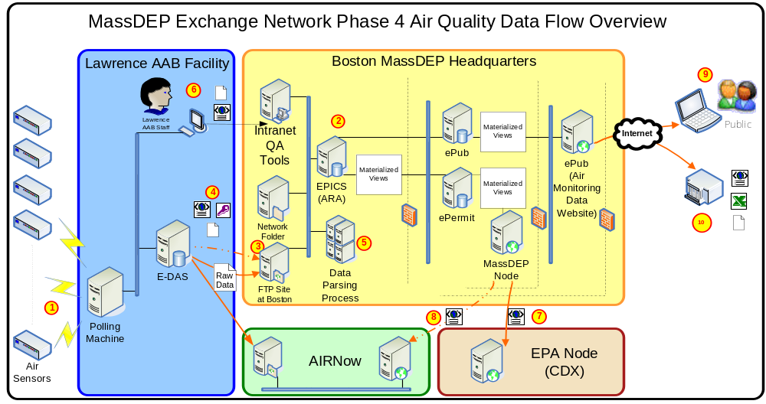
Figure 1: Overview of the AQS System Components

The following sections describe the components of the AQS System as numbered in the diagram above.

Data Polled and Maintained in E-DAS
The existing business process will continue to retrieve data from the Air Quality monitoring stations and populate this information into E-DAS, located at the Lawrence facility, on an hourly basis.
Although the E-DAS system will continue to serve as the primary data management tool at the Lawrence AAB facility, a separate data store will be established at Boston.

Aggregate and Store Complete set of AQS Data in EPICS (ARA)
Because the Air Quality data maintained in E-DAS is stored in a proprietary format, IT proposes to create a separate storage of AQS data in a new EPICS (ARA) database module to be created under this project. The EPICS storage of AQS data will store a complete set of AQS data to allow review and to aggregate separate AQS data sources if necessary. The EPICS AQS Data will support the following data sharing applications to be developed under this project, at a minimum:
- AQS-XML Submissions
- MassDEP Air Monitoring Website
- Ad hoc Data Downloads
Because there are a variety of data sharing needs, the data at Boston will need to include a full set of information, including:
- Latest hourly raw data
- Site, monitor, protocol, precision/accuracy, and QA’d raw data that will support a complete AQS submission (and provide necessary supporting information on the website).

Capitalize on AIRNow FTP submission to Feed AQS Raw Data to EPICS
In order to allow the latest set of hourly data to be displayed on the MassDEP website, an automated mechanism will need to be established to transfer this data from Lawrence to Boston. Please see the “MassDEP_AQS_QATools_SDD_v1.2.doc” for more information on the Data Transfer, Parsing/Upload process.

Full AQS Data Exchanged to EPICS
While the previous section would accomplish the transmittal of Raw Data to EPICS, additional data would need to be maintained in EPICS that includes all information needed to support a complete AQS submission. Based on Design Discussions with MassDEP Staff, the initial design is to load this data into EPICS with a one-time migration. MassDEP Staff will then be responsible for maintaining the Full AQS Data (e.g. Monitor Details, Basic Site Info, etc.) within EPICS via the QA Tools Application (similar to how it is done via AQS and AirNOW currently). We will use the Raw AQS Data together with the Full AQS Data to submit AQS Raw Data electronically to the EPA.
Please see the “MassDEP_QATools_SDD_v1.2.doc” for more information on the Data Transfer, Parsing/Upload process, and please see the “MassDEP_AQS_FCD_v1.2.doc” for more information on the AQS Node Submission to the EPA.

Parse Data to EPICS Oracle Database
As noted above, the ideal solution would be to utilize the existing AirNOW FTP process to transfer real-time Raw Air Quality Data to be displayed on the Air Monitoring Data Website. In order to do this, the “OBS” file FTP’d to AirNOW would need to be parsed to the EPICS database once it was transferred to the MassDEP environment at Boston. A process will be built to do this.
Please see the “MassDEP_AQS_QATools_SDD_v1.2doc” for more information on the Data Transfer, Parsing/Upload process.

QA Tools
A comprehensive Web-based QA Toolset will be developed that will allow Lawrence staff to manage their quality assurance tasks and quickly identify potentially erroneous air quality data. In order to provide a comprehensive, solution, IT recommends that the different QA tools be combined into one solution. This will enable Lawrence staff to complete a variety of QA tasks within one application. The major components included in this Toolset are:
- Data Upload Module
- Field Analyst Compliance Module
- Data Comparison and Graphing Module
- Speciation Analysis Module

Please see the “MassDEP_AQS_QATools_SDD_v1.2.doc” for more information on the Data Transfer, Parsing/Upload process.

Node Plug-in Submits AQS Data through MassDEP Network Node to EPA
A Node Plug-in will be developed to plug into the existing MassDEP Node which will generate the AQS XML file and submit to the EPA on an on demand basis formatted according to the AQS v2.0 schema.

Please see the “MassDEP_AQS_ FlowConfigurationDocument_v2.1.doc” for more information on the AQS Node Submission to the EPA.

Node Plug-in Submits Updated (QA) AQS Data to AIRNow (Optional)
The same Node plug-in described in the section above used to submit AQS Data to the EPA can also be used to feed data to AIRNow.
The advantages of implementing an XML-based AIRNow data flow are:
- The traditional flat (OBS) files to AIRNow do not allow data to be updated. But the XML data transmission to AIRNow does allow updates to be automatically made. This is especially important in allowing users of the AIRNow Tech application to see QA’d information.
- Ensures data is consistent, regardless of the exchange partner.
- Ultimately reduces the number of different exchange mechanisms, thus reducing long-term support costs.

Air Quality Data Reporting Public Website
The Air Quality Data Monitoring Website will relay live, near real-time data to the Commonwealth, while engaging public interest in and knowledge of air quality. The Website is the main topic of this Design Document. Please see the “ Air Quality Data Monitoring Website” Section (3) for a Detailed System Design Overview.

Utilize Existing Exchange Network Technology to Support Public Data Download on the Air Monitoring Website
A module of the Website will allow Public User’s to query and download Real Time as well as Historical Massachusetts Air Quality Data from the MassDEP in multiple file formats, including, HTML, XML, GML, and CSV. This function may potentially be built by integrating with the MassDEP AQS Node Web Service to also be developed under this process. Please see the “Data Source for Data Download Module” Design Decision section for more information on this functional design. A detailed layout of the Data Download pages is also included in this document in the “Page by Page Layouts” Section.

Design Decisions
At the time that this document was first drafted, the following 2 design decisions pertaining to the Air Monitoring Public Data Website were still pending. Decisions were reached on each item, as noted in the corresponding footnotes:

Using Web Services to feed the Air Monitoring Website
- The recommendation is to continue with the initial design concept outlined in option A below. The Website has been re-designed from the initial concept to include being fed from the AQS version 2.0 XML Schema. Please see the “Data Population to Website” Section (3.1.2) for more information on this new functionality. All initial design options for this issue are included below:

  - Continue with the recommended approach thus far of having the Data Download portion of the site be fed by a Node AQS Query Data Service, but have the rest of the Website data be fed by reading data directly from the ePub Database.
    - Pros:
      - More efficient; Better performance
      - Shorter development time
      - Enables more complicated functions to be built into the website
      - Since the website is to be built to be easily managed by MassDEP Staff, it could also be easily modified and adapted by other states.
      - It still is a new way of using the Node to publish data
      - We could build a way of using the Data Download portion of the site to add context to the data and to make it more informational to casual public users. We could add a block to the AQS schema to do this to indicate user location (rural, city, etc.), user community, user interests, and user details in order to tailor the information. In this way, we could fulfill the spirit of the grant and provide a function that educates a user on Air Quality in their community and is fed directly from the Node Web Service.

    - Cons:
      - Not directly transferrable to other Exchange Network states without providing other pieces to support it, such as the database structure and web pages (which could be done).

  - Investigate the capabilities of the MassDEP Node further; build a Data Service on the MassDEP Node using the standard Query service if possible to feed the website
    - Pros:
      - The Data Service itself could be transferrable to other states, but may not be all that useful without the Website itself, since the Website would be where the innovative new code would reside. The Data Service would be the standard AQS Data Service used to submit data to the EPA.

    - Cons:
      - There would be a performance decline on the website
      - There would be a potential performance decline on the MassDEP Production Node
      - There would be increased development time and the current version of the MassDEP Node has some potential problems that may need to be dealt with first.
      - The Data Service would have to be built very basically to minimize transaction time and increase performance; this may result in less functionality in the web site and/or less transferability to other states on the Exchange Network.
      - In order to fit this development within the scope of the project, we would not be able to address areas of the current Node 1.1 version Web Services that are lacking, including Security Management, Policy Management, and Transaction Management
      - The new Node 2.0 spec may provide some benefits to this approach, but the 2.0 spec is still not finalized and I don’t think the upgrade of the MassDEP Node to version 2.0 is planned to be completed by the end of the time of this project

  - Develop non-Node Web Services to feed the data to the Air Monitoring Data Website
    - Pros
      - Would be transferrable to other Exchange Network States
      - Would allow us to build sophisticated enough Web Services to support the detailed functions of the website

    - Cons
      - Would greatly increase the development time and reduce the efforts to be spent in other areas of the project.
      - The Web Services would not be built as part of the Exchange Node itself, so it would not be a true Exchange Network component.

Data Source for Data Download Module
There are two options for supporting the Data Download Module of the Website because of the new design of the Website that will enable data to be published to it via the AQS version 2.0 XML Schema.

Option 1
Retrieve data for the Data Download Module via the same process used to feed the rest of the data to the Air Monitoring Data Website. Under this option, the Website would be streamlined and would interact with less servers and applications. However, there are potential concerns with performance in having the Data Download Files, which could be multiple Megabytes in size in some cases, generated by the same process that needs to deliver Air Quality Data quickly to each page of the Air Monitoring Website when it is viewed.

Option 2
Develop the Website to interface with the MassDEP AQS Node Web Service. Because the Node would be fed by the ePermit Database and the Website would be fed by the ePub database, using this option would divide the resources that need to be expended to support both the Air Monitoring Data Website and the Data Download Module. However, under this option, the functionality of the Data Download Module would be tied to the EPA NAAS Web Services and the MassDEP Node. If either option is not operational, then the Data Download Module will not be operational.

Detailed System Overview – Air Quality Data Monitoring Website
A key part of MassDEP’s mission is the protection of public health and education about environmental issues. MassDEP wants to allow citizens of the Commonwealth to have timely access to localized air quality data and make informed decisions about outdoor activities, which may affect their health. The Air Quality Data Monitoring Website will relay live, near real-time data to the Commonwealth, while engaging public interest in and knowledge of air quality.

The following sections below are provided in this document to outline the following design components of the Air Quality Data Monitoring Website:

- Section 3.1: System Design Components – This section defines in more detail the relevant design considerations
- User Interface
  - Section 3.2.1: Webpage Sections – The team has identified 7 separate Webpage Sections that may be included in any combination in the Website pages. This part of the document defines the 7 sections in further detail.
  - Section 3.2.3: Page by page layouts for each of the identified web pages to be developed.
  - Appendix A – Webpage Flow Diagrams: A flow diagram attempting to outline the paths of interaction that a user may experience through the website.

System Design Components

Integration with Mass.gov Website
Multiple design discussions were held with the intention of determining the most efficient way to integrate the Air Monitoring Data Website with the Mass.gov web pages, while still being able to implement and maintain the necessary functionality. The team has determined that the best option is to host the new Air Monitoring Data Website pages on the MassDEP ePub server, and to still include the standard MassDEP Web Template for display of the header and navigation panel. This means that whenever the MassDEP Web Template is updated on the Mass.gov servers the updated template must also be copied over the version hosted on the MassDEP ePub server being used by the Air Monitoring Data Website.

In general, the design concept is that the transition between the Mass.gov hosted website and the MassDEP hosted website should be seamless and unnoticeable to the casual public user. The user should only become aware of the new navigation function to be included at the top of the Air Monitoring Data Website pages.

Data Population to Website
There are three types of data that will be fed to the website via the Air Quality Schema tables to be added to EPICS. They are AQS Data, AQS Related Data and Non-AQS Data. Each type of data will be fed to the website via an XML schema as explained in further detail below:

- AQS Data: AQS Data is Air Quality data (including Sites and Monitor Information, Monitoring Results, Parameter Information, etc.) that is also contained in the AQS Submission to the EPA. In order to make the website more Exchange Network centric, the website will be designed to be fed directly from data in an AQS version 2.0 XML Schema format for this type of data.

- AQS Related Data: AQS Related data is data that is calculated or determined based on the AQS Data. For example, Air Quality Index is calculated based on the AQS Data by the Website and then subsequently displayed. Information, such as AQI, will be generated by the Website based on the AQS data being published to the Website.

- Non-AQS Data: Non-AQS Data is the data on the website that is not contained in the AQS submission to the EPA. A new web page layout schema will be developed to transfer and publish this type of data to the website.

By developing the website to be fed from the AQS version 2.0 XML Schema, it opens the possibility for other Exchange Network states or tribes, or any other agency able to produce Air Quality data in the AQS version 2.0 schema, to be able to host the Air Monitoring Data Website to publish Air Quality content to the internet. The following Website page functions that will be directly fed from the AQS schema and would be transferrable to other Exchange Network agencies producing the AQS schema with relatively small modifications:

- Air Quality Google Map Displays
- Two Dimensional Graph (Trends by Monitor, Trends by Pollutant)
- Tabular AQS Data to support the Maps and Graphs

Node Interface
Under this project the design is to not have the website retrieve the AQS XML from the MassDEP Node due to performance, access, and reliability concerns. Instead the AQS Schema will be generated via stored procedures located on the Website Database. The diagram below illustrates the conceptual flow of data for the AQS Website and how an Exchange Network Node could be used to feed the AQS Website in the future.

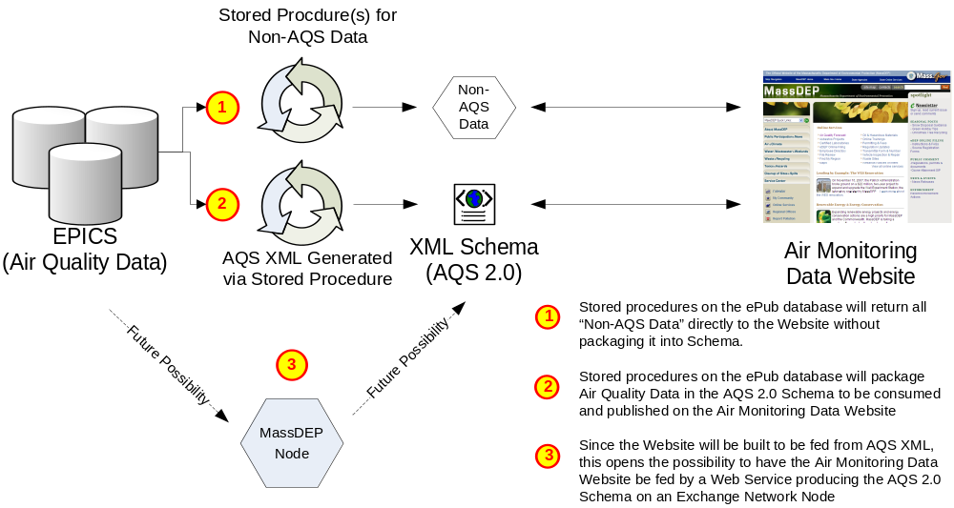
Figure 2: Website Data Population

“Non-AQS Data” Content Management
Due to the business needs expressed by MassDEP during the requirement gathering phase of this project, IT plans to build an internal application to allow MassDEP Users to manage the Non-AQS Data content of the Air Monitoring Data Website. To save development cost and time, IT plans to build this management tool as a module in the QA Tools application.

The Air Monitoring Data Website will be developed in such a way that the “Non-AQS Data” Content will be driven by HTML Code Snippets that will be stored and maintained in the EPICS Air Quality Data Storage. The Team is planning to use the HTML editing capabilities of Infragistics to build an HTML editing interface in the QA Tools Application to allow MassDEP Staff with appropriate rights the ability to update and add to these HTML Code Snippets. In this way, the “Non-AQS Data” content will actually be stored in EPICS and will not be directly part of the Air Monitoring Data Website .aspx pages. The Air Monitoring Data Website will retrieve the HTML Code Snippets from the EPICS database (according to the process identified in the “Data Population to Website” Section [3.1.2]) and render them as part of the Air Monitoring Data Website during runtime.

As noted in the ‘Webpage “Sections”’ Section of this document (3.2.2), the Google Maps, Two Dimensional Graphs, Table Data, and Alerts will not be updatable via this process; however, these “Sections” will have updatable options as described in the ‘Webpage “Sections”’ Section of this document (3.2.2).

NOTE: MassDEP Staff with rights to edit the HTML Code Snippets will have full access to update data in the Production Environment. MassDEP will be responsible for ensuring a business process is implemented to ensure that unauthorized or invalid data is not updated to the Air Monitoring Data Website. Invalid HTML or Javascript could cause the entire Air Monitoring Data Website to experience functional failures. MassDEP should test all data updates within the MassDEP Dev → Test → Stage environments before updating data to the Production version of the Air Monitoring Data Website. Only MassDEP Staff with appropriate responsibilities should be given the rights to this update option.

Maps
In order to effectively present the State of Massachusetts Air Quality information to the public, the AQS project team has identified many areas of the website where an interactive map will be used to display the Air Monitoring information. After multiple design discussions with MassDEP technical experts and subject matter expert staff, the team has decided on using the Google Maps API in order to accomplish the

Licensing Requirements
The team researched the licensing requirements to use the Google Maps API and found that the license is free to obtain and use provided that the functions it supports are freely available to the public. Since the Air Monitoring Data Website is a public website without any fees required to view or visit it, the Google Maps API can be used. The website URL for use with the Google Maps will need to be registered with Google to obtain the free license. This can be done from this website: http://code.google.com/apis/maps/signup.html

Security Requirements
It is understood that the Air Monitoring Data Website will be hosted on the MassDEP ePub database located in the DMZ. Because of this, the server hosting the Air Monitoring Data Website may not generate any “outgoing” traffic. The implementation of Google maps must be able to fit within the confines of the MassDEP technical infrastructure and security guidelines. The diagram below illustrates the technical process by which Google Maps are to be designed and included in the Air Monitoring Data Website:

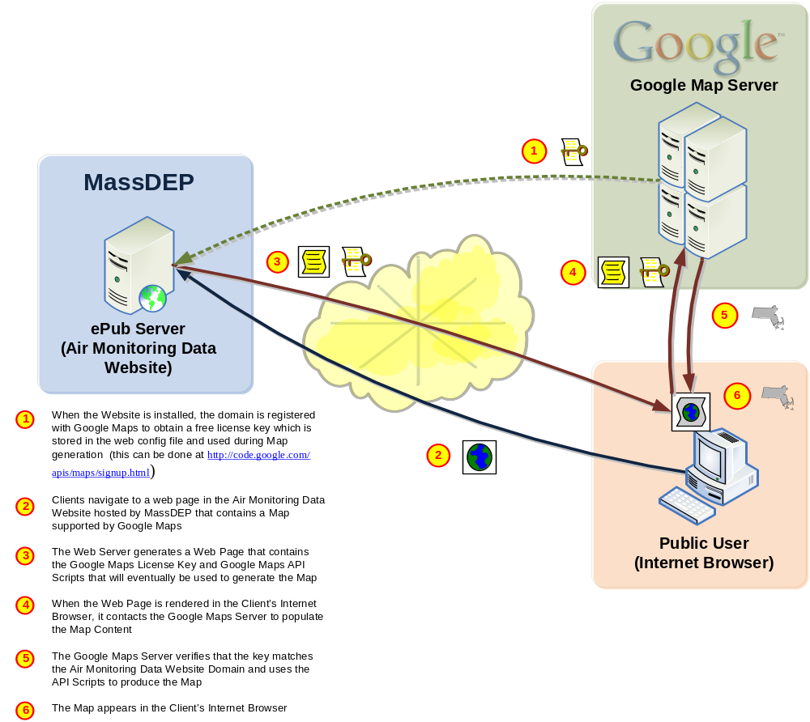
Figure 3: Google Maps Design

Section 508 Compliance
The Air Monitoring Public Data Website needs to be designed to be Section 508 Compliant. A checklist will be used to test and ensure that the Website is developed to meet the Section 508 requirements. An example checklist is included in this document as “Appendix B – WebAIM Section 508 Compliance Checklist”.

User Types and Security Roles
The Air Monitoring Data Website itself will not host any features or functionality that will be restricted to website users; thus, all users visiting the Website will have full access to all the web pages.

If the Data Download module is implemented under the option that integrates with the MassDEP Exchange Network Node, a guest NAAS account will need to be procured and configured for the Air Monitoring Data Website. This account will be used for authentication to enable the Node Web Service to be executed and Air Quality Data to be retrieved.

Pending System Design Features
There are two Website System Design Features that are currently being investigated further by the team and will be designed based on the available options that come out later in this Project. They are described below:

Alerts Linked to MassDEP on Mass.gov Servers
Currently MassDEP places an alert image file manually into a folder that is referenced by the Mass.gov web page when there is an Air Quality alert in the state. This process is not efficient as it means that Air alerts over the weekend are not able to be broadcasted.
- The Air Monitoring Public Website should have a feature built in to raise alerts specific to each monitor when a certain threshold is reached.
- The Alerts should allow the user to jump to a page where they can see reasons for poor Air Quality.
- The hope is that a process could also be worked out so that the Alert could be automatically promoted to the Mass.gov home page to take the place of the current manual process.

Data from outside the State Network
Forecasting: Currently, a few MassDEP staff calculate forecast data for the Air Quality in the state and publish it to the Mass.gov MassDEP Air web pages currently. MassDEP has the ability to update this information from outside the State Network currently and would need to maintain such functionality in the future.
- The AQI forecast data can be thought of as a separate Air Quality Parameter that is tracked for each monitor. It does not require extra functionality to show the Forecast data for a monitor or parameter.
- An ideal solution would be to allow MassDEP forecasters VPN access to login and update the Forecast data via the QA Tools application, however, this has been an issue previously resulting in such a process not being allowed to be setup by the State.
- One possible option would be to have the Forecast data placed on an FTP site hosted by MassDEP and pulled into EPICS via an internal parsing process (discussed later in the document). Either way, the forecast data needs to be updatable, most likely from the external network.

User Interface

Two Level Navigation

The team has identified a “Two Level” Navigation concept to be included at the top of the Air Monitoring Data Website Pages. The functional design of the “Two Level” Navigation will mimic the functionality of many mainstream websites, such as CNET (see http://reviews.cnet.com/?tag=hd_ts for an example). A screenshot is provided below:


Figure 4: Example of Two Level Navigation from CNET

The First Level of Navigation () will be a set of Tabs. The following Tabs have been defined to be included in the Air Monitoring Data Website:

- Levels Now & Forecast*
- Pollutants & Trends
- My Community
- Monitors
- Data Download

The Second Level of Navigation () will be a set of links located at the top of each tabbed page. The following 2nd Level Links have been defined to be included based on each Tab:

- Levels Now & Forecast *
  - Max AQI
  - Particulates
  - Ozone
  - Carbon Monoxide
  - SO₂
  - NO_{x}
  - Toxics**

- My Community
  - Particulates
  - Ozone

- Pollutants and Trends
  - Trends by Pollutant
  - Trends by Monitor
  - Health Effects**
  - Standards**
  - Preventing Air Pollution**
  - Exceedances**

- Monitors
  - Where We Monitor & Why**
  - What We Monitor & Why**
  - How We Monitor**

- Data Download
  - Data Download
  - Annual Reports**

* Navigation Tabs marked with a star indicate that the 2nd Level Navigation Links will be dynamically generated based on Database Reference Data that MassDEP Staff will have the ability to configure. For example, MassDEP Staff could flag a new parameter to show up on the ‘Levels Now & Forecast’ Navigation Tab (through the QA Tools Administration module) and the new Parameter and corresponding Web Page will be available for viewing on the Air Monitoring Data Website without having to expand or re-deploy the Air Monitoring Data Website itself.

** The second level navigation pages denoted by two stars are pages that do not contain any Air Quality AQS Data. These pages will initially be slated to be included as part of the list of pages to be designed by IT, but MassDEP may decide to manage these pages separately within the MassDEP Mass.gov Website. During the iterative website development process, each page will be discussed and the ultimate creation, hosting, and maintenance process for each of these pages will be determined. Also, the content for these pages has not been thoroughly designed by MassDEP; therefore, the pages will not be included in the “Page by Page Layouts” Section (3.2.3) or the “Appendix A – Webpage Flow Diagrams” Section (5).

Please see the “Page by Page Layouts” Section (3.2.3) for more information on the detailed design for each page represented by the Navigation process identified above.

Webpage “Sections”
Based on the MassDEP Functional Requirements and follow-up design discussions, the AQS Project Team has identified 8 Conceptual Webpage “Sections” that will be mixed and matched in order to produce all the Air Monitoring Data Website Pages.

The purpose of identifying these 8 separate sections is to further define the update options and functionality of each Section and to identify areas of the Website that can be reused. This type of modular design will increase efficiency, allow for easier maintenance, and decrease development cost for the Air Monitoring Data Website.

All 7 “Sections” will be fed by dynamic data loaded to the Website within a pre-defined XML Schema. It is important to note that the order and layout of a “Section” on each of the Air Monitoring Data Website Pages will be fixed. Section 3.2.3 (“Page by Page Layouts”) is the first draft of the layout. While the layout can be adjusted throughout the Development lifecycle of the Website, in Production, the “Sections” will not be able to be re-arranged without changing the Website Source Code and re-deploying the Website.

Please see below for more information on the functionality and configurability of each “Section”:

Google Maps
- “Section” Description:
  - The map section will contain two parts. One part will list all the monitor locations and contain relevant monitoring levels depending on the Parameter being viewed. The other part will display the Google Map itself with Monitor Locations from the database.

- Dynamic Behavior:
  - The Monitors displayed will be all “Active” Monitors contained within the MassDEP EPICS Air Quality Data Storage.
  - The Parameters tracked for each Monitor will be dependent on the Parameters configured in the MassDEP EPICS Air Quality Data Storage.
  - The Parameter levels displayed for each Monitor will be the most current result available in the MassDEP EPICS Air Quality Data Storage.

- Public User Interaction:
  - Zoom, Pan, and Change the Map Type
  - Click on a Monitor to be taken to the corresponding ‘Trends by Monitor’ Page
  - Click on a Parameter to be taken to the corresponding ‘Trends by Pollutant’ Page
  - Click on a Monitor icon in the Google Map to view more detailed Monitor Information including:
    - Monitor Name
    - Monitor Location
    - Air Quality Status (Good, Moderate, Unhealthy)
    - Parameters Monitored and Current Levels
    - Most Recent Update Date/Time
  - Click on a Monitor in the left part of the map to readjust the Map view to center on the corresponding Monitor

- State Administrator Maintenance:
  - By importing Data that contains new Parameters or new Monitors, the new Parameter or Monitor will automatically be included in the corresponding display function on the Map.

- Navigation Tabs that this “Section” Could Appear in:
  - Levels Now & Forecast
  - My Community

- Representative Screenshot:
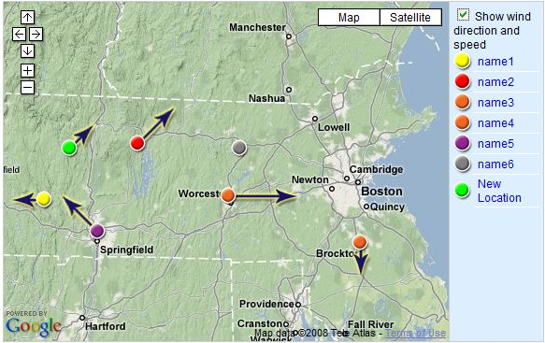
Figure 5: Representative Google Maps Screenshot
- Screenshot Description: This is how the Air Quality Maps should look:
  - The Map on the right would be zoomed in by default to show the State of Massachusetts.
  - Each Monitor would be represented by an icon on the Map; the icons would be a different color (Green = Good AQI; Yellow = Moderate AQI; Red = Unhealthy AQI) to indicate the current Air Quality at the Monitor.
  - There will also be arrows originating from the Air Quality Monitors to show the Wind Direction and relative Wind Speed at each monitor.
  - Clicking on a Monitor icon will pop-up a bubble similar to the one shown above with detailed information about the Monitor and its Current Levels.
  - Users can browse the high level information about each Monitor on the left hand side of the Map area.
  - All information on the Map will be presented in a table below as well for accessibility reasons.

Two Dimensional Graph
- “Section” Description:
  - There are two types of graphs identified to be made available in the Air Monitoring Data Website: “Trends by Pollutant” and “Trends by Monitor”. Each type is a Two Dimensional Graph where Pollutant concentration (or AQI) is plotted over time by Parameter or by Monitor depending on the type.

- Dynamic Behavior:

  - The Monitors available to display in the graphs will be all Monitors contained within the MassDEP EPICS Air Quality Data Storage.
  - The Parameters tracked for each Monitor will be dependent on the Parameters configured in the MassDEP EPICS Air Quality Data Storage.
  - The most recent data for Parameter levels will be available for display in the graphs.

- Public User Interaction:
  - Trends by Pollutant
    - Users can choose to Show/Hide Monitor plot lines for each parameter
    - Users can increase or decrease the time line for each Graph
    - Users can hover over a plot line on the Graph to see the specific point details (including Monitor, Parameter, Concentration [or AQI], Time, Wind Speed, Wind Direction, Temperature and Humidity.)
    - Users can choose to display results in AQI for PM and O-Zone
    - Users can choose to display up to two additional graphs below the default graph for other Parameters
  - Trends by Monitor
    - Users can choose to Show/Hide Parameter plot lines for each Monitor
    - Users can increase or decrease the time line for each Graph
    - Users can hover over a plot line on the Graph to see the specific point details (including Monitor, Parameter, Concentration [or AQI], Time, Wind Speed, Wind Direction, Temperature and Humidity.)
    - Users can choose to display results in AQI for PM and O-Zone
    - Users can choose to display up to two additional graphs below the default graph for other Monitors

- State Administrator Maintenance:
  - By importing Data that contains new Parameters or new Monitors, the new Parameter or Monitor will automatically be included in the corresponding display function on the Map.
  - Administrators can configure the Max AQI for Parameters; this value will show up as a dotted line crossing the graph horizontally when the graph is showing results as AQI (available for PM or O-Zone).

- Navigation Tabs that this “Section” Could Appear in:
  - Pollutants & Trends

- Representative Screenshot:

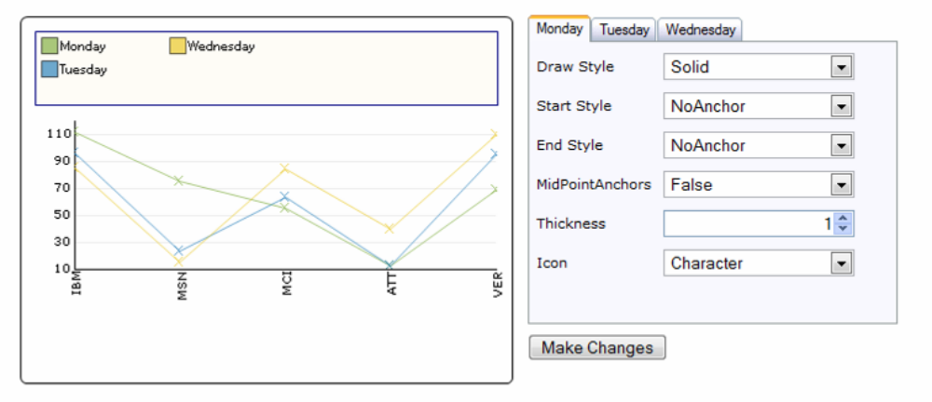
Figure 6: Representative Graph Screenshot (with existing Infragistics capabilities)
- Screenshot Description: This is similar to how the Air Quality Graphs would look:
  - The area on the right will be available to allow users to Show/Hide Parameters or Monitors. This will be done via dropdowns, checkboxes, and/or tabbed sub-pages.
  - The graph on the right would display a default depending on the origination of the request to view the graph, and then users would be allowed to change the graphs by using the area on the right.
  - When the graph displays AQI (available for PM or O-Zone) there would be a dotted line crossing the graph horizontally where the Max AQI is configured to be.
  - All information on the Graph will be presented in a table below as well for accessibility reasons.

Simple Links
- “Section” Description:
  - Simple Links are “Sections” that contain links to other Web Pages (could be within the Air Monitoring Public Data Website or outside of it). They do not have detailed information accompanying them – only the Link and a Mouse-Over Short Description.

- Dynamic Behavior:
  - The Link Text, Link URL, Link Type (Same Window or New Window), and Link Mouse-Over Short Description will be retrieved from the MassDEP EPICS Air Quality Data Storage.

- Public User Interaction:
  - Users can hover over the Link with their Mouse to view the Link Mouse-Over Short Description.
  - Users can click on the Link to Navigate to the Link or open a new window with the URL in it (depending on the configuration for the type of Simple Link)

- State Administrator Maintenance:
  - Administrators can configure the Link Text, Link URL, Link Type (Same Window or New Window), and Link Mouse-Over Short Description.

- Navigation Tabs that this “Section” Could Appear in:
  - All

- Representative Screenshot:

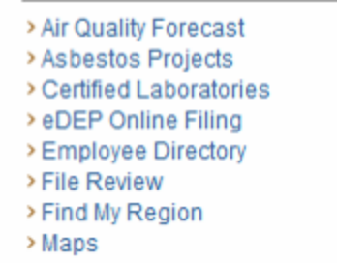
Figure 7: Representative Simple Link Screenshot
- Screenshot Description: This is how the Simple Links should look using current links from the MassDEP Website as a reference.

Complex Links
- “Section” Description:
  - Advanced Links are “Sections” that contain links to other Web Pages (they could be within the Air Monitoring Public Data Website or outside of it). They have detailed information accompanying them – a Title, a brief Description, a Thumbnail Image, and a Mouse-Over Short Description.

- Dynamic Behavior:
  - The Link Text, Link URL, Link Title, Link Description, Thumbnail Image, Link Type (Same Window or New Window), and Link Mouse-Over Short Description will be retrieved from the MassDEP EPICS Air Quality Data Storage.

- Public User Interaction:
  - Users can hover over the Link (or Thumbnail Image if included) with their Mouse to view the Link Mouse-Over Short Description.
  - Users can click on the Link, Link Title, or Thumbnail Image if included to Navigate to the Link or open a new window with the URL in it (depending on the configuration for the type of Simple Link)

- State Administrator Maintenance:
  - Administrators can configure the Link Text, Link URL, Link Title, Link Thumbnail Image, Link Type (Same Window or New Window), and Link Mouse-Over Short Description.

- Navigation Tabs that this “Section” Could Appear in:
  - All

- Representative Screenshot:


Figure 8: Representative Complex Link Screenshot
- Screenshot Description: This is how a Complex Link should look using a current “Complex Link” from the MassDEP Website as a reference.

Body Text
- “Section” Description:
  - Body Text is free text on the Web Page. It can be configured to have a title and different font. The layout of the text could be modified to include standard HTML features, such as bullet points and line breaks.

- Dynamic Behavior:
  - The Title and Text will be retrieved from the MassDEP EPICS Air Quality Data Storage.

- User Interaction:
  - Users can read the text only.

- State Administrator Maintenance:
  - Administrators can configure the Body Text (including layout and font) and the title (including omitting it).

- Navigation Tabs that this “Section” Could Appear in:
  - All

- Representative Screenshot:


Figure 9: Representative Body Text Screenshot
- Screenshot Description: This is how Body Text could look using a current example from the MassDEP Website as a reference.

Alerts
- “Section” Description:
  - Alerts are triggered when a certain Monitoring threshold is exceeded. The Alert is only visible for a pre-defined duration after the Alert is triggered. The Alert should be immediately visible on the page that is on and should be included at the top of the page for accessibility purposes.

- Dynamic Behavior:
  - The Alert is only triggered when a pre-defined Monitoring threshold is exceeded.
  - The Alert is only visible for the pre-defined duration.
  - The Alert Description and Link Information will be retrieved from the MassDEP EPICS Air Quality Data Storage.

- Public User Interaction:
  - Users can clink on the Alert Link to navigate to a new page with more information about the Air Quality Alert as pre-defined by MassDEP State Administrators.

- State Administrator Maintenance:
  - Administrators can configure the Alert thresholds for each Parameter.
  - Administrators can configure the Alert Description, Alert Link, Alert Link URL, and Alert Duration for each Parameter Specific Alert.

- Navigation Tabs that this “Section” Could Appear in:
  - Levels Now & Forecasts

- Representative Screenshot:

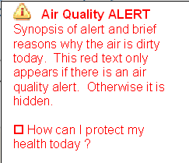

Figure 10: Representative Alert Screenshot

- Screenshot Description: This is a content representation of what an Alert would contain. In practice, the Alert would be laid out to extend horizontally across the Web Page. The font would also be modified to be more in-line with the rest of the MassDEP Website style, but should still stand out to indicate that it is an important message.

Webcams or Static Images
- “Section” Description:
  - A Webcam or Static Image will appear on a Web Page with or without captions. Webcam Images will be a link to the corresponding host of the Webcam. An image tag and image description will be included in the Web Page for Accessibility reasons.

- Dynamic Behavior:
  - The Webcam URLs or Static Images and associated information will be retrieved from the MassDEP EPICS Air Quality Data Storage.

- Public User Interaction:
  - Users can hover over the images to see an Image Mouse-Over Short Description.
  - Users can click on the Webcam images to open a new window with the Webcam URL displayed.

- State Administrator Maintenance:
  - Administrators can configure the following:
    - For Webcams
      - URL
      - Short Description Mouse-Over
      - Caption (optional)

    - For Static Images
      - The Image
      - Image URL (if hosted elsewhere)
      - Short Description Mouse-Over
      - Caption (optional)

- Navigation Tabs that this “Section” Could Appear in:
  - All

- Representative Screenshot:


Figure 11: Representative Webcam/Image Screenshot

- Screenshot Description: This is how a Webcam Static Image or other Image could appear on the Web Site.

Table Data:
- “Section” Description:
  - To supplement the Google Maps and the Two Dimensional Graph “Sections”, all data included in those sections will also be displayed in a table for Accessibility reasons. The table will be tabbed to allow for multiple days worth of data to be displayed compactly.

- Dynamic Behavior:
  - The data will be fed from the EPICS Air Quality Data Storage.
  - The number of Tabs worth of data in the Table will be dynamically determined based on the amount of Forecast data available in the database.

- Public User Interaction:
  - Users can view the data.
  - Users can click on the Table Tabs (if available) to toggle between the available columns of the Table of data.

- State Administrator Maintenance:
  - Administrators can configure the following:
      - Forecast Data

- Navigation Tabs that this “Section” Could Appear in:
  - Levels Now & Forecast
  - Pollutants & Trends

- Representative Screenshot:

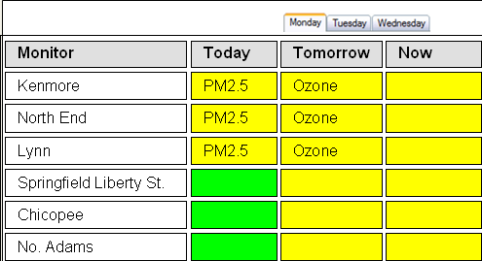
Figure 12: Representative Table Data Screenshot

- Screenshot Description: This is how the layout of the Table data may look with all the monitors listed in the left of the table, 3 columns of data to the right, and Tabs used to include data for additional Forecast days as necessary.

Downloads (Tentative):
- “Section” Description:
  - This section is similar to Simple Links, but geared toward displaying download details in a concise layout and also to download the files directly. With this ability, Website Management staff could add/update download files on the Air Monitoring Data Website without having access to the Host Website since the files will be stored in the accompanying Website Database.

- Dynamic Behavior:
  - The data will be fed from the EPICS Air Quality Data Storage.

- Public User Interaction:
  - Users can view the data.
  - Users can download the files.

- State Administrator Maintenance:
  - Administrators can configure the following:
      - File Name
      - File Description
      - The File Itself

- Navigation Tabs that this “Section” Could Appear in:
  - All

- Representative Screenshot:

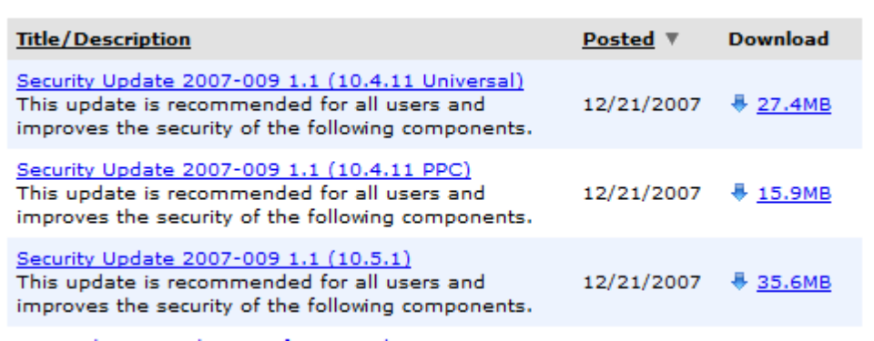
Figure 13: Representative Downloads Screenshot

- Screenshot Description: This is how the layout of the Downloads “Section” could look.

Page by Page Layouts
For each page identified to be developed for the Air Monitoring Data Website a mock page layout is provided below. The layouts are provided primarily to identify the functional content that will be available on each page and are not meant to be the final design of each Web Page.

The final implementation of the Web Pages will be reached via an Iterative review process. Development Web Screens will be shared and reviewed with MassDEP at critical points throughout the Development Process. During these review sessions the Project Team will work together to identify Web Page Modifications as necessary. IT will document the review meetings for historical purposes and make any agreed upon changes. The newly updated Web Pages will be reviewed again with MassDEP and the process as just described will be repeated. In this way, the Air Monitoring Data Website pages will eventually reach the QA and ultimately Production versions.

More detailed mock Web Pages provided by MassDEP for select Air Monitoring Data Web Pages are provided at the end of this document as “Appendix D – Air Monitoring Data Website Mock-up Web Pages from MassDEP”.

Levels Now & Forecast – Max AQI
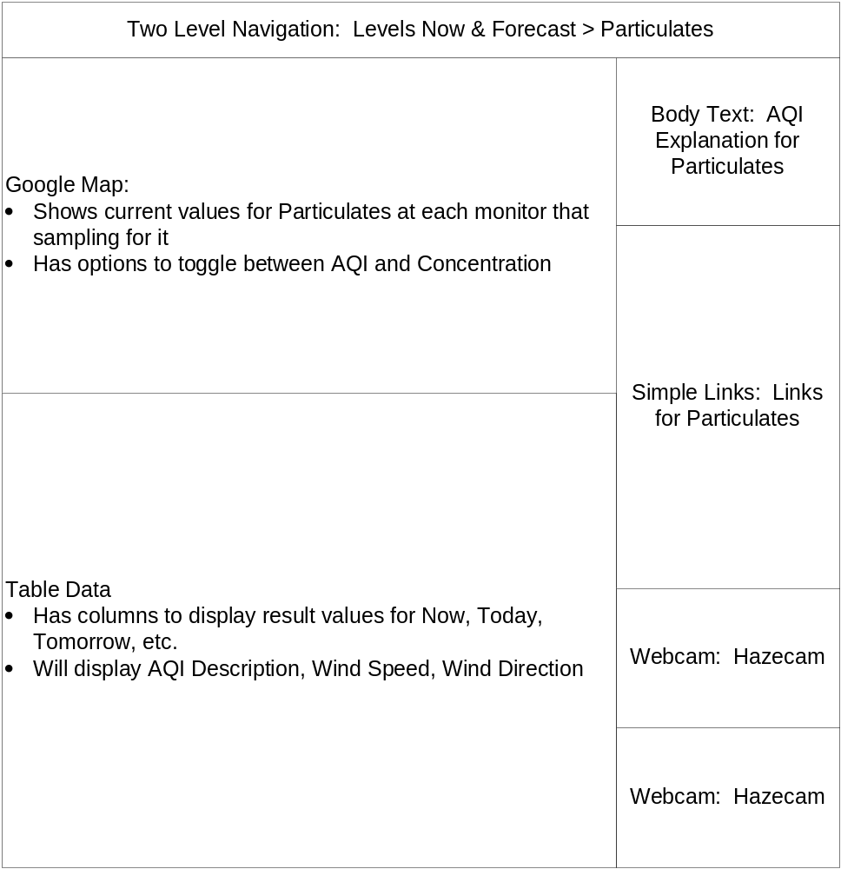
Figure 14: “Levels Now & Forecast > Max AQI” Layout

Levels Now & Forecast – Particulates
Figure 15: “Levels Now & Forecast > Particulates” Layout

Levels Now & Forecast – Ozone
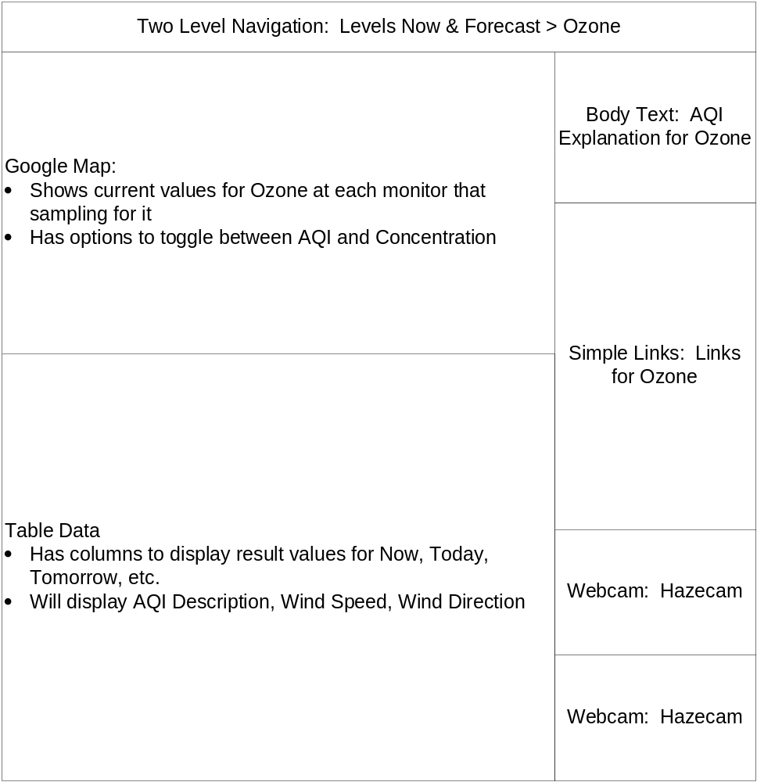
Figure 16: “Levels Now & Forecast > Ozone” Layout

Levels Now & Forecast – Carbon Monoxide
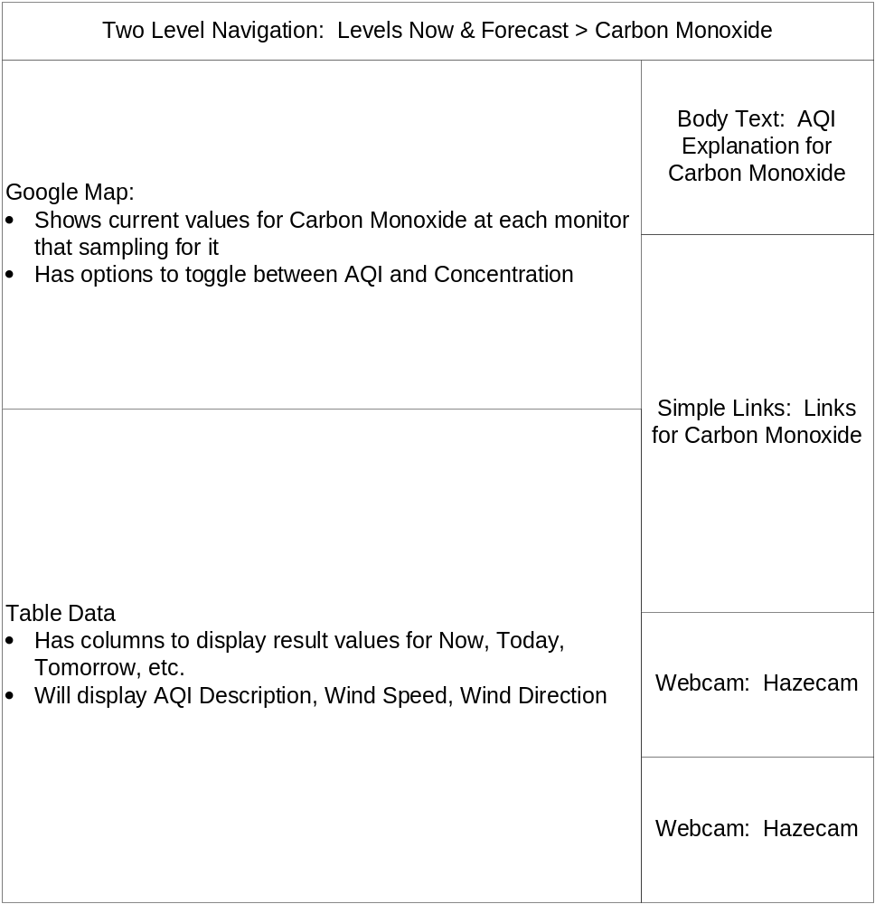
Figure 17: “Levels Now & Forecast > Carbon Monoxide” Layout

Levels Now & Forecast – SO2
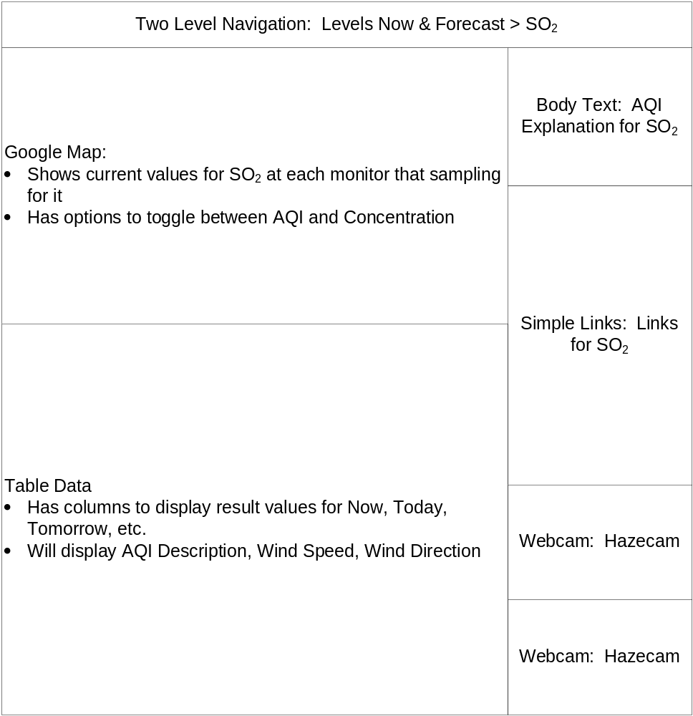
Figure 18: “Levels Now & Forecast > SO₂” Layout

Levels Now & Forecast – NO_{X}
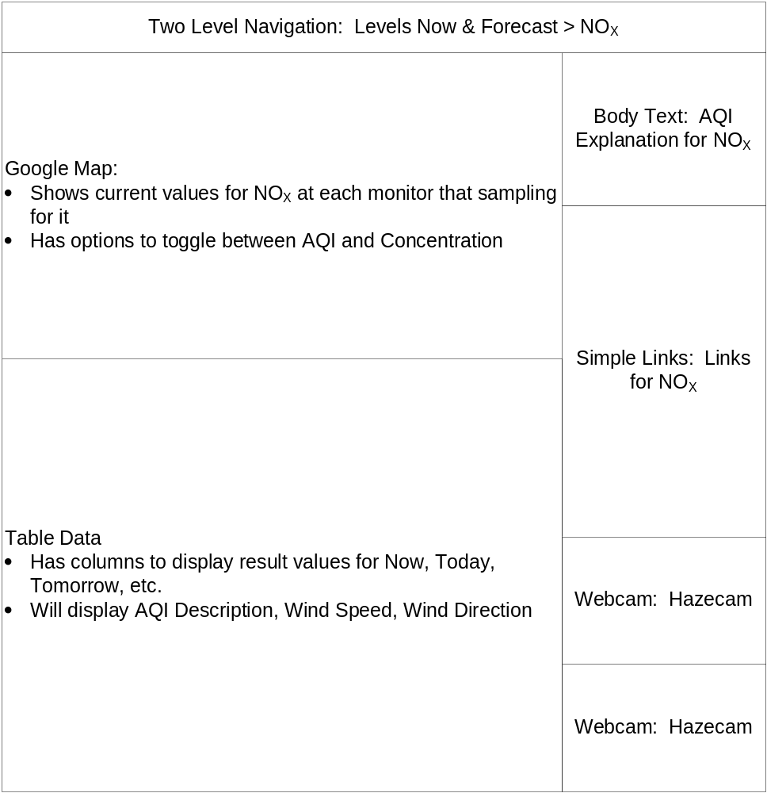
Figure 19: “Levels Now & Forecast > NO_{X}” Layout

My Community – Particulates
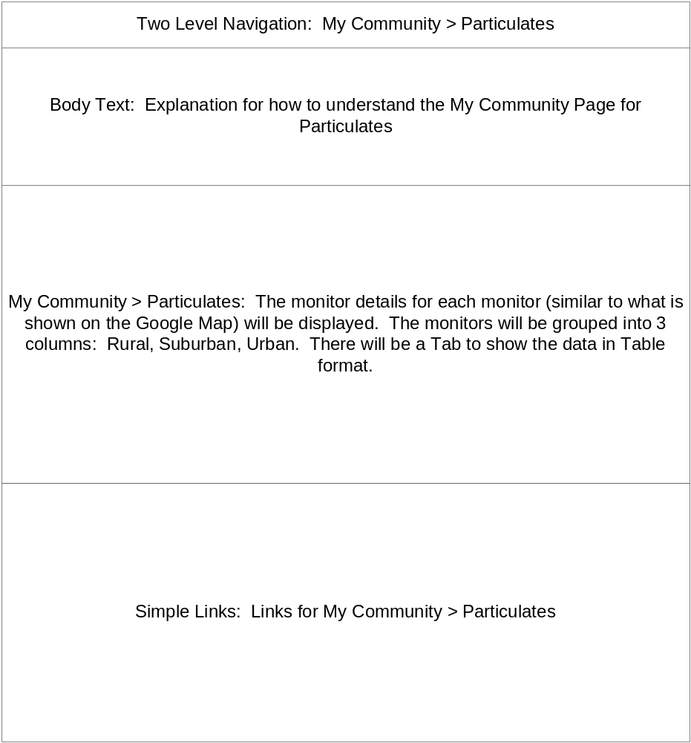
Figure 20: “My Community > Particulates” Layout

My Community – Ozone
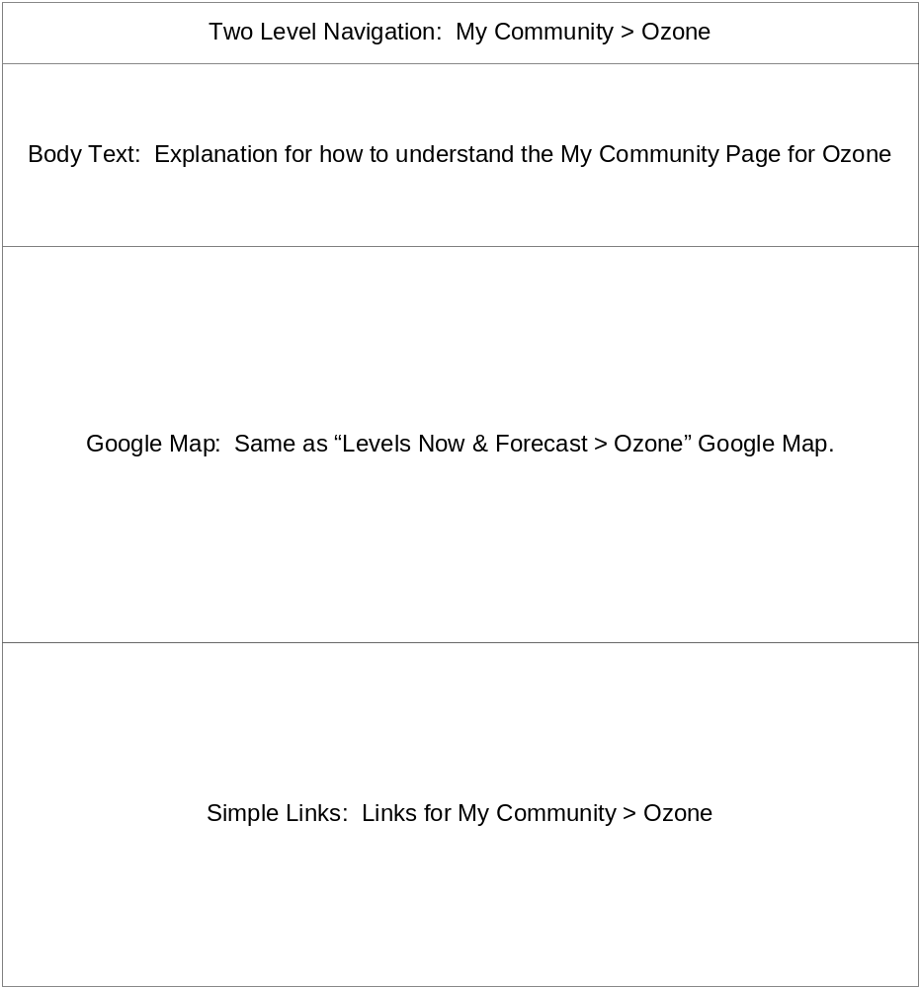
Figure 21: “My Community > Ozone” Layout

Pollutants & Trends – Trends by Pollutant
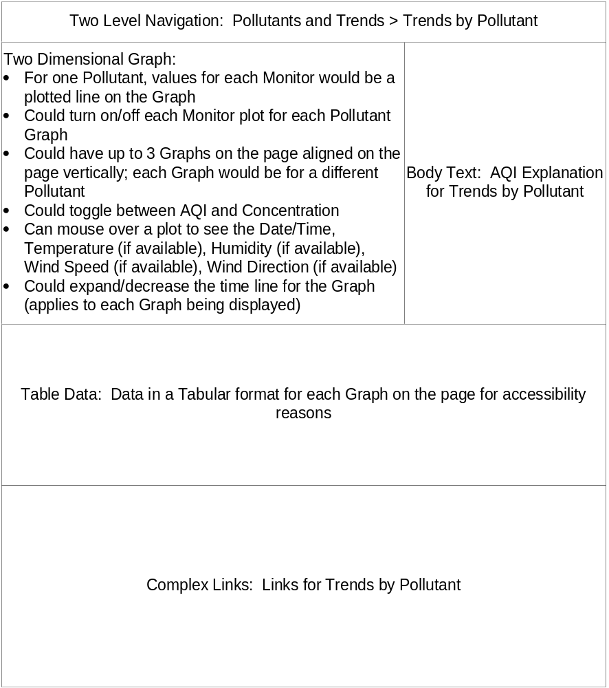
Figure 22: “Pollutants & Trends > Trends by Pollutant” Layout

Pollutants & Trends – Trends by Monitor
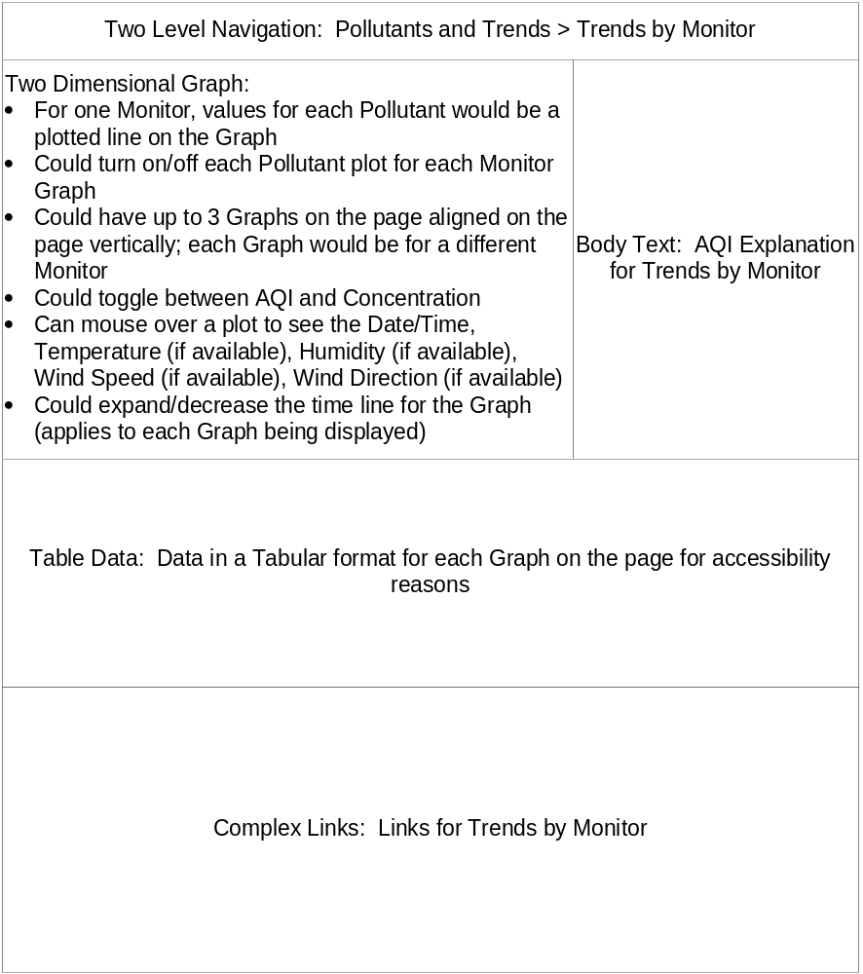
Figure 23: "Pollutants & Trends > Trends by Monitor" Layout

Data Download – Download Utility
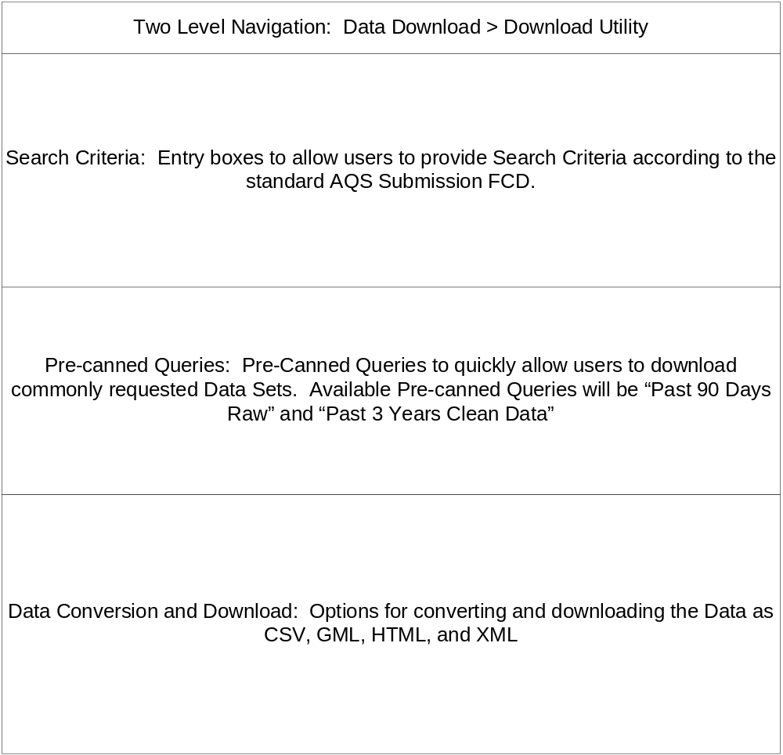
Figure 24: “Data Download > Download Utility” Layout

EPICS AQS Database Expansion
As noted in the “ Aggregate and Store Complete set of AQS Data in EPICS (ARA)” Section (2.1.2), the Air Quality data to support the Air Monitoring Data Website will come from a storage of Air Quality Data in EPICS to be designed and developed under this project. The sections below outline the Database Design Standards and Database Size Estimates. Draft Entity relationship diagrams are included in this document as “Appendix C – EPICS Expansion Draft Entity Relationship Diagrams”; the initial draft Database Structure will need to be updated in the future for the following two reasons:

- QA Tools Support: The QA Tools will be built off of the EPICS Air Quality Data Storage as well. Tables will need to be added/modified
- Website Design Iterations: As noted in the “Page by Page Layouts” Section (3.2.3), the final Website design will be updated through an iterative review process. Because of this, the Air Quality EPICS Data Storage may also need to be added to or updated.

Though changes will be made in the future, the following two sections (Database Design Standards and Database Size Estimates) will still apply to any updates to the Database.

Database Design Standards
The following database design standards will be implemented as required by MassDEP:

- Each database table will have a numeric primary key, controlled by an Oracle sequence number.

- Each database table will have the following standard fields
  - DATE_CREATE {DATE}
  - USER_CREATE {NVARCHAR2(25)}
  - USER_ID_CREATE {NUMBER(11,0)}
  - DATE_UPDATE {DATE}
  - USER_UPDATE {NVARCHAR2(25)}
  - USER_ID_UPDATE {NUMBER(11,0)}
  - END_DATE {DATE}

- Stored Procedures will be used to INSERT and UPDATE to the tables.

- Out-dated or obsolete will be denoted be including a Date Value in the corresponding END_DATE field.

Database Size Estimates
Initial design estimates

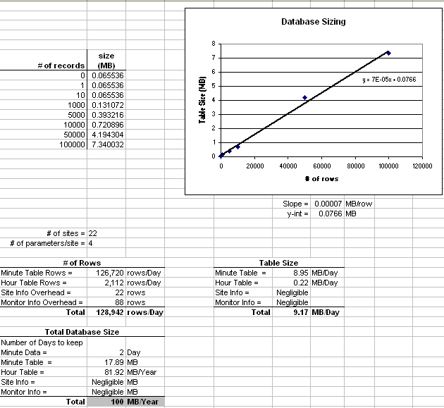
Figure 25: Database Sizing Calculations

Getting Data from EPICS to the Air Monitoring Data Website
The diagram below illustrates the process that will be used to publish data to the Air Monitoring Data Website; this process has been designed based on the Design Decision to feed the Air Monitoring Data Website from the AQS Version 2.0 Schema.

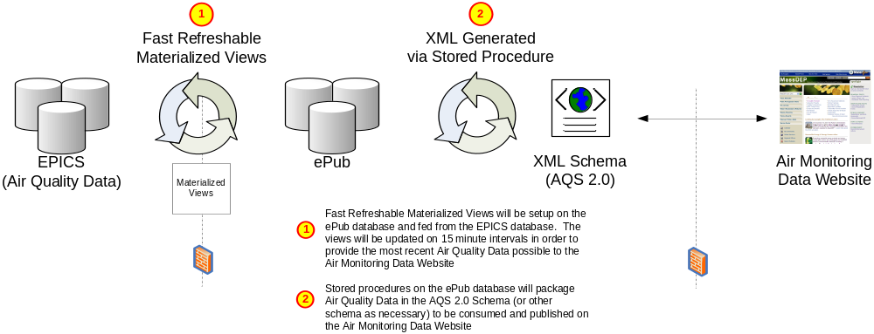
Figure 26: Getting Data from EPICS to the Air Monitoring Data Website

Deployment
This section identifies the different areas requiring installation and configuration in order to support the Air Monitoring Data Website.

Overview
The following Servers are proposed to be used at MassDEP Boston to support the Air Monitoring Public Data Website:

  - ePub Web Server
    - Hosts the Air Monitoring Public Data Website

  - ePub Database Server
    - Hosts Fast Refreshable Materialized Views on Oracle Database
    - The source of the views will be EPICS
    - Stored Procedures in the Oracle Database will generate XML from the Data in the views to feed the Website

  - EPICS Database Server
    - Hosts the Air Quality Data Storage Objects in the EPICS Oracle Database

Web Server Requirements
  - Software:
    - Windows Server 2003 with latest updates
    - .NET Framework 2.0 with latest updates
    - WSE 3.0 with latest updates
    - IIS 6.0 with latest updates
  - Hardware:
Table 2: Web Server Hardware Requirements
Web Server | Minimum Requirements | Recommended System
Load Balancing | Not Required | Network Load Balancing Recommended
Processor | Pentium IV 2.4 GHz or higher | Pentium IV 2.8 GHz or higher
Memory | 2 GB of RAM | 4 GB of RAM or higher
Disk Space | 20 GB free hard disk space | 40 GB free hard disk space or higher

Database Server Requirements
  - Software:
    - Windows Server 2003 with latest updates
    - Oracle 9i with latest updates
  - Hardware:
Table 3: Database Server Hardware Requirement
Web Server | Minimum Requirements | Recommended System
Load Balancing | Not Required | Cluster Server with RAID 5 Storage Array
Processor | Pentium IV 2.4 GHz or higher | Pentium IV 2.8 GHz or higher
Memory | 2 GB of RAM | 4 GB of RAM or higher
Disk Space | 40 GB free hard disk space | 80 GB free hard disk space or higher

Application Server (Optional) Requirements
  - Software:
    - Windows Server 2003 with latest updates
    - .NET Framework 2.0 with latest updates
    - WSE 3.0 with latest updates
  - Hardware:
Table 4: Application Server (Optional) Hardware Requirements
Web Server | Minimum Requirements | Recommended System
Load Balancing | Not Required | Network Load Balancing Recommended
Processor | Pentium IV 2.4 GHz or higher | Pentium IV 2.8 GHz or higher
Memory | 2 GB of RAM | 4 GB of RAM or higher
Disk Space | 20 GB free hard disk space | 40 GB free hard disk space or higher

Appendix A – Webpage Flow Diagrams

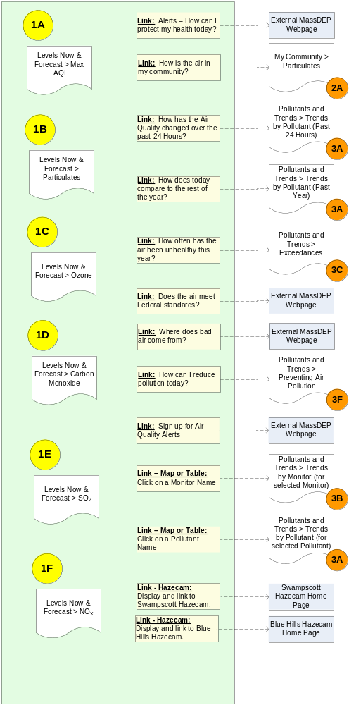
Figure 27: Page Flow - Levels Now & Forecast

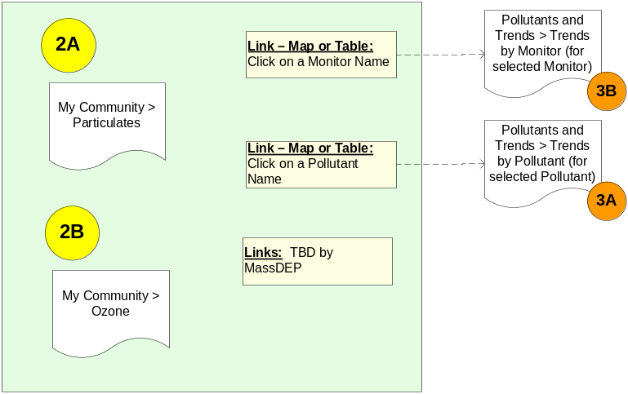
Figure 28: Page Flow - My Community

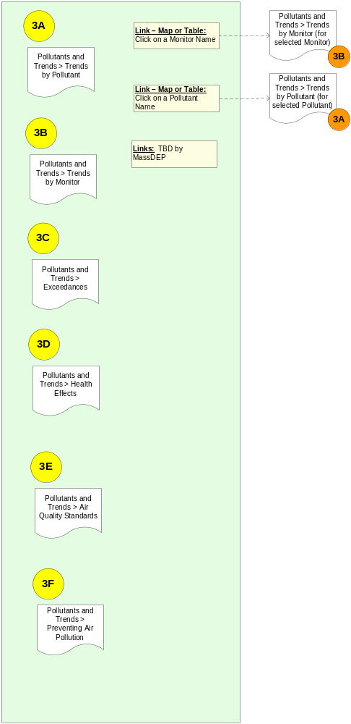
Figure 29: Page Flow - Pollutants by Trend

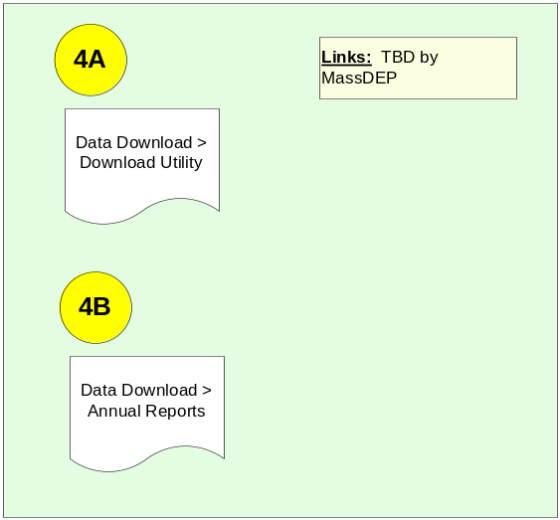
Figure 30: Page Flow - Data Download

Appendix B – WebAIM Section 508 Compliance Checklist

Part 1: for HTML
The following standards are excerpted from Section 508 of the Rehabilitation Act, §1194.22. Everything in the left hand column is a direct quote from Section 508. The other two columns are only meant to serve as helpful guidelines to comply with Section 508. These guidelines are suggestions only, and are not part of the official Section 508 document. For the full text of Section 508, please see the Official government 508 web site - external link.

SEC. 508 STANDARD | PASS | FAIL
(a) A text equivalent for every non-text element shall be provided (e.g., via "alt", "longdesc", or in element content). | Every image, Java applet, Flash file, video file, audio file, plug-in, etc. that conveys content has an equivalent alt description or text description, or is described in the adjacent text. | A non-text element has no alt or text description or the description is not equivalent, or is not described in the adjacent text.
 | Complex graphics (graphs, charts, etc.) are accompanied by detailed text descriptions, either through a description in the body of the page, a link to a description on a separate page, or the longdesc attribute [See Note 1] | Complex graphics have no alternative text or the alternative does not fully convey the meaning of the graphic.
 | The alt descriptions succinctly describe the content conveyed by the objects, without being too verbose (for simple objects) or too vague (for complex objects). | Alt descriptions are verbose (picture of, image of, etc.), vague, misleading, inaccurate or redundant to the context (e.g. the alt text is the same as the text immediately preceding or following it in the document).
 | Alt descriptions for images used as links are descriptive of the link destination. | Alt descriptions for images used as links are not descriptive of the link destination.
 | Decorative graphics with no other function are inserted as background images using CSS or have empty alt descriptions (alt= ""), but they never have missing alt descriptions. Images with text alternatives in element content are given empty alt text (alt= ""). | Decorative graphics have alt descriptions that say "spacer", "decorative graphic," or other extraneous text. Graphics have alt descriptions that are redundant with text descriptions within content.
(b) Equivalent alternatives for any multimedia presentation shall be synchronized with the presentation. | Video files have synchronized captions. | Video files do not have captions or captions are not synchronized.
 | Audio files have captions and/or transcripts. | Audio files do not have captions or transcripts.
(c) Web pages shall be designed so that all information conveyed with color is also available without color, for example from context or markup. | Color is not used solely to convey important information. | Color is the sole means of conveying information.
 | Sufficient contrast is provided. | Contrast is poor.
(d) Documents shall be organized so they are readable without requiring an associated style sheet. | Style sheets may be used for layout, but the document is still understandable (even if less visually appealing) when the style sheet is turned off. | The document is confusing or information is missing when the style sheet is turned off.
(e) Redundant text links shall be provided for each active region of a server-side image map. | Separate text links are provided outside of the server-side image map to access the same content that the image map hot spots access. Client-side image maps CANNOT be used to provide the same hot spot areas (see section f). | The only way to access the links of a server-side image map is through the image map hot spots, which usually means that a mouse is required and that the links are unavailable to assistive technologies. Client-side image maps can provide the same hot spot areas.
(f) Client-side image maps shall be provided instead of server-side image maps except where the regions cannot be defined with an available geometric shape. | Client-side image maps are used and appropriate alt text is provided for the image as well as each hot spot region. | Server-side image maps are used when a client-side image map would suffice. Appropriate alt text is not provided for the image and each hot spot region.
(g) Row and column headers shall be identified for data tables. | Data tables have the column and row headers appropriately identified (using the th tag). | Data tables have no header rows or columns.
 | Tables used strictly for layout purposes do NOT have row or column headers. | Tables used for layout use the header attribute when there is no true header.
(h) Markup shall be used to associate data cells and header cells for data tables that have two or more logical levels of row or column headers. | Data table cells are associated with the appropriate headers (e.g. with the id, headers, scope and/or axis attributes). | Data table cells are not associated with column and row headers or they are associated incorrectly.
(i) Frames shall be titled with text that facilitates frame identification and navigation. | Each frame is given a title that describes the frame’s purpose or content. | Frames have no title or a title that is not descriptive of the frame’s purpose or content.
(j) Pages shall be designed to avoid causing the screen to flicker with a frequency greater than 2 Hz and lower than 55 Hz. | No elements on the page flicker at a rate of 2 to 55 cycles per second, thus reducing the risk of optically-induced seizures. | One or more elements on the page flicker at a rate of 2 to 55 cycles per second, increasing the risk of optically-induced seizures.
(k) A text-only page, with equivalent information or functionality, shall be provided to make a web site comply with the provisions of this part, when compliance cannot be accomplished in any other way. The content of the text-only page shall be updated whenever the primary page changes.  [See Note 2] | A text-only version is created only when there is no other way to make the content accessible or when it offers significant advantages over the "main" version for certain disability types. | A text-only version is provided when the main version is not accessible, but could be made fully accessible.
 | The text-only version provides equivalent content and is up-to-date with the "main" version. | The text-only version is not up-to-date with the "main" version.
 | The text-only version provides the functionality equivalent to that of the "main" version. | The text-only version is an unequal, lesser version of the "main" version.
 | An alternative is provided for components (e.g. plug-ins, scripts) that are not directly accessible. | No alternative is provided for components that are not directly accessible.
(l) When pages utilize scripting languages to display content, or to create interface elements, the information provided by the script shall be identified with functional text that can be read by assistive technology. | Information within the scripts is text-based, or a text alternative is provided within the script itself, in accordance with (a) in these standards. | Scripts include graphics-as-text with no true text alternative.
 | All scripts (e.g. Javascript pop-up menus) are either directly accessible to assistive technologies and the keyboard or an alternative method of accessing equivalent functionality is provided (e.g. a standard link). | Scripts only work with a mouse and there is no keyboard-accessible alternative either within or outside of the script.
(m) When a web page requires that an applet, plug-in or other application be present on the client system to interpret page content, the page must provide a link to a plug-in or applet that complies with §1194.21(a) through (l).  [See Note 3]  [See Note 4]  [See Note 5] | A link is provided to a page where the plug-in can be downloaded. | No link is provided to a page where the plug-in can be downloaded.
 | All Java applets, scripts and plug-ins (including PDF files and PowerPoint files, etc.) and the content within them are accessible to assistive technologies, or else an alternative means of accessing equivalent content is provided. | Inaccessible plug-ins, scripts, and other applications are used without providing an accessible alternative.
(n) When electronic forms are designed to be completed on-line, the form shall allow people using assistive technology to access the information, field elements, and functionality required for completion and submission of the form, including all directions and cues. | All form controls have text labels. | Form controls have no labels.
 | Form elements have labels associated with them in the markup (i.e. the id and for or label elements). | There is no association between the form element and its label.
 | Dynamic HTML scripting of the form does not interfere with assistive technologies and is keyboard accessible. | Dynamic HTML scripting makes parts of the form unavailable to assistive technologies or is not keyboard accessible.
(o) A method shall be provided that permits users to skip repetitive navigation links. | A link is provided to skip over lists of navigational menus or other lengthy lists of links. | There is no way to skip over repetitive lists of links.
(p) When a timed response is required, the user shall be alerted and given sufficient time to indicate more time is required. | The user has control over the timing of content changes. | The user is required to react within limited time constraints.
Note 1:Until the longdesc tag is better supported, it is best to use it in conjunction with a standard link to a longer description.
Note 2:"Text-only" and "accessible" are NOT synonymous. Text-only sites typically only help people with certain types of visual or cognitive disabilities. They are usually not helpful to users with disabilities.
Note 3: Standalone media players are usually more accessible than embedded media players.
Note 4: A PDF file can be made accessible to screen reader users, but it may be best to include an accessible HTML version of a document instead of or in addition to PDF.
Note 5: PowerPoint files are currently not directly accessible unless the user has a full version of the PowerPoint program on the client computer. It is recommended that an accessible HTML version be provided instead of or in addition to the PowerPoint version.

Part 2: for Scripts, Plug-ins, Java, etc.

The following standards are excerpted from Section 508 of the Rehabilitation Act, §1194.21. Full text of Section 508 - external link.
SEC. 508 STANDARD
(a) When software is designed to run on a system that has a keyboard, product functions shall be executable from a keyboard where the function itself or the result of performing a function can be discerned textually.
(b) Applications shall not disrupt or disable activated features of other products that are identified as accessibility features, where those features are developed and documented according to industry standards. Applications also shall not disrupt or disable activated features of any operating system that are identified as accessibility features where the application programming interface for those accessibility features has been documented by the manufacturer of the operating system and is available to the product developer.
(c) A well-defined on-screen indication of the current focus shall be provided that moves among interactive interface elements as the input focus changes. The focus shall be programmatically exposed so that assistive technology can track focus and focus changes.
(d) Sufficient information about a user interface element including the identity, operation and state of the element shall be available to assistive technology. When an image represents a program element, the information conveyed by the image must also be available in text.
(e) When bitmap images are used to identify controls, status indicators, or other programmatic elements, the meaning assigned to those images shall be consistent throughout an application's performance.
(f) Textual information shall be provided through operating system functions for displaying text. The minimum information that shall be made available is text content, text input caret location, and text attributes.
(g) Applications shall not override user selected contrast and color selections and other individual display attributes.
(h) When animation is displayed, the information shall be displayable in at least one non-animated presentation mode at the option of the user.
(i) Color coding shall not be used as the only means of conveying information, indicating an action, prompting a response, or distinguishing a visual element.
(j) When a product permits a user to adjust color and contrast settings, a variety of color selections capable of producing a range of contrast levels shall be provided.
(k) Software shall not use flashing or blinking text, objects, or other elements having a flash or blink frequency greater than 2 Hz and lower than 55 Hz.
(l) When electronic forms are used, the form shall allow people using assistive technology to access the information, field elements, and functionality required for completion and submission of the form, including all directions and cues.

Appendix C – EPICS Expansion Draft Entity Relationship Diagrams

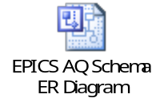
Figure 31: EPICS AQ Schema Entity Relationship Diagram (Visio 2002 Drawing)

Appendix D – Air Monitoring Data Website Mock-up Web Pages from MassDEP

Figure 32: MassDEP Air Monitoring Public Data Website Mock-up Screens

The AQS 2.0 schema will be used to populate the website with all the data that would be reported to the EPA via the AQS Submission. A separate business XML schema will be developed to transfer and populate the non-AQS data on the website, such as
IT has worked with MassDEP previously to implement projects that integrate with the new ARA Data Management Model which will eventually incorporate the entire EPICS data repository. In this project, the Air Quality Data Storage will provide for an option to integrate with the ARA Data Model for Air Monitor Site Location Data. Please see the “EPICS AQS Database Expansion” Section (3.3) for more information on the EPICS Database.
The Team has decided to continue with Option A in light of the new Website Design which includes having the Website consume data from the AQS version 2.0 XML Schema. Please see “Data Population to Website” (Section 3.1.2) for more information.
Under the new design, the Website will be built to consume data directly from the AQS version 2.0 XML Schema. This would enable the Website to be integrated with virtually any Exchange Network Node that publishes the AQS Schema in the future. Please see “Data Population to Website” (Section 3.1.2) for more information.
At the time that this document was last update, the Project Team had decided to continue with the initial Website Design of feeding the Air Quality Data Download Module from the AQS Node Web Service.
Please see the “Deployment” Section (4) for more information and installation and deployment.
Please see the “Two Level Navigation” Section (3.2.1) for more information on the Air Monitoring Data Website Navigation design.
The AQS 2.0 schema will be used to populate the website with all the data that would be reported to the EPA via the AQS Submission.
The Data Download portion of the website may still be integrated with the AQS Web Service to be implemented on the MassDEP Node. Please see the “Data Source for Data Download Module” Design Decision for more information on this option.
The Website Database is preliminarily identified to be ePub. Please see the “” section for more information on Website deployment.
Please see the “MassDEP_AQS_SDD_QATools_v1.2.doc” for more information on the non-data content management module.
The HTML Code Snippets could possibly contain Javascript as well.
In order to ensure the website is Section 508 Compliant, each Map will be accompanied by an option to view the data presented in the map in a tabular format.
Please see the “Deployment” Section (4) for more information on installation and deployment.
Please see the “Data Source for Data Download Module” Design Decision for more information on the different options that may be implemented to support the Air Monitoring Data Website Download Module.
The “Two Level” Navigation option will be included at the top of the center page located to the bottom of the Header piece and the right of the Navigation Panel piece of the MassDEP Web Template.
The “Data Download Module > Search Criteria” and the “My Community > PM” Web Pages will contain unique Web Page layouts and functionalities. They will function similar to the Google Maps “Section” in that the layout and presentation of these areas of the Website will not be able to be maintained by Administrator Staff via the QA Tools Website Administrator Module.
MassDEP expressed that this section would not be useful in their implementation of the Website, but that if possible, this option may be useful for other Exchange Network States or Agencies that may want to host a version of this Website. The Project Team will implement this option depending on the time and resources available during the development phase of the project; if the team is running short on time and/or resources, this functionality will most likely not be implemented.
The Second Level Navigation pages marked by ** in the “Two Level Navigation” Section (3.2.1) will not be included in this section. Please see that Section for more information.
Please see “Data Population to Website” (Section 3.1.2) for more information on this Design Decision.
The Second Level Navigation pages marked by ** in the “Two Level Navigation” Section (3.2.1) will not be included in this section (unless they are linked to from other pages in the Air Monitoring Data Website. Please see that Section for more information.

